SCP Universal Vessel Fatigue Assessment and Validation

Mr Richard Neely and Dr Dax Sun   
*(Sellafield Ltd, UK)*

**Abstract**

The SCP Universal Vessel (UV) is a universal ion exchange vessel currently being manufactured to filter effluent on the Sellafield site. The UV has an internal 3m long discharge pipe suspended form the top of the vessel braced approximately halfway down its length by two support pipes. A test rig was set up for two UV's, each ran through a full program of functional tests. Strain gauges and accelerometers were placed on the discharge pipe of each UV to understand the behaviour of the pipe in response to the various loading scenarios applied during the operations.

This presentation aims to share the learning gained from the structural design work carried out for the SCP UV fatigue substantiation. In summary, the instrumentation output from testing was processed and used as input into a harmonic response FE model, where the modal responses were combined allowing stress ranges to be determined for evaluation in a fatigue assessment to PD5500. The trial test results showed the discharge pipe was being excited at several natural frequencies. The FE assessment showed that the UV design fatigue performance on a functionally critical vessel component was acceptable for a 50-year operational life.

# Introduction



1. SCP UV General Design Detail

The Sellafield site effluent abatement prior to sea discharge is provided by the Site Ion Exchange Effluent Plant (SIXEP). The SIXEP Continuity Plant (SCP) is an extension of this facility currently being constructed that will provide the same service once SIXEP reaches the end of its operational life. The SCP Universal Vessel (UV) is a stainless steel universal ion exchange vessel that is designed to hold sand (for particulate) or clinoptilolite (for ion exchange) to filter effluent (Figure 1). The design is based on the original SIXEP UV design with several modifications to ensure a 50-year operational life. Design changes include the alteration of supports for the filter medium discharge pipe. This pipe is essential to the operation of the UV as it allows the filter medium to be removed once saturated. The pipe is approximately 3m long, supported approximately halfway down its length by two support pipes (Figure 1).

The operations to remove the filter medium are highly dynamic and energetic events designed to breakup and fluidise the compressed medium. They include directing a high velocity turbulent mixed phase (water and air) flow into the pressurised UV and through the discharge pipe. These operations results in a complex multimode loading on the discharge pipe. Due to the complexity of loading, design changes, and a need to functionally test the UV, a commissioning test rig was set up at the premises of the manufacturers. Two completed UVs were placed in the test rig, and each ran through a full program of functional tests. Strain gauges and accelerometers were placed on the discharge pipe of each UV for the tests to understand the behaviour of the pipe in response to the various loading caused by the operations. However, all instrumentation except the accelerometers on one of the UVs failed during testing. The time history results showed the jet ring sequence provided the worst-case accelerations. With no working strain gauges the accelerometer data was processed and used to derive displacements (Table 1) and develop response spectra (Figure 2).



1. Maximum Displacement during Jet Ring Sequence for Channel 4X & Z

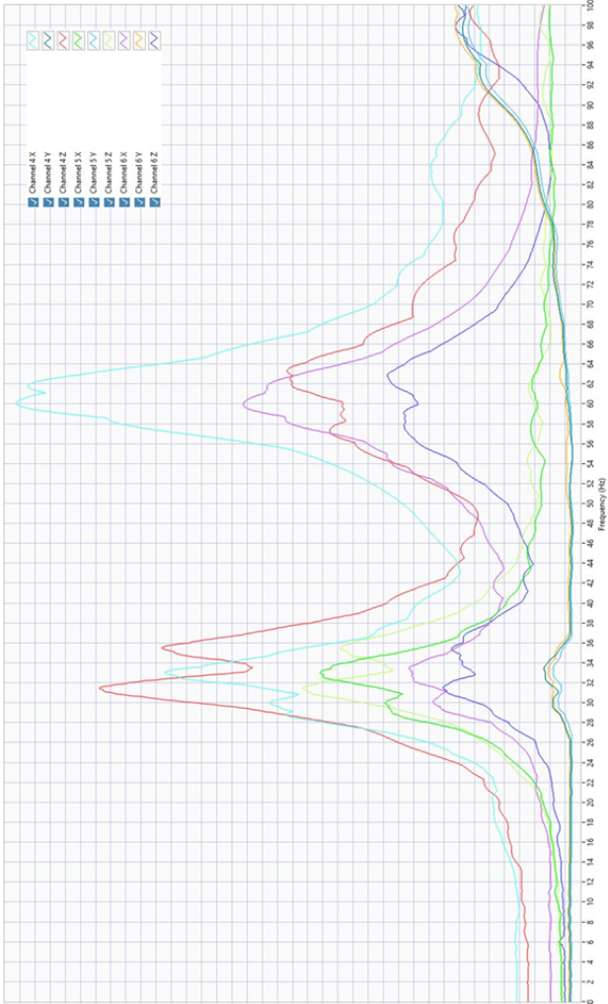

1. Response Spectrum from the Jet Ring Sequence Test Data (0-100Hz)

# Summary of the FE Modelling Results

The response spectrum shows the vibration in the discharge pipe is complex with multiple natural frequencies acting simultaneously throughout the operation. A simple static model could not capture the structures response at different natural frequency's and instead a harmonic response analysis was used to capture the response of those modes and allow their combination. The derived displacement data from the accelerometers has been used to adjust the loading in the FE model to fit the output displacement, which provides a representative response that can be used for further calculation.

The harmonic analysis provides the response of the structure to cyclic loads over a frequency range. Mode superposition method was used for this analysis, it combines the linear mode shapes defined by a normal modal analysis to derive a displacement vector over the range of frequencies. As the response is determined from the modes considered, it is important to include any dominant mode shapes that to contribute to the structure’s response. The cumulative mass fraction in the modal analysis shows the first four modes ranging from 30.96Hz to 64.4Hz are the dominating natural frequencies. The harmonic analysis develops a response for the first four modes of the structure (Figure 3). It determines the peak displacement response around each of those modes, and the force input is iterated to match the FE model response to the test data.

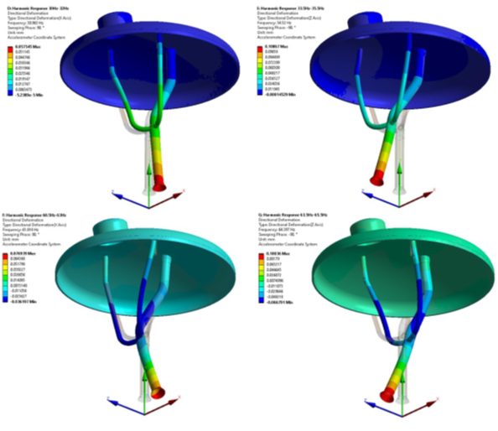

1. Harmonic Response Deformation Results (30.96Hz Top Left, 34.52Hz Top Right, 61.81Hz Bottom Left, 64.4Hz Bottom Right)

Once corelation is achieved the results are combined. Combination of the results is necessary as all modes are being excited throughout the operation. This is done using the using the square root sum of the squares method for each mode. Combined stresses are then used as the stress range for the fatigue assessment.

The fatigue assessment was conducted in accordance with PD5500:2015 Annex C (Reference 1). Stress ranges were extracted from the highest stressed areas through parent material and weld throats. This was then evaluated to aa appropriate PD5500 defined S-N curve to predict the fatigue life of that section (Figure 4).

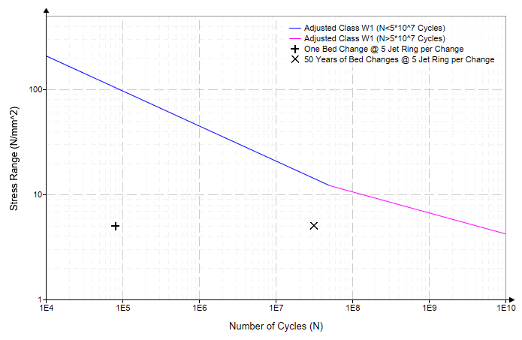

1. PD5500 S-N Curve Showing Fatigue Results for a Weld Throat

The harmonic analysis FE model outputs were corelated with test data to provide representative stress ranges for a PD5500 fatigue assessment. This demonstrated that the fatigue performance on a functionally critical vessel component was acceptable for a 50-year operational life.

# References

1. PD5500:2015, Specification for Unfired Fusion Welded Pressure Vessels.