Converging AI/ML techniques with traditional physics-based computational fluid dynamics (CFD) simulations to streamline conceptual design processes across automotive, motorsport, and energy industries
Ashish Naik, on behalf of Dr. Vidyasagar Ananthan, Satheesh Maheswaran, Neil Ashton, and Srinivas Tadepall
(Amazon Web Services).
Abstract
The integration of AI/ML techniques with traditional physics-based simulations heralds a transformative era for conceptual design within automotive, motorsport, and energy industries. These fusion promises to catalyze design innovation, accelerate iteration cycles, and propel the development of more sustainable technologies. Through collaborative efforts with our customers, we've discerned fundamental computing patterns essential for effectively marrying these domains, specifically for simulation driven design optimisation.
Foremost among these patterns is the need to orchestrate dynamic pipelines, characterized by a dynamic directed acyclic graph (DAG) where the execution path isn't predetermined but is instead determined by predictive modeling algorithms at runtime. Additionally, the capability to run tasks within pipelines asynchronously is crucial for maximizing task parallelization, thereby optimizing computational efficiency.
Furthermore, our customers demand the ability to execute models across heterogeneous compute architectures, from different languages and simulations, within a single workflow pipeline to harness the full potential of available computing resources. Equally important is ensuring traceability and auditability throughout the workflow to facilitate transparency and compliance.
These requirements span a hybrid combination of high-performance computing (HPC) and machine learning (ML) workloads, presenting challenges that transcend traditional techniques from either domain. In our upcoming session, we aim to delve into practical examples of how customers leverage simulation for engineering design optimization and scenario analysis. These examples encompass a spectrum of applications, including automotive manufacturing component simulation, system-level engineering design optimization for offshore wind farms, and the integration of Generative AI with CFD for vehicle design. Through these case studies, we aim to showcase the transformative potential of combining AI/ML techniques with traditional physics-based simulations in driving innovation across diverse industries.

Simulation driven design optimisation
Simulation driven design optimization is used by OEMs performing engineering design of equipment and processes. For example, manufacturers perform thousands of structural analysis simulations to optimize the physical design of subcomponents. Similarly, pharmaceutical companies use simulations to design the layout of new bioreactor manufacturing lines to optimize the yield.

Example – Component injection trajectory
In Figure 1, we show the results of a component-level engineering design optimization in an automotive use case involving injection of a liquid which hardens into a foam to provide structural strength for vehicle body panels. The challenge here is to find the optimal injection trajectory to maximize the contact surface, while minimizing void formation and foam wastage. TwinFlow is used to orchestrate 3 distinct models run on different compute infrastructure (foam growth on AWS Batch, trajectory optimizer on Docker, and trajectory perturbation on local Python) within the optimization algorithm. The optimization ran 1280 foam growth simulations, generating 11140 graph elements, with each simulation taking 9-11 min (including 5-6 min of post-processing).
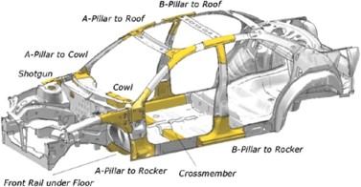
Figure 1 a) Diagram showing structural elements of a vehicle, specifically the B-pillar which is modeled; b) Video showing a simulation run for the foam injection (click video).

Example – System-level engineering design
In another example, we use TwinFlow for system-level engineering design optimization of an offshore wind farm (using the International Energy Association (IEA) benchmark IEA37 wind farm use case). The challenge here is to identify the optimal layout (geographic coordinates) of 64 wind turbines to maximize wind farm energy production, while taking into account the impact of the wake generated by each wind turbine within the wind farm. The approach uses an analytical wake model (Bastankhah & Porte-Agel, 2014), with added turbulence (Frandsen, 2017) solved using the open-source PyWake package. Figure 2 shows the simulation convergence curve. The optimization took 450 iterations to converge and 18 minutes to run with an approximate runtime of 10 seconds per simulation.
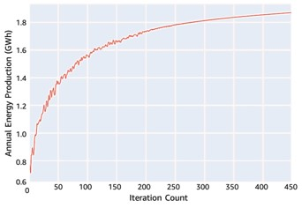
Figure 2 Graph showing the convergence of the simulation to maximize wind farm energy production.

Example – combining GenAI, ML and computational physics
Finally, we’ll demonstrate how generative AI techniques can be combined with conventional physics-based computational fluid dynamics (CFD) simulations to create a rapid conceptual design process that can be used to explore new design concepts in the automotive, motorsport, and aerospace sectors from just a single image.

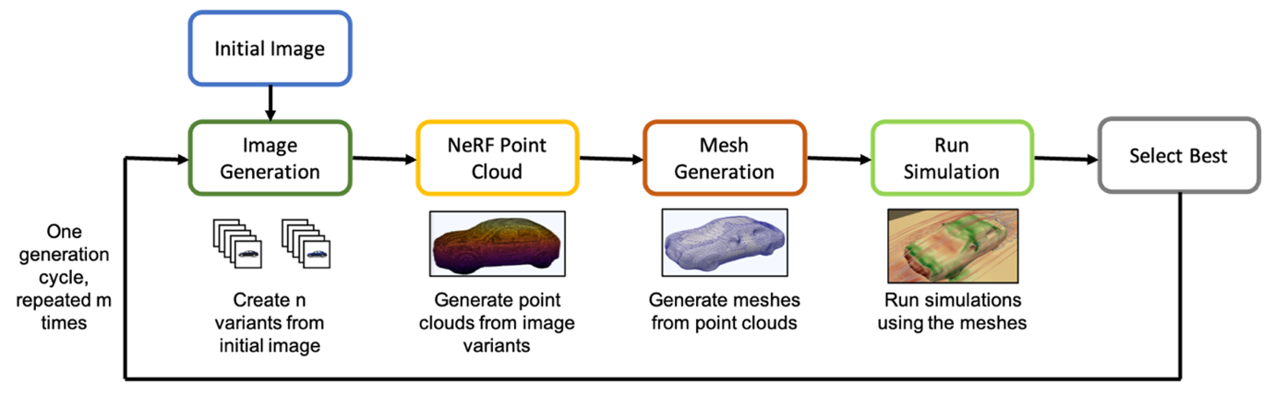
Figure 3 Overall workflow for iterative design optimization of car aerodynamics by combining Generative AI techniques and Computational Fluid Dynamics simulations
The overall workflow has five key components: image generation, Stable Diffusion, point-cloud with NeRF, mesh generation with Open3d and NKSR, and finally the OpenFoam CFD simulation. Each of these are containerized and orchestrated by the TwinGraph orchestration module within the TwinFlow framework.
We deployed this workflow by using AWS Batch and scaled it as needed to find the optimal designs. We repeated the experiment for a number of generated images across multiple cycles, and uploaded the results from each experiment automatically to Amazon Simple Storage Service (Amazon S3). The necessary meta-data provenance information from each experiment was automatically uploaded to an Amazon Neptune graph database for the subsequent analysis.
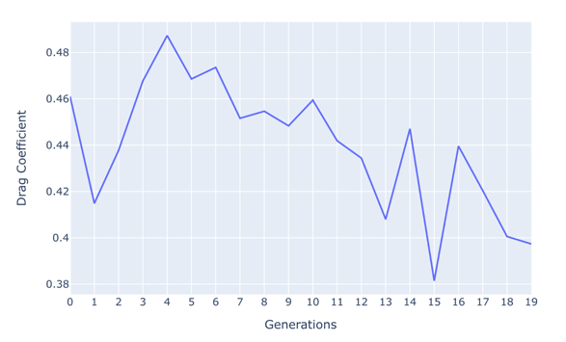
This figure provides insights into the evolution of car design across generations. The hood of the car adapts to a curved shape with considerable removal of material. Also, the angle of the windshield to the horizon reduces and there are slight changes in the curvature of the car’s rear section. Overall these are subtle, yet significant, changes driven by a generative AI process demonstrating the potential for guiding and making informed design choices through an automated physics-informed pipeline.

