Taking the Analyst Out of the Box: Removing the Boundaries to Achieve Success
Andrew Pettifer, CEng FIMechE
(Collins Aerospace, Wolverhampton, UK)

Introduction
One of the key reasons to invest in simulation capability is the desire to minimise risk. Often, this is to avoid issues where testing is the formal means of compliance. However, simulation is only part of the picture where a desire to pass first time is critical to meet project timescales. Failing to have a joined-up approach that considers the system and sub-system environments, simulation, and test environments and all their individual limitations and nuances can result in unexpected issues late in the engineering lifecycle.
This presentation will walk through the journey to bring together all the engineering elements including operating environments, requirement flow-down, simulation definition and test definition. Topics include; breaking down discipline silos, mutual consideration of physical and virtual limitations and encouraging deeper customer integration. This has led to a significant reduction in test issues and ‘pass first time’ success.
Key to this success is taking the analyst out of the box!
Summary
This summary reflects on the lessons learnt from the perspective of structural analysis but is equally applicable to other analytical disciplines and industries.
Structural simulation capability has advanced significantly in the past two decades. The power of simulation methods affords us more confidence and accuracy, more detail, more complexity, and more understanding than ever.
Fundamentally though, in many cases, the analysis is still used to support a physical test. Whilst testing accuracy, control and data capture has advanced, the physical test environment typically has not and in some cases cannot change significantly.
Structural test failures that were previously seen due to a lack of simulation capability are now replaced by failures due to disconnects between the analytical model and the test environment.
Whilst developing simulation capability is of course important to remain competitive, reduce risk and increase credibility, it is easy to lose sight of the final certification route. Silos of expertise that reside in the same building become so focussed on their specific area of interest that we forget to join the dots. This can result in a highly detailed simulation that fails to consider the physical limitations of the test or tests that do not adequately verify the product.
An approach is required to tackle a key issue in product certification that is driven by two factors:
- Simulation often happens early in the product development lifecycle.
- Testing often happens late in the product development lifecycle. (and the high risk, high cost, high consequence tests often happen even later).
One way we have tackled this with great success is to develop ‘method taxonomies’ which ensure all the engineering stakeholders are considered and involved. For example, a simulation method for vibration is not restricted to the Stress Analysis discipline, but also considers design for vibration, vibration test setup and vibration test guidance. The whole suite is tackled as a multi-disciplinary team, breaking down the silos that exist and ensuring robust handovers between functions. Many of the elements require involvement and inputs from the different engineering expertise as illustrated below.
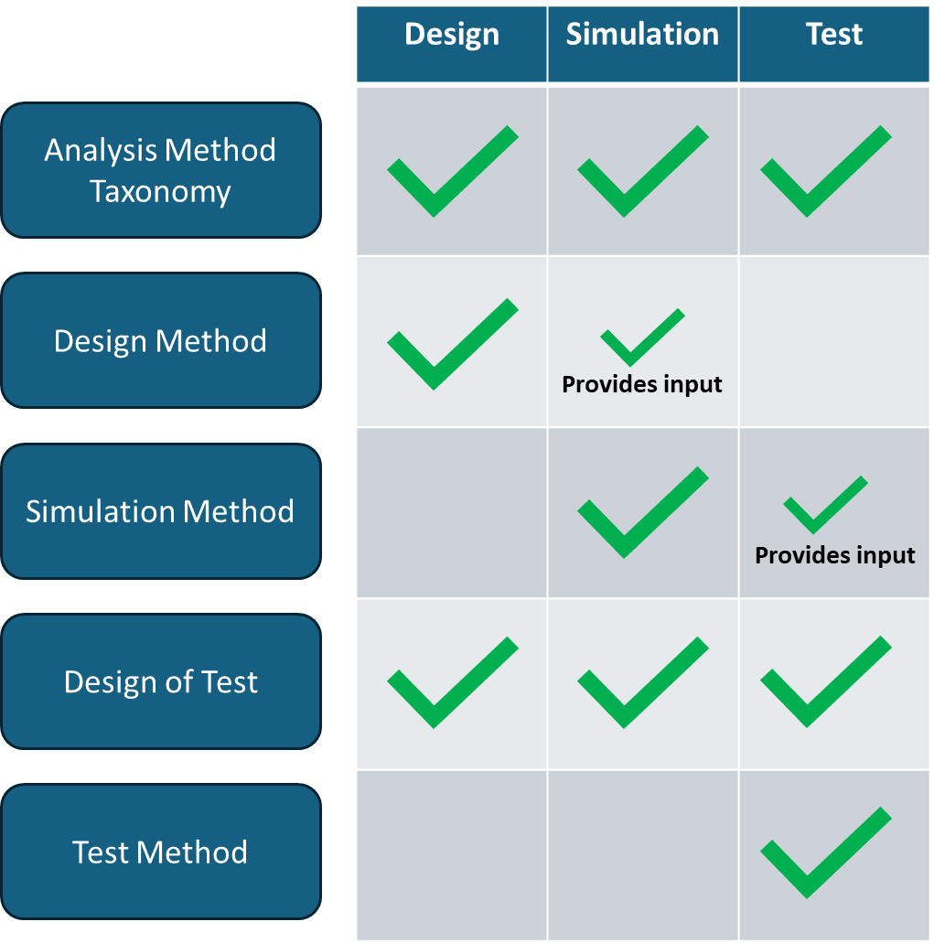
- Illustration showing the linkage between Design, Simulation and Test into a method taxonomy.
This ensures that the test experts are involved early on when the simulation experts are building their models. It encourages an early dialogue between the disciplines to develop alignment and agreement. It also ensures that the test is representative of ‘the reality of interest’ and is suitable for product verification.
Furthermore, we encourage the simulation experts to get involved in the testing. Whether that is by witnessing tests or carrying out the tests. The benefit of this cannot be understated. Being able to see, first hand what is happening, how the test compares with the model, how the part is behaving brings about an appreciation of the physical nuances of testing that can often be missed. Taking a simulation expert outside of their ‘natural environment’ can be a hard sell when resources are limited, but the effort is rewarded with the insight and understanding gained for future projects.
This insight into test capability can also aid early discussions with the customer on potential difficulties – such as customer interfaces and customer furnished equipment or the product requirements. Examples where these may impact the ability to test, or the test outcome can be picked up early and demonstrated by analysis. Furthermore, it instils a much greater level of confidence that when the hardware gets onto test, the risk of discovering a late issue is minimised.
In conclusion, ‘taking the analyst out of the box’ and breaking down discipline silos ensures an overlap of understanding between the virtual and physical environments. It also brings the physical test into the simulation realm early in the design and development process and this leads to a significant increase in test success beyond the development of pure simulation capability. Furthermore, it demonstrates that the product verification method is carried out with an appropriate test regime backed up by analytical evidence.

