Achieving Effective and Efficient Modelling and Simulation
Insights into the current position across industry sectors.
Mr Andy Richardson CEng MIMechE
(PHRONESIM Ltd, UK)
Abstract
Organisations have higher expectations and are more dependent on their Modelling and Simulation capabilities (M&S) than ever before. M&S teams are expected to deliver highly accurate and reliable results, in increasingly short timescales. Indeed, some strive to achieve the goal of physical test free development and verification. Many organisations are also exploring the potential opportunities from Machine Learning to complement their Engineering Simulation to help achieve their goals.
It is important that organisations do not lose sight of the fundamentals required to achieve a high performing, effective, and efficient, M&S capability. It is these fundamental elements that provide a critical foundation to support these goals.
As part of the ‘Implementing an Engineering Simulation Strategy’ eLearning course, participants from across sectors take part in a survey. So far, 155 people have taken part, representing; over 100 organisations, covering multiple sectors, from over 20 countries.
Asked to pick their ‘Top 3 Challenges for M&S’, respondents answered:
- 60% - Processes (are complex, in-efficient, slow, ….)
- 59% - People & Organisation (skills, collaboration, efficiency, ...)
- 46% - Methods (are missing methods, or lack confidence, ….)
This presentation discusses the consequences of these, as well as other, key findings and introduces some actions that organisations can take, to; i) assess the health, and ii) address the readiness, of their M&S organisations.

Why do we use Modelling and Simulation?
Any organisation using, or considering using, M&S needs to address two critical questions – what are our goals for M&S, and, what are our requirements?
Typically organisations will have two types of goals (Figure 1); i) Product goals (such as a performance target), and ii) Business goals (such as reducing development cost). Understanding which goals have to be achieved and what are the organisation priorities are key to any modelling and simulation activity.
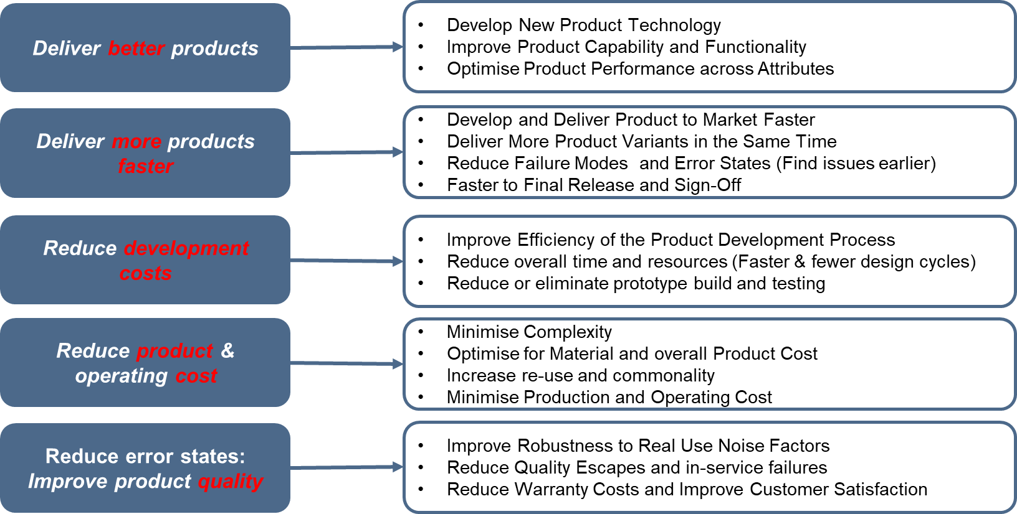
- Why do organisations use M&S? .

What is needed to help organisations achieve their goals?
To develop and deliver any product, organisations need to build an effective and efficient M&S capability, and must address 7 essential elements to achieve this (Figure 2).
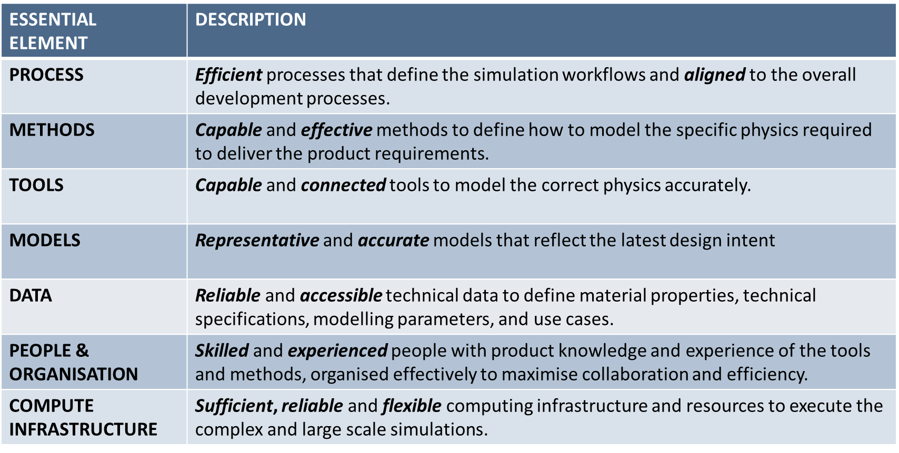
Figure 2: The Essential Elements for Effective Efficient M&S

Product and Business Goals for M&S
In the first session delegates are asked about their organisation’s product and business goals, responding that their top product goals are to; engineer (77%), optimise (69%), and verify (68%) their organisation’s products. Asked about business goals, the top responses were; speed to market (72%), development efficiency (70%), and reducing testing (68%).

Most Significant Challenges

Delegates are next asked to identify the top 3 challenges their organisations face in delivering effective and efficient M&S (Figure 3).

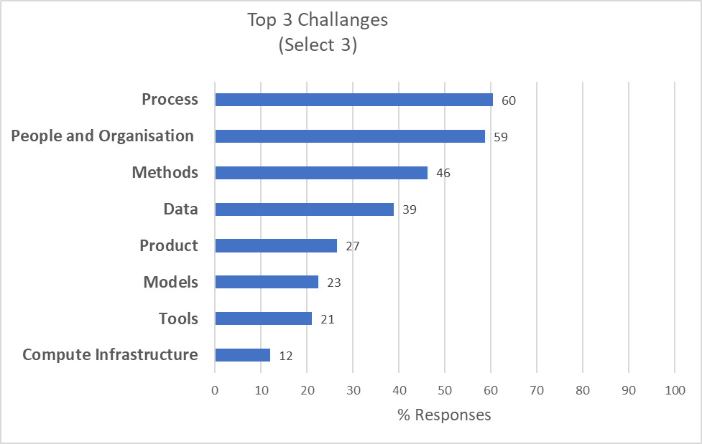
Interestingly, Process is identified as the most significant challenge by 60% of respondents, followed by People and Organisation at 59%, with Methods 3rd at 46%.
Figure3: Organisations vote for their top challenges in delivering M&S
To understand why Process is seen as the most significant challenge, delegates are asked to name their organisations top 3 process challenges.
- 60% identified that their processes take too long,
- 55% that they are too complex,
- 41% that they are un-documented.
The inevitable follow up questions for organisations are; – why are our processes taking too long, how are they too complex, how should they be documented?

Other Key Survey Headlines
Some other interesting survey findings covering the M&S essential elements:
- 56% of delegates responded that their M&S teams spend between ¼ and ½ of their time on ‘non-value add’ tasks.
- 77% of organisations use ‘experienced based (un-documented) methods, whilst 48% responded that they also use ‘documented methods’.
- 81% of organisations use a structured file system to manage their M&S data, and 57% use manual transfer (e.g. email) to share data.
- 69% of organisations use mostly manual methods to create models.
- When it comes to measuring confidence in their capability; 49% responded that they rely on ‘user expertise or peer review’ to assess confidence, whilst 31% use a confidence metric ‘sometimes‘.
- Only 4% of delegates responded that their organisations are using a public cloud for their M&S computing needs.
Organisations should consider their own status and ask; What is the significance of this data? What does it mean for us? Is it an issue, or opportunity for us?

Key Lessons – What’s your Strategy?
Due to the nature of the survey the results should be treated as indicative and informal. Nonetheless, they provide some interesting insights into the state of play for engineering simulation across a wide range of industries. The results certainly provide some pointers for organisations to consider.
Every organisation will be different and should assess their own status, gather data for key metrics, identify possible root causes, and consider potential improvement actions.
Indeed, given the importance of Engineering Simulation today, its critical for every organisation to review their goals, understand the current status (maturity) of their M&S, and build a strategy with an improvement roadmap to progress their capability towards achieving their goals.

