An Innovative Inquiry into Weld Durability Challenges in Heavy Commercial Vehicles A Paradigm Shift Towards Robust Design through Strategic Material Optimization
D. Elibol
(Ford Otosan, Türkiye)
Abstract
This study addresses a strength issue in the tandem structure of a heavy-duty commercial truck's rear axle, prompted by a crack in the Heat Affected Zone (HAZ) of a failed rear axle housing. The investigation involves theoretical considerations, vehicle architecture integration, and simulation environments with specific boundary conditions. Engineering calculations predict axle loads, validated by Computer-Aided Engineering (CAE) simulations, which identify a damage hotspot. Post-static analyses include weld fatigue calculations, highlighting the challenge of weld fatigue.
Instrumentation with strain gauges, accelerometers, and displacement sensors reveals non-proportional loading. Dynamic analysis methods are employed, and strain data from the vehicle's durability parkour are compared with CAE-simulated strains, showing a 70% correlation. Accelerated loading scenarios and duty cycles based on strain data are developed. Fatigue analyses yield lifetimes correlating with real-world damage, validating the methodology. Confidence in the approach is high, leading to an engineering optimization strategy involving material reduction for a lighter, more durable structure.

Introduction
During vehicle testing, a crack in the heat-affected zone of a weld connecting two sheet metals in a rear axle was observed. A theoretical framework identified longitudinal and vertical forces as principal causes, confirmed by initial manual force calculations. To determine precise loading, strain gauge instrumentation on suspension arms was employed, and an innovative approach using accelerometers and displacement meters was devised to address vertical loading challenges. Advanced data processing allowed real-time determination of axle travel in three directions and estimation of vertical loads by using stiffness of the suspension leafs.
Figure 1: Microsection of the welded zone
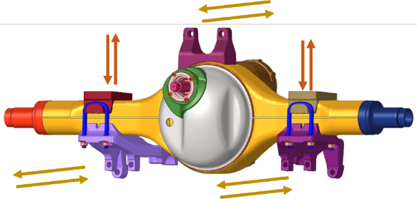
Strain gauges on the rear axle housing facilitated correlation and validation, showing high concordance between computational simulations and physical tests. Computational constraints limited full vehicle testing, leading to non-linear quasi-static FE analyses focused on short road data intervals for verification and validation. Fatigue analyses utilized linear superposition and duty cycle adjustments for faster computation.
Figure 2
The new methodology effectively identified the weld fatigue and critical regions within the CAE model, leading to confidence in the approach. Remedial measures, including strategic material removal from the housing, were undertaken to enhance durability while reducing weight, showcasing an unconventional yet effective intervention strategy.

Data Acquisition & Processing
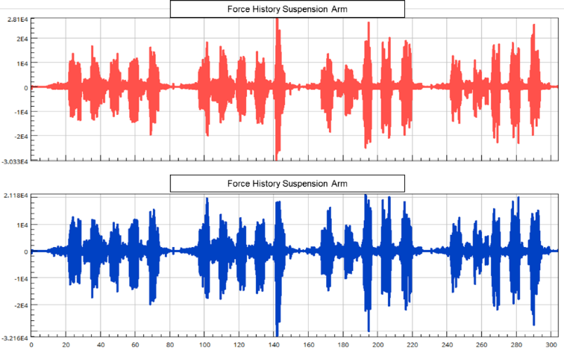
In the study concerning steel suspension arms, strain gauges were employed to capture force dynamics. Subsequently, these strain-gauge instrumented bars underwent calibration via tension-compression tests to ensure accuracy and reliability. However, capturing the vertical load history posed a challenge due to the intricacies of the suspension system, primarily utilizing leaf springs. To overcome this hurdle, accelerometers and displacement meters were strategically positioned on both sides of the chassis and axle.
Figure 3: Transient Force Data
Accelerometer measurements were meticulously processed to ascertain displacements along each axis. To validate and refine these findings, the resultant displacements were compared against displacement meter measurements, thereby facilitating iterative verification and modification. This dual-validation approach was deemed necessary given the inherent complexities and sensitivities associated with deriving displacements solely from accelerometer data. Since displacement meters solely provide resultant travel data, their integration alone cannot provide comprehensive information regarding travel across all three axes, necessitating the concurrent use of accelerometers.
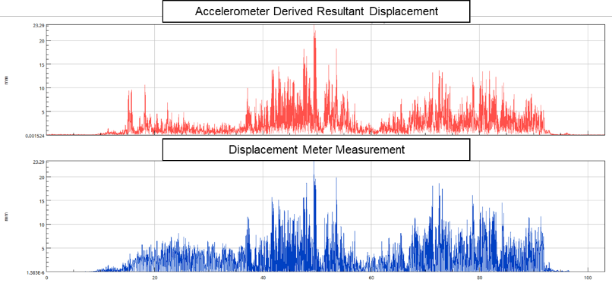
Visual representations demonstrate a good correlation between resultant displacement data derived from accelerometers and actual measurements obtained from displacement meters. By leveraging the known stiffness of the leaf spring system and the measured axle travel, the study successfully elucidated the vertical force history in conjunction with the force dynamics observed in the steel suspension arms via strain measurements. Consequently, the analysis revealed a nuanced transient load history characterized by non-proportional loading patterns.
Figure 4

Transient Quasistatic Non–Linear FE Model & Linear Superposition Approach
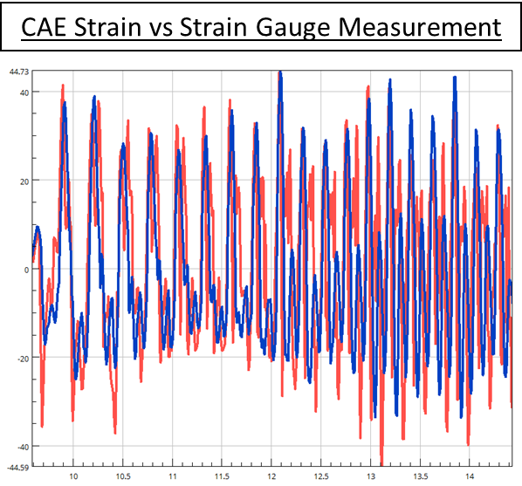
Upon obtaining the load histories, the subsequent step entailed conducting dynamic analyses and comparing the CAE resultant strains on the rear axle against strains measured from the proving ground using strain gauges. Initially, a quasi-static nonlinear transient dynamic Finite Element (FE) analysis approach was pursued, wherein assembly steps were meticulously replicated before simulating real-life conditions within the FE environment. Remarkably, the resulting yielding strains exhibited substantial agreement with real life measurements.
However, the length of measurements from various proving ground trials rendered the exhaustive simulation of all road scenarios using a transient nonlinear FE approach unfeasible within reasonable timeframes. Consequently, an alternative methodology was devised. Initially, leveraging cumulative strains derived from strain gauge measurements, all proving ground datasets were condensed into one relatively short road, and the duty cycle was subsequently adjusted accordingly.
Figure 5: Correlation between CAE & Measurement
Subsequently, a comparative analysis between linear and original analyses revealed negligible differences, primarily attributable to the high-cycle regime of the loads, thereby rendering elastic material models suitable. The finalized load scenario was subsequently executed utilizing a linear superposition technique, markedly benefiniting from computational cost. The resultant stress history from this approach was then used for fatigue calculations.
- Weld Fatigue Durability
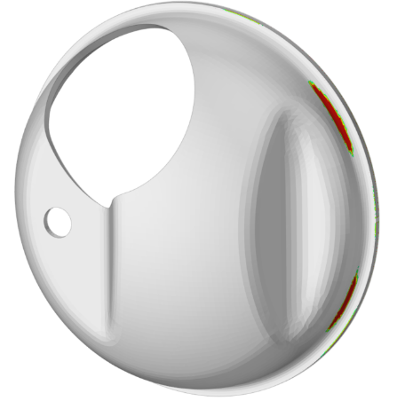
Employing an equivalent force history and duty cycle, fatigue calculations were conducted utilizing specialized fatigue software tailored for weld-specific analysis. A transient fatigue approach was adopted, integrating Miner Modified SN curve behavior to model fatigue behavior accurately. Notably, various influence factors including size, surface finish, stress gradient, and mean stress were considered in the analysis. Of particular significance was the incorporation of weld influence, which was computed based on weld seam geometry and contact points (toe and root) within the weld seam.
Figure 6
Empirical formulations were employed to quantify damage at these critical locations, yielding results that demonstrated good agreement with real-life instances of damage occurrence. This comprehensive approach underscores the efficacy of integrating nuanced considerations of weld characteristics and their inherent influence on fatigue behavior, thereby enhancing the fidelity of fatigue predictions in welded structures.

- Innovative Design With Material Optimization
Following the identification of failure under base conditions in the CAE process, numerous design interventions were explored to enhance the system's resilience against proving ground forces. One particularly noteworthy strategy that yielded promising outcomes involved the targeted reduction of material from strategic sections of the rear axle housing.
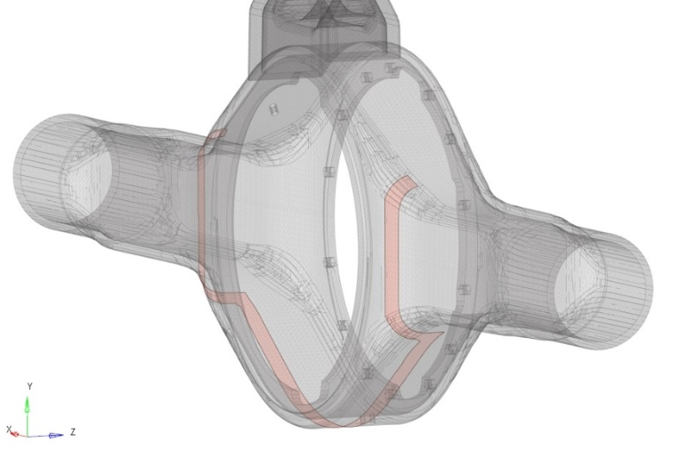
This innovative design concept focused on reducing the thickness of areas distant from the identified hotspots, as well as the stiff frontal region of the rear axle. By redistributing stress away from the critical hotspot, which typically experiences significant pure bending, towards more durable portion of the housing, the bending mode effectiveness of the hotspot was mitigated. This approach promoted a more durable structural response.
Figure 7
Visual representations illustrate this concept, showcasing the designated areas marked in red for material reduction. Through this intervention, it was observed that the welded backcover region exhibited enhanced durability.

