Advancing Shock Durability Assessment: Accelerated Testing Strategies for Enhanced Performance and Resilience
D. Elibol, B. Yılmaz
(Ford Otosan, Türkiye)
Abstract
In this study, accelerated testing of components in the vehicle structure predominantly affected by impact/shock-induced Road Load Data (RLD) is investigated. Certain road profiles, such as potholes and speed bumps, are primarily composed of shocks. Despite their brief durations within the load scenario, these impacts can constitute up to 99% of the damage resulting from loading. This paper explains a new method to correlate real high-intensity impact loading damage with computational analysis, shock detection, and shock equivalence.
Testing such RLDs using existing methods in the literature is not feasible. Methods employing fatigue damage spectrum, shock response spectrum analyses, and PSD/FFT analyses cannot accurately detect sudden and short-duration shocks. The only way to test them accurately is to run transient loading data precisely on transient test rigs. However, this process is lengthy, costly, and complex. For instance, pothole road load data can be reduced in time to 1% of its duration with equal damage characteristics by only extracting impacts. Additionally, computational analysis of such RLDs is another important issue for reducing time, cost, and complexity. Existing analysis methods, like Rainflow Analysis, in the literature also struggle to capture the frequencies and amplitudes of impacts adequately. Particularly, frequencies lead to seemingly meaningless values due to noise in the signal. This study proposes a new method for shock extraction that is observed to effectively capture frequencies and amplitudes. Furthermore, prevalent methods in the literature for equivalencing obtained shocks to a new frequency, such as energy and FDS methods, are widely used but often ignore modal dynamic behaviour and exhibit a quasistatic approach. In this study, a method is proposed to equivalize impacts to a new frequency, considering the structure's damping and natural frequencies. This allows representing damage at different frequencies of impacts when test rig capabilities are insufficient.

Introduction
Vehicle components are exposed to a variety of conditions that affect their dynamic and durability behaviour throughout their operational lifespan. In automotive industry, mechanical shock loadings are mainly caused by curbs, potholes, speed bumps, and other road irregularities. The minimum accepted period length for shock loads in automotive proving grounds may vary depending on the specific regulations or standards being followed. However, in general, it is recommended that the period length of shock loads should be at least 10 milliseconds to accurately capture the dynamic behaviour of the vehicle and its components under testing. Furthermore, shock loads in automative, typically have durations of less than 100 milliseconds. Accurately detecting these mechanical shocks becomes a critical issue for engineering.
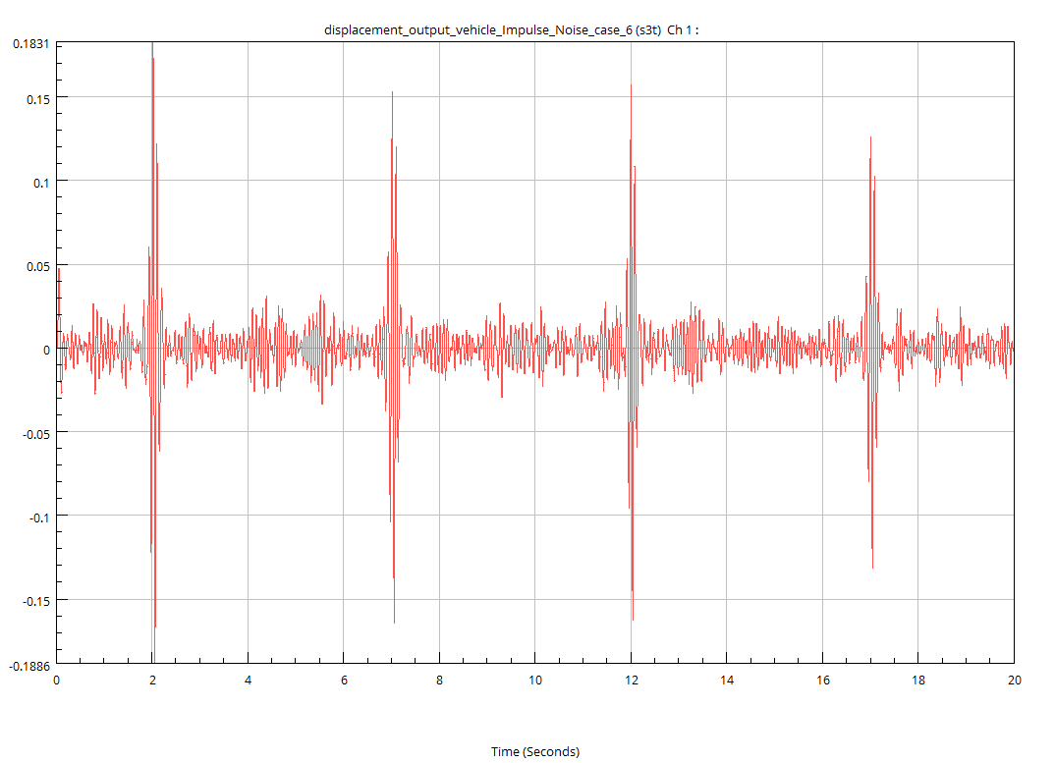
Effectively applied R&D processes can reduce costs, time, and workload. Additionally, more reliable predictions about component behaviour can lead to better maintenance practices and improved customer relations. This paper is a good example of brilliant engineering practices which is unique accelerated testing method of mechanical shocks on vehicle components. While this study is not the first approach in the literature based on accelerated testing, it stands out for its effectiveness in transient domains. In Shafiullah [1] and Coutinho [2] studies, ‘test tailoring approach’ were investigated with different perspectives for accelerated durability testing. Conversely, Abdullah, Nizwan, and Nuwai’s suggested to utilize the Short-Time Fourier Transform (STFT) parameter to shorten signals [3]. Additionally, Frequency Response Function (FRF) is another method for fatigue life estimation mentioned in Jung and Bae’s work [4]. On the other hand, Wolfsteiner and Trapp [5] explained a way to calculate non-Gaussian excitation effect on structures. However, the strengths of the method that outweigh previous approaches, proposed in this article will be explained through different applications and simulation results.
The tests and simulations of road load conditions, that are driven by impacts, should ideally be conducted as transient applications for greater accuracy. However, transient tests and analyses are expensive, complex, and extremely time-consuming events. Therefore, this study focuses on minimizing these drawbacks of transient analysis while maintaining result quality. To illustrate, Figure 1 presents an example of the concerned loading data. It demonstrates that remaining loads are relatively small compared to shock loading. Moreover, testing the total dynamic response with a 1-second-high impact loading scenario, rather than simulating the full road condition which consumes 100 seconds, can be more efficient. So that, as Xiong and Shenai [6] study, this article aims to reduce the spent time for fatigue applications.
Figure 1: Example of RLD
The new methodology focuses on generating half sine shock profiles which create similar effects with real situations for vehicle components. Through the article, the procedures, challenges, and improvements will be mentioned. Mainly, the difficulties of the study are:
- Shock loading detections and extractions,
- Transform the impacts into half-sine configurations,
- Required equivalence of shocks to test conditions,
- Validations of the methods.
These four criteria will be detailed, and solutions will be explained in the next sections.

Data Processing
In this study, the most challenging task is to detect the impacts from an acceleration measurement autonomously. As mentioned, due to the nature of mechanical impacts, these impact characteristics are going to be lost if frequency domain approaches will be used. This is because they are sudden, non-repeating & very fast.
Therefore, this article suggests a time-domain transient investigation to detecting shocks. However, since these shocks are not purely visible and ideal in a real-life measurement, an advance process is suggested. Otherwise, robustly detection of impact’s amplitudes and periods will not be possible or accurate.
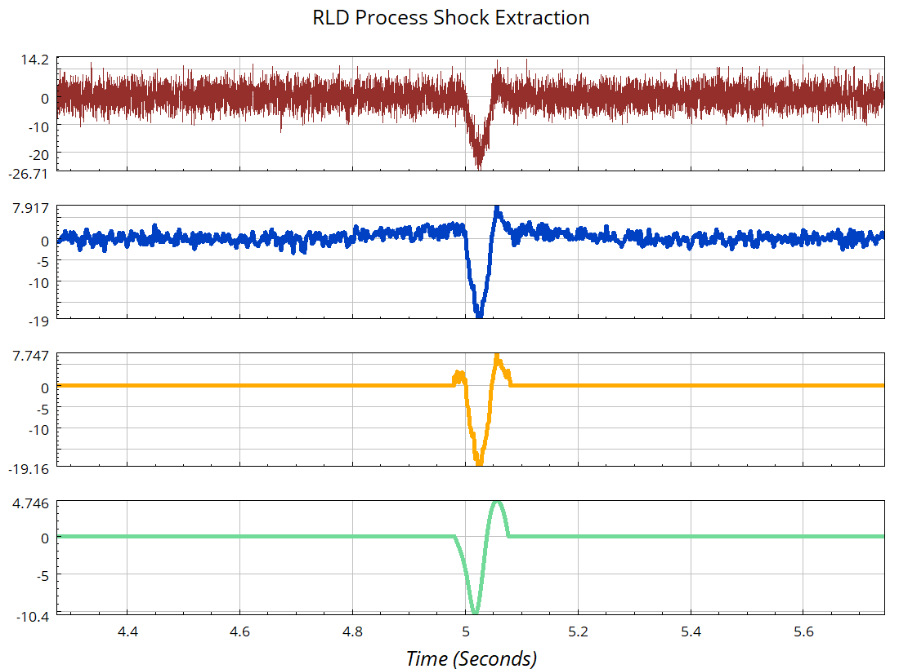
The new data process approach involves steps such as filtering & sample rate adjustment, statistical impact deduction, reversal extraction, multiple steps of peak correction, racetrack simplification, peak conservative interpolation and for the last step, once the data becomes ideal, rainflow analysis for amplitude and period calculation.
An example of the process is shown on RHS. The acceleration measurement starts from the top, a raw RLD and the last version (green) is ready for rainflow analysis.
Figure 2: RLD Process Example
The main strength of this process is the fact that it is extremely autonomous. This process is tested with both artificial & real rld measurements. For any instance, it was seen to work perfectly without a need of interfiring. It would take a long time to examine all RLD measurements manually without the proposed method, individually.
The fact that the shocks are transformed into half-sine mechanical impact profiles as soon as they are identified is another significant feature. In most cases, the impact duration plus the settling time should be less than a second. In addition to being extremely complicated and expensive to conduct on a test rig, these RLD measurements require at least 30 seconds, so it would take 30 times longer.
The main reason behind the accelerated shock testing methos is to save money and time. Therefore, duration of the test should be minimized to increase feasibility. Reducing the amount of time and effects of consecutive shocks on each other, the required minimum delay time should be determined appropriately. So, the settling time equation when the decaying exponential reaches 1% is:
$t_{s}=\frac{4.6}{ζw_{n}}$[7]
Where $ζ$ is damping ratio and $w_{n}$ is natural frequency.

Profile Generation & Equivalencing to New Frequencies
The figure illustrates the half sine profiles generated from impact-driven RLDs. Running transient fatigue analysis show that the generated profiles are creating damage values that are correlated with original RLD damage.
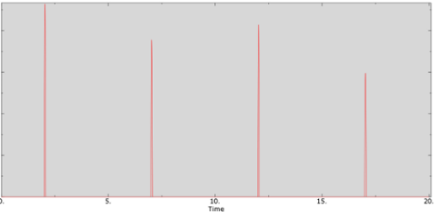
Figure 3:Mechanical Shock Profiles
This study unveils an intriguing aspect, posing two fundamental questions: 1) Can a histogram comprising varying amplitudes and frequencies be equivalenced to a single half sine shock profile with a designated duty cycle? 2) What implications arise if the test rig lacks the capability to replicate the determined amplitudes at their corresponding periods?
Both inquiries converge on the concept of equivalencing the half sine profiles to a new frequency. Examination reveals the important role of the system's modal behavior, particularly within the bandwidth of potential shocks, typically ranging between 10 and 100 Hz. Should the system possess natural modes within this frequency range, quasistatic approaches prove inadequate, necessitating consideration of dynamical behavior.
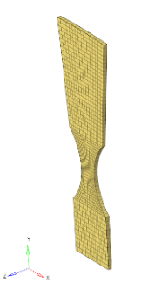
For systems characterized by pronounced modal participation from multiple modes, a straightforward approach is untenable due to differential effects across various areas influenced by distinct modes. In this context, the article proposes a method tailored for systems exhibiting a dominant mode, where residual modal contributions are negligible. A more conservative strategy involves equivalencing within the region preceding the first mode resonance. For instance, if a system manifests a dominant global mode at 50 Hz, calculations for profiles below 50 Hz are equivalenced to a new frequency below 50 Hz.
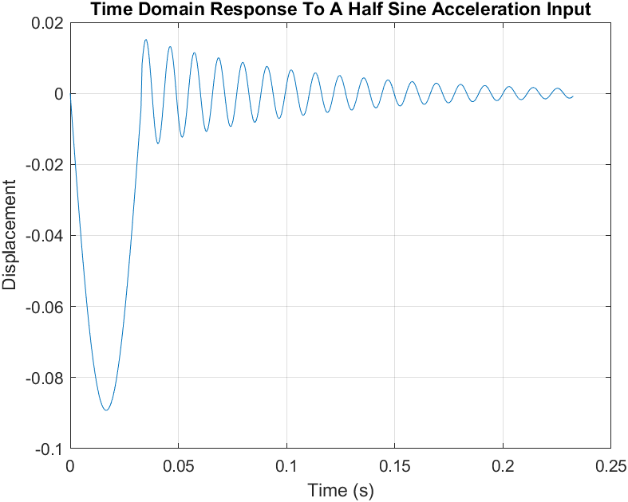
Exemplary studies demonstrate that for systems governed by a predominant global mode, a simplified single degree of freedom mass-spring-damper model suffices in depicting relative displacement across different frequencies. Frequency Response Function (FRF) examples derived from this simplification align notably well with the actual FE model's FRF response, facilitating a discernment of frequency effects and equivalence procedures accordingly. The method's development is elucidated through the utilization of a representative specimen, shown on the figure 4.
Figure 4:Specimen
In implementing this approach, the equation of motion is solved, with fatigue analysis guiding the determination of maximum ranges. Equivalence is deemed complete when these ranges are equal. This transient sol’n example is shown in the figure 5.
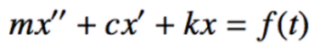
Figure 5: Transient Response Calculation

4) Verification & Validation
In this section, the methodologies employed to verify and validate the computational models and experimental procedures utilized in this study are represented. Verification refers to the process of ensuring that the numerical models accurately illustrate the real conditions which vehicles are exposed, while validation involves comparing model predictions with experimental data to assess their accuracy and reliability. Thus, in this study, there are 3 main verification topics and a validation approach. These are:
- Vehicle Simulation: The aim of scripting vehicle simulation is to demonstrate real world situations such as curbs, potholes, and speedbumps on the computational analysis. Therefore, the working principle of the simulation is to translate the transient road profile on the tires into the response loading on structural component part. Then, this response is used as input acceleration values for a representative vehicle component.
- Damage Density of Impacts with respect to Whole Loading: The study dives into the comparison between impact and full loading effect on durability. As a result, high amount of damage (approximately 80-95%) which are caused by these impact loadings, is proved.
- Extraction and Equivalence of Shocks from Road Load Data: To minimize costs and time, the study finds a way to separate impacts and remaining load on the transient data. Then, according to the capabilities of the test rigs, the shock profiles are generated.
- Validation: With these mentioned processes, the damage characteristics of real and computational works are compared. Consequently, the fatigue results show that the total road condition, extracted shock and equivalence shock affects the component similarly. Thus, this similarity confirms that methods which are mentioned in article are applicable and reliable.

Comparison To Other Methods
With completing the validation processes, different situations for comparison to other methods are simulated. The results show that frequency domain applications are not as efficient as the proposed method, with respect to transient road load conditions, that are driven by impacts. Detailed explanations are made with variety of proofs, through the article. So, the importance and strengths of this method are reinforced with these comparison results.

References:
[1] A. K. M. Shafiullah and C. Q. Wu, “Generation and validation of loading profiles for highly accelerated durability tests of ground vehicle components,” Engineering Failure Analysis, vol. 33, pp. 1–16, Oct. 2013. doi:10.1016/j.engfailanal.2013.04.008
[2] I. A. Coutinho and J. Landre, “Enhanced tailored durability test specification for multiaxial dynamically excited structures attached to a single input base under off-road loading environment,” Engineering Structures, vol. 219, p. 110768, Sep. 2020. doi:10.1016/j.engstruct.2020.110768
[3] Abdullah, S., Nizwan, C. K. & Nuawi, M. Z. (2009). A Study of Fatigue Data Editing using the Short-Time Fourier Transform (STFT). American Journal of Applied Sciences, 6(4), 565-575. https://doi.org/10.3844/ajassp.2009.565.575
[4] D. H. Jung and S. I. Bae, “Automotive component fatigue life estimation by frequency domain approach,” Key Engineering Materials, vol. 297–300, pp. 1776–1783, Nov. 2005. doi:10.4028/www.scientific.net/kem.297-300.1776
[5] P. Wolfsteiner and A. Trapp, “Fatigue life due to non-Gaussian Excitation – an analysis of the fatigue damage spectrum using higher order Spectra,” International Journal of Fatigue, vol. 127, pp. 203–216, Oct. 2019. doi:10.1016/j.ijfatigue.2019.06.005
[6] J. J. Xiong and R. A. Shenoi, “A load history generation approach for full-scale accelerated fatigue tests,” Engineering Fracture Mechanics, vol. 75, no. 10, pp. 3226–3243, Jul. 2008. doi:10.1016/j.engfracmech.2007.12.004
[7] G. F. Franklin, J. D. Powell, and A. Emami-Naeini, Feedback Control of Dynamic Systems. Reading, Mass, Wokingham: Addison-Wesley, 2002.

