Enhanced implicit-iterative coupling algorithms for strong-coupled multiphysics
Dr. E. Veron, Dr. A. Kürkchübasche, Mr. S. Subbarayalu
(Dassault Systemes UK Ltd, United Kingdom)
Abstract
In a co-simulation [FEL01], the engineering problem is decomposed into two or more subdomains, with each subdomain solved individually while continually exchanging data on their boundaries. A common use case is fluid-structure interaction, in which computational structural and fluid mechanics solvers are used and interact over common interface regions. This partitioned treatment has many merits but also poses stability and accuracy challenges when the physics coupling is strong; for example, when the fluid and structure have similar densities [CAU04], such as in the case of blood flow in an artery or a compliant structure subjected to forces imposed by a heavy and incompressible fluid.
In recent years, numerical techniques, called accelerator methods, have been developed [DEG10, UEK16]. These accelerators enhance the coupling by enlarging the convergence radius from a stability point of view; in other words, the accelerators allow us to solve strongly-coupled physics problems that we could not solve prior. Furthermore, the accelerators can significantly reduce the computational cost of these simulations.
We present convergence studies of several fluid-structure benchmarks [TUR06, FER05] and an industrial example, and provide a guide on using these numerical methods.

Numerical Methods for Implicit-Iterative Coupling
The SIMULIA Co-Simulation Services is an open architecture for coupling two or more solvers for multiphysics and multiscale simulations. Currently the Co-Simulation Services is embedded in over twenty solvers, including Dassault Systèmes solvers, partner solvers and customer in-house solvers to perform co-simulation.
We have introduced extrapolators, accelerators and filtering techniques to provide more robust coupling at reduced computational cost. All enhancements are available as services provided by the Co-Simulation Services, and are available for third-party solvers to use when coupling to Abaqus/Standard.

Extrapolation
Extrapolation methods are not new and have been used for many years. Extrapolation uses the previous coupling step solution(s) to provide an initial guess for the current coupling step. Zero-order, first-order and second-order extrapolation are available; we recommend second-order extrapolation by default. Extrapolation is used in conjunction with any of the accelerators described below. It may also be used without an accelerator for weak-coupled physics problems.

Accelerators
Accelerators enhance the coupling by enlarging the convergence radius from a stability point of view. Two classes of accelerators methods are available: (i) relaxation methods and (ii) Quasi-Newton methods.
Relaxation is a numerical technique that is employed commonly to improve the stability of a computation. Using a relaxation factor less than one improves the stability at the expense of slower convergence (more coupling iterations). A relaxation factor greater than one typically enhances the convergence rate, but lowers the stability. Constant relaxation and Aitkens relaxation methods are supported. As the name implies, Constant Relaxation uses a constant user specified relaxation factor. Constant relaxation is used for the initial exchange with the Aitken and Quasi-Newton methods. For completeness, it is also available for use for all coupling exchanges, however, preferably, you should use the Aitken or Quasi-Newton methods instead. In the Aitken relaxation method, the relaxation factor is adapted based on the residual from past coupling iterations. Aitken relaxation works well for moderate-strength physics coupling and is computationally less expensive than the Quasi-Newton methods.
Quasi-Newton methods approximate an inverse Jacobian at the interface based on residual information from past coupling iterations and coupling steps. Anderson and Broyden methods are supported. Broyden method can deliver a close to exact inverse Jacobian if sufficient past residual information is provided. Our Broyden implementation involves an advanced SVD algorithm in order to limit memory requirements and avoid computations of full SVD. For most strongly-coupled problems, we recommend the use of the Anderson method, requiring marginally more coupling iterations but being less computationally intensive.
To ensure that the inverse Jacobian is well conditioned and to reduce the memory requirements, we use a filtering technique to orthogonalize and remove linear dependent equations when the inverse Jacobian is constructed. Three filtering techniques based on the Gram-Schmidt method are available, referred to as QR1, QR2 and QA2. We recommend the QR2 method, which is more efficient than QR1. The difference between QRA and QR2 is that for the QRA method the filtering criterion is adapted during the QU factorization in order to loosen the filtering as much as possible.

Benchmarks and Industrial Examples
We compare the convergence behavior for strongly coupled Fluid-Structure Interaction for benchmark and industrial examples using the implemented numerical methods. The fluid solver used is 3DSFlow, a Navier-Stokes CFD solver availble on the 3DEXPERIENCE Platform, and the implicit dynamic structural solver, Abaqus/Standard.

Turek & Hron FSI-3 Benchmark
Turek and Hron [TUR06] defined a set of numerical benchmarks of fluid-structure interaction between an elastic body and laminar incompressible flow shown in Figure 1. The FSI-3 benchmark is particularly difficult because the modeling parameters are chosen to make this a strongly-coupled physics problem.
Tables 1 and 2 compare the average number of coupling iterations per coupling step for the various methods: Gauss-Seidel Iterative coupling using 0th-order and 2nd-order extrapolation, constant relaxation, Aitken’s relaxation, and Anderson and Broyden Quasi-Newton methods. Table 1 summarizes results when we accelerate the displacement field and Table 2 when we accelerate the force field. We are not able to solve the FSI-3 challenge when using iterative coupling without any accelerators, as represented by the KO’s in the tables. Aitken relaxation allows us to solve the problem and is the least numerical costly accelerator method when it comes to interface calculations. However, with slight increase in numerical cost at the interface, the Quasi-Newton methods can reduce the average number of coupling iterations which reduces the number of solver passes required for the individual systems (typically far more expensive then the interface computations). We do not see a significant difference between the Anderson and Broyden Quasi-Newton schemes; in fact, Anderson gives slightly fewer coupling iterations for this benchmark. We observe that accelerating the force field yields fewer coupling iterations than accelerating the displacement field.
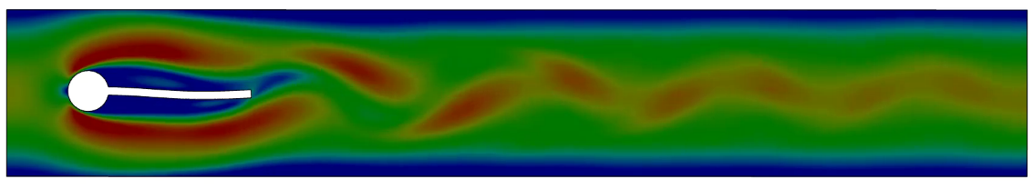
- Turek & Hron Benchmark

 | Gauss-Seidel Extrapolation (Order 0) | Gauss-Seidel Extrapolation (Order 2) | Constant Relaxation | Aitken Relaxation | QN Anderson (REUSE) | QN Broyden
Iteration per Increment | KO | KO | KO | 15.4 | 10.7 | 11.6
Ratio | KO | KO | KO | 1.0 | 0.69 | 0.75
- Turek & Hron FSI-3 Benchmark (Accelerated Field: Displacement)
 | Gauss-Seidel Extrapolation (Order 0) | Gauss-Seidel Extrapolation (Order 2) | Constant Relaxation | Aitken Relaxation | QN Anderson (REUSE) | QN Broyden
Iteration per Increment | KO | KO | KO | 12.6 | 9.4 | 11.1
Ratio | KO | KO | KO | 1.0 | 0.75 | 0.88
- Turek & Hron FSI-3 Benchmark (Accelerated Field: Force)

Artery Pulse Benchmark (Bio-medical industry)
The artery pulse benchmark is a more realistic benchmark as it applies to the Bio-medical industry. It is discussed in reference [FER05], and is a very challenging FSI problem due to the large added mass effects, incompressible flow in an enclosed volume, very thin structure, and having a fluid-to-structure density ratio close to unity.
Figure 3 shows a pressure wave propagating in a thin-walled elastic vessel (density 1200 kg/m3, Young’s modulus = 300 kPa, and Poisson ratio = 0.3) conveying an incompressible fluid (viscosity=0.003 Pa.s, and density 1000 kg/m3) representing the hemodynamics in a large blood vessel. Four time snapshots are shown at t=0.0025 s, t=0.005 s, t= 0.0075 s and t=0.01 s. Similar to the previous example, Table 3 and Table 4 compare the average number of coupling iterations per coupling step for the various methods when we accelerate the displacement field and when we accelerate the force field, respectively. The problem is extremely challenging; we are not able to solve it using iterative coupling without accelerators. It is also difficult to obtain a solution when using Aitken’s method. The only reason we obtained a solution with the Aitkens when accelerating the force field was that we adjusted various parameters in the code to obtain a solution during our research. We are able to obtain solutions using the Quasi-Newton methods with an average of 20 - 24 iterations. Similar to the previous benchmark, we do not see any significant difference between the Anderson and Broyden schemes; in fact, Anderson gives us slightly fewer coupling iterations for this benchmark and is computationally more efficient. We also observe that when accelerating the force field rather than the displacement field, we get improved convergence.
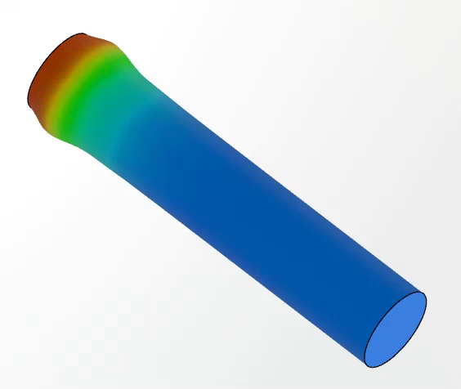  $$(c) t=0.0025s$$ | 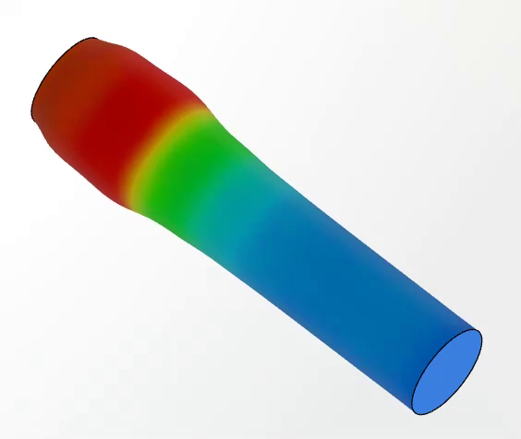  $$(c) t=0.0050s$$
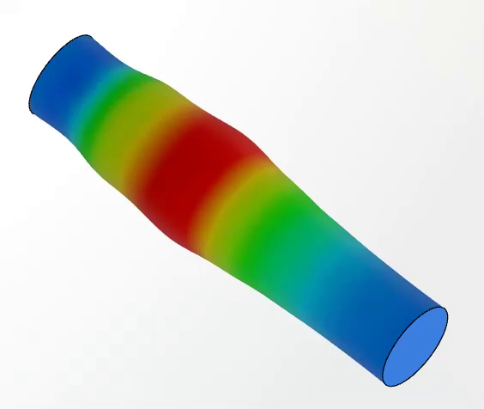  $$(c) t=0.0075s$$ | 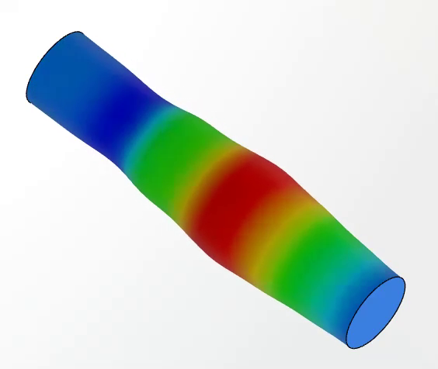  $$(c) t=0.0100s$$
- Artery Benchmark Model

 | Gauss-Seidel Extrapolation (Order 0) | Gauss-Seidel Extrapolation (Order 2) | Constant Relaxation | Aitken Relaxation | QN Anderson (REUSE) | QN Broyden
Iteration per Increment | KO | KO | KO | KO | 23.9 | 23.8
Ratio | KO | KO | KO | KO | 1.0 | 1.0
- Artery Benchmark (Accelerated Field: Displacement)

 | Gauss-Seidel Extrapolation (Order 0) | Gauss-Seidel Extrapolation (Order 2) | Constant Relaxation | Aitken Relaxation | QN Anderson (REUSE) | QN Broyden
Iteration per Increment | KO | KO | KO | 22.6 | 20.6 | 24.0
Ratio | KO | KO | KO | 1.1 | 1.0 | 1.17
- Table 4 : Artery Benchmark (Accelerated Field: Force)

Bottle Squeeze (Consumer Package Goods Industry)
Bottle squeeze tests are very relevant to the Consumer Packaged Goods (CPG) industry (shampoo/shower gel bottles, moisturizing lotion, toothpaste tubes …). Product designer may want to analyze the effect of bottle flexibility, nozzle design and fluid viscosity (fluid formulation), on the stress level in the material and the flow rate. The fluid-structure interaction simulation also provides an assessment of the required squeezing force to eject the product from the packaging, thus providing insight of the customer sensation.
Simulating such cases arises several numerical challenges: modeling two-phase flows (incompressible liquid and compressible air), dealing with high density ratio (strong coupling) and solving fluid-structure interaction with a high viscous flow. The combination of the incompressible air cavity and the density ratio of one generated large added mass effects and led to numerical instabilities and convergence issues. With the recent implementation of compressible VOF and the implementation of strong coupling algorithms, we are able to simulate this kind of application.
Table 5 compares the average number of coupling iteration per coupling step for the reference method and Anderson Quasi-Newton method when relaxing the displacement field and the force field. The Quasi-Newton method reduces significantly the average number of iterations.
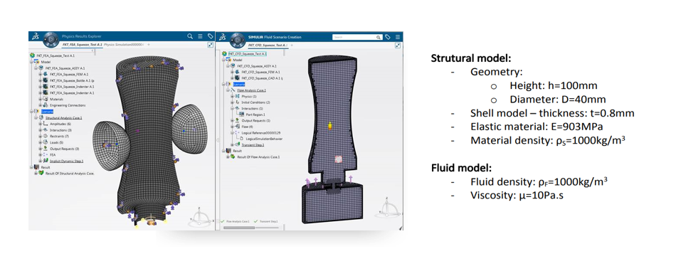
- Bottle Squeeze Model
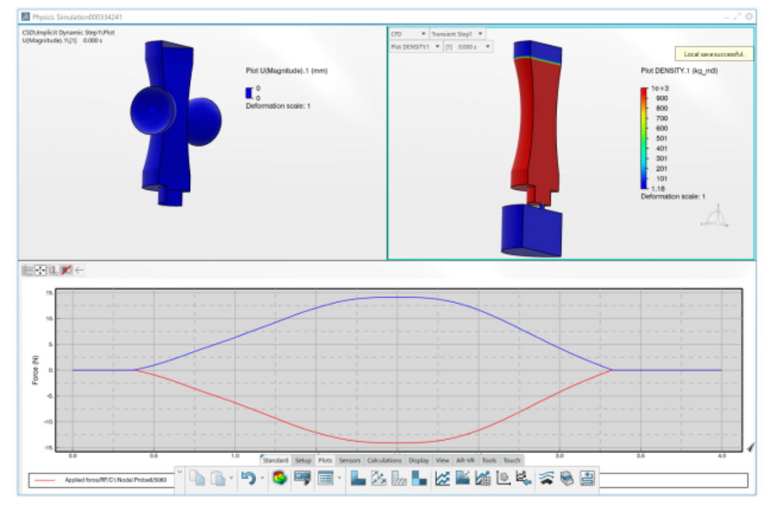
- Bootle Squeezing Analysis on 3DEXPERIENCE Platform

 | Aitken Relaxation | QN Anderson (REUSE) | QN Broyden
Iteration per Increment | 21.8 | 15.1 | 13.9
Ratio | 1.0 | 0.70 | 0.64
- Table 5 Botle Squeezing

Conclusion
The Quasi-Newton methods allow us to solve strongly-coupled industrial multiphysics problems, that we were not able to solve before. Furthemore, they can significantly decrease the number of coupling iterations at the marginal cost of interface computations. These have been implemented as part of the SIMULIA Co-Simulation Services and are available to partners to employ with their solvers when coupling to Abaqus/Standard.

References
[CAU04] CAUSIN P., GERBEAU J.-F., NOBILE F., Added-mass effect in the design of partitioned algorithms for fluid–structure problems. Computer Methods in Applied Mechanics and Engineering, 2005; 194(42–44):4506–4527.
[DEG10] DEGROOTE J., HAELTERMAN R., ANNEREL S., BRUGGEMAN P., VIERENDEELS J., Performance of partitioned procedures in fluid–structure interaction. Computers & Structures, 2010; 88(7–8):446–457.
[FEL01] FELIPPA C. A., PARK K.C., FARHAT C., Partitioned analysis of coupled mechanical systems. Computer Methods in Applied Mechanics and Engineering, 2001; 190(24–25):3247–3270.
[FER05] FERNANDEZ M. A., MOUBACHIR M., A Newton method using exact Jacobians for solving fluid-structure coupling. Computers & Structures, 2005; 83(2):127–142.
[TUR06] TUREK S., HRON J., Proposal for numerical benchmarking of fluid-structure interaction between an elastic object and laminar incompressible flow. In BUNGARTZ H.-J., MEHL M., and SCHAFER M., editors, Fluid Structure Interaction II: Modelling, Simulation, Optimization. Springer, 2006.
[UEK16] UEKERMANN B. W., Partitioned Fluid-Structure Interaction on Massively Parallel Systems. PhD thesis, Institut für Informatik, Technische Universität München, 2016.

