Uncertainty-a voyage into the unknown

Making the most of small data in an age of big data
Jack Reijmers
(Nevesbu B.V., The Netherlands)
Abstract
The focus of the NAFEMS’ Stochastics Working Group (SWG) is to champion and improve best practices that relate to stochastic engineering analysis and simulation methods and tools. It will promote the extension of current engineering analysis and simulation practices to include stochastic methods and tools to enable the virtual product development processes to be closer to the real-world behaviour of the modelled systems and components.
Over the last decade the SWG challenged the engineering community with benchmark problems in the field of uncertainty, and the most recent set of problems encompasses epistemic uncertainty. This means that the uncertainty can be reduced by gathering more information, however, the participant in the challenge is provided with just a small data set.
The solutions received show a large scatter in the predicted probability of failure. The SWG will publish a Benchmark article to document different assumptions and solution approaches to better understand the differences in the solutions.
The solution given in this presentation is based on the application of a Student or t-distribution. The limited input data gives a bell-shaped distribution that resembles a normal distribution, however, with thicker tails. This approach gives probabilities of failure that are in the lower region of the solution space.

Challenge number one
The first problem considers the basic relationship between load and load carrying capability. Such a challenge was earlier presented based on two normal distributions (SWG, 2019) with a known mean and standard deviation. The challenge presented in (SWG, 2022) considers a limited number of observations, and it is up to the participant to deal with this lack of knowledge. Figure 1 shows the two distributions and the available data. The load S is presented by 10 values and the resistance R by 5 values. As stated above the participant is invited to come with her or his own solution, and the variation on outcome was amazing. In a Benchmark article in progress an overview will be presented of the results and the methods applied to produce an answer.
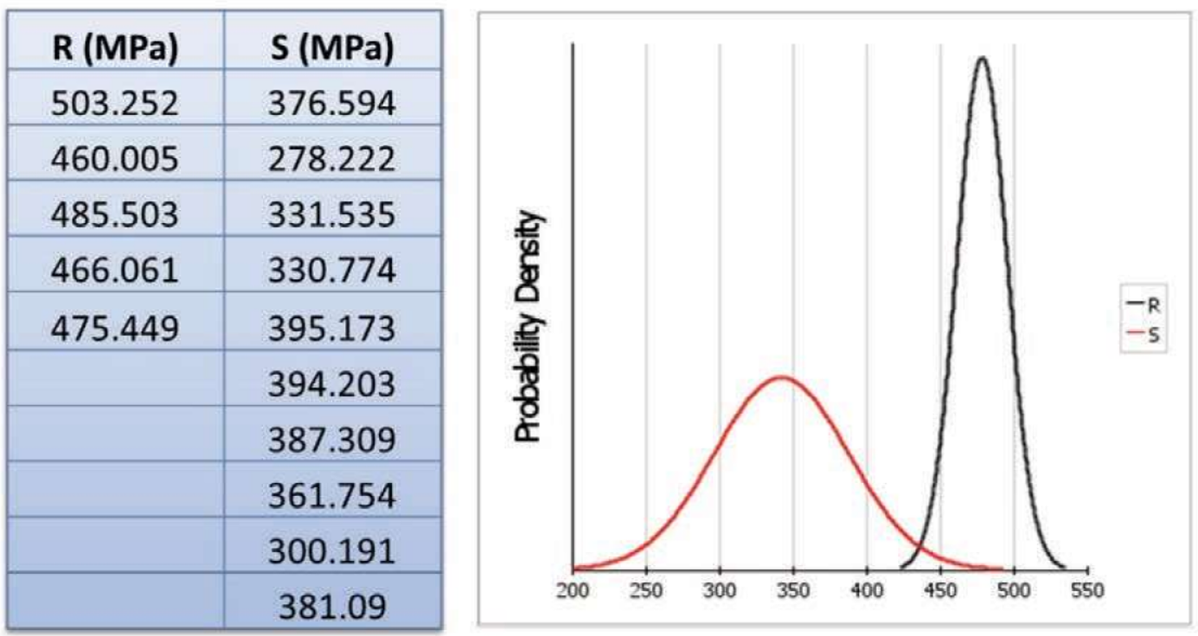
- Epistemic challenge problem 1
The solution given in this presentation is based on the application of a Student or t-distribution. The limited input data gives a bell-shaped distribution that resembles a normal distribution; however, the variation is unknown. This results in thicker tails of the distribution with respect to the normal distribution. This is illustrated in Figure 2.
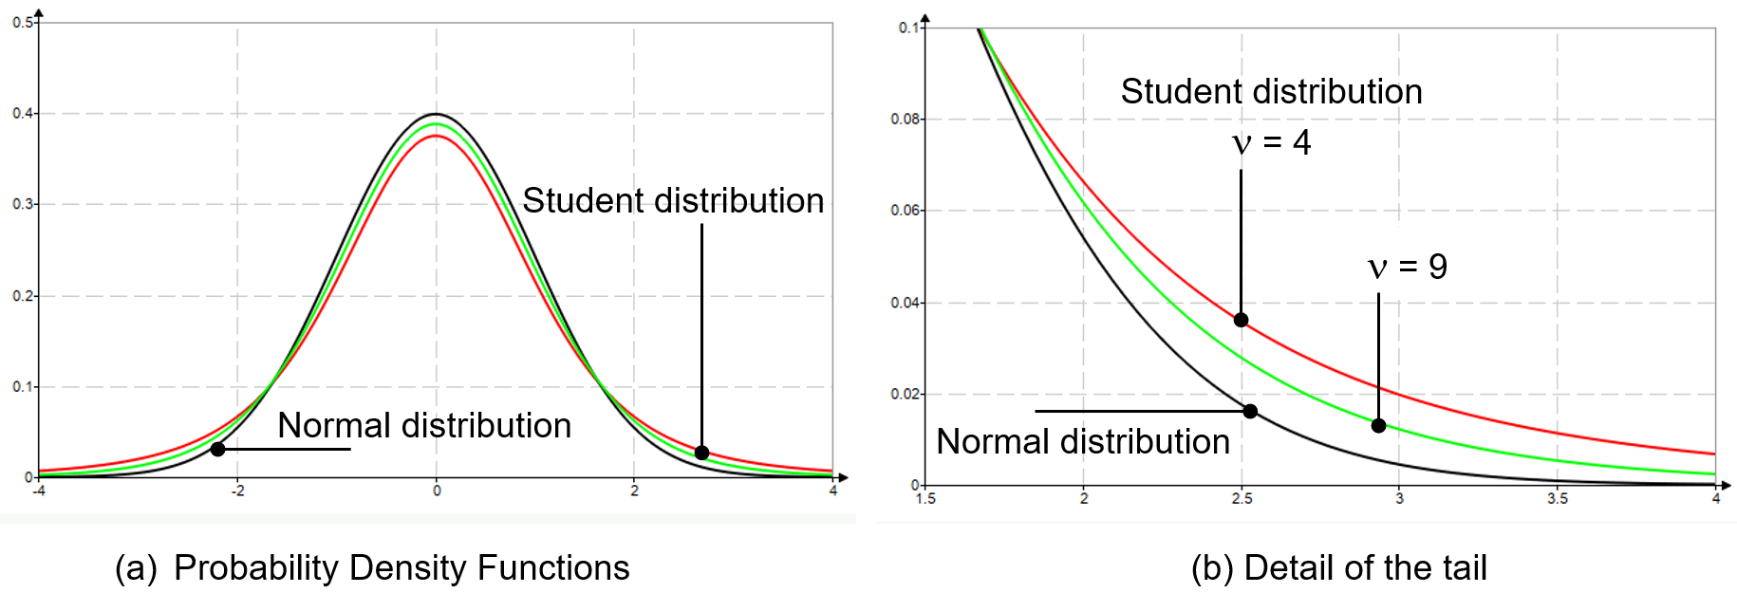
- Two Student distributions versus the normal distribution
Five observations for the resistance R (n = 5) results in four degrees of freedom (ν = n – 1 = 4). For the load S 10 observations are available giving ν = 9 and the tendency to the normal distribution is apparent. For 50 observations the difference between the Student and normal distribution is negligible. The samples for the load S and resistance R produce a mean and a standard deviation, and the distributions are displayed in Figure 3.
The limit state function is defined by:
$$g=R-S$$
And the required probability of failure follows from:
$$p_{f}=Prob\left(g<0\right)$$
This probability is calculated with the program Prob2B (TNO, 2007) and since the limit state function is very basic the First Order Reliability Method (FORM) should be adequate to produce an answer. The result is $p_{f}=0.94\%.$
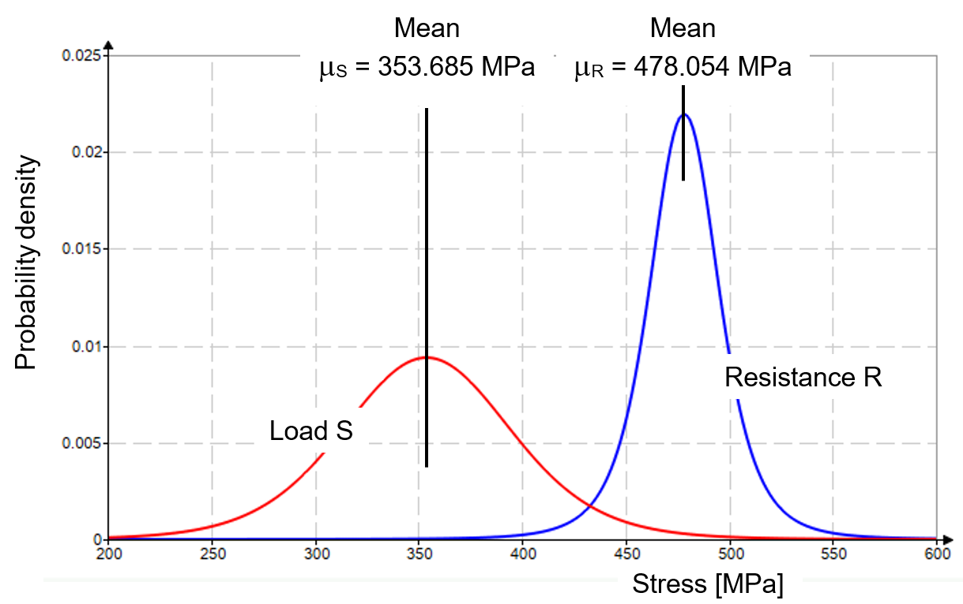
- The Student distributions of load and resistance

Challenge number two
The second challenge presented in (SWG, 2022) considers a potential industrial scenario of a fluid flow through a porous material. This is schematically presented in Figure 4. The pressure drop in the flow should not exceed a certain value and the governing parameters are the length of the path through the porous material L [m], the diameter of the porous media D_{p} [m], the porosity ε [-], the density of the fluid ρ [kg/m³], the dynamic viscosity of the fluid μ [kg/m·s] and the fluid velocity v_{s} [m/s].
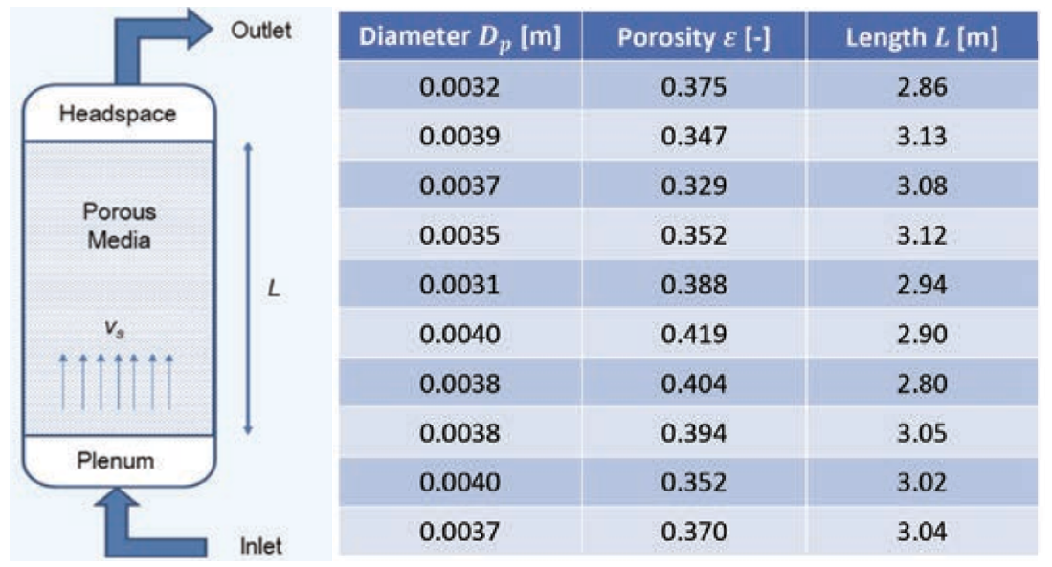
- Fluid flow through porous media

The first three parameters are given by 10 observations each (see Figure 4). The remaining three parameters are deterministic, so given by fixed values. The pressure drop is defined by:
$$∆p=\frac{150∙μ∙L}{D_{p}^{ 2}}∙\frac{{\left(1-ε\right)}^{2}}{ε^{3}}∙v_{s}+\frac{1.75∙L∙ρ}{D_{p}}∙\frac{1-ε}{ε^{3}}∙v_{s}^{ 2}$$
This pressure drop shall not exceed the threshold value ${∆p}_{o}$ and this leads to the limit state function:
$$g={∆p}_{o}-∆p$$
And the desired probability of failure follows from:
$$p_{f}=Prob\left(g<0\right)$$
The description of the first challenge clearly states that the problem is based on the assumption of two normal distributions, while the second challenge only mentions natural variability in the uncertainty. Nevertheless, this statement is considered as a justification to apply Student distributions. Also, for this problem the program Prob2B is applied, and since the limit state function is a bit more complicated than for the first challenge more solution options are assessed.
- FORM $p_{f}=Prob\left(g<0\right)=0.20\%$
- Numerical integration $p_{f}=Prob\left(g<0\right)=0.21\%$
- Crude Monte Carlo $p_{f}=Prob\left(g<0\right)=0.26\%$
Although there is some scatter in the solutions, the three results give a fair idea about the Probability of Failure.

References
SWG - Stochastics Working Group (2019). Benchmark Magazine April 2019: NAFEMS, pp. 44 – 45.
SWG - Stochastics Working Group (2022). Benchmark Magazine April 2022: NAFEMS, pp. 14 – 47.
TNO Built Environment and Geoscience (2007). Prob2B Report 2007-D-R0887/A: TNO

