High-fidelity Digital Twin for Laser Metal Deposition by Wire
Joanna Tumelty, Will Alden, Alex Ballisat
CFMS, UK

Abstract
Laser Metal Deposition by wire (LMDw) is an additive manufacturing process used to produce high-value products in the aerospace industry. The technique enables precision layer-by-layer deposition to produce parts with complex three-dimensional geometries. LMDw involves a range of multi-scale and multi-physics processes involving many process parameters that ultimately affect the quality of the printed part. Process optimisation is therefore essential to consistently achieve the high production rates of high-quality parts needed for the industrialisation of this technology. Performing experimental trials to achieve this is time, cost and resource intensive; using simulations instead can greatly reduce the expense.
To this end, a digital twin of the LMDw manufacturing process, integrating several high-fidelity simulations and modelling the end-to-end process, has been developed. The digital twin includes a robot model that uses toolpath information to determine the physical locations and times at which material is deposited. This information is fed into higher fidelity multi-physics simulations that capture the phase changes and material addition near the melt pool, and the post-print thermal distortion of the final part. This allows properties of custom printed parts to be determined. Using this digital twin facilitates process optimisation by enabling a much greater exploration of design spaces than would be achievable through experimental trials. This can be used to develop deeper understanding of process parameters, which enables faster and easier identification of those required to manufacture high-quality parts.

Introduction
Laser Metal Deposition by wire (LMDw) is a novel additive manufacturing process used to produce high-value products in the aerospace industry. The process uses a laser to heat a titanium alloy (Ti-6Al-4V) substrate and create a melt pool of molten material into which a metal wire is inserted. Material is deposited and rapidly solidifies as the heat source moves away from the deposition point, leaving an area of locally raised material. This deposition process is repeated over multiple layers, building up parts with complex three-dimensional geometries layer-by-layer. A robot controls the position of the laser and wire together to facilitate the precise placement of deposited material. This reduces material wastage and machining needs post-deposition, and enables high deposition rates compared to alternative manufacturing techniques (Abuabiah et al., 2023).
As a newer technology, one of the main challenges of LMDw is consistently producing high-quality printed components. The manufacturing process involves a range of coupled multi-scale and multi-physics processes involving many process parameters that ultimately affect the quality of the printed component. For example, the rapid solidification of deposited material near the melt pool induces residual stresses in the component and results in thermal distortion of the final printed part, which could render the part unusable. Process optimisation to determine appropriate robot toolpaths and values of process parameters, including laser power and wire feed rate, is therefore essential to achieve consistency. While this can be achieved using experimental trials, this approach tends to be time, cost and resource intensive; using simulation instead can greatly reduce the expense.

Digital Twin
A digital twin to model the end-to-end LMDw manufacturing process and facilitate process optimisation has been developed. The digital twin integrates three main modelling stages: a robot model computing the robot’s position over time; and two high-fidelity simulations, one to model the melt pool dynamics during deposition and the second to model the post-print thermal distortion of the final part.
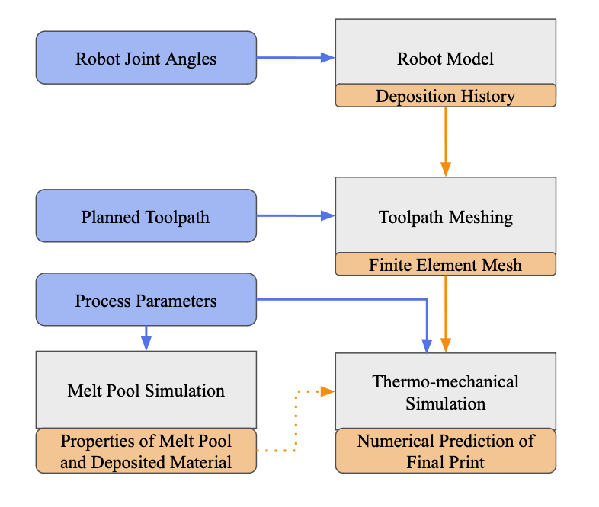
Figure 1: System diagram of the digital twin for the LMDw manufacturing process, which illustrates how input data (blue) and computed numerical results (orange) propagate through stages of the digital twin (grey). The dotted line indicates a connection that will be made in future development of the digital twin.
Figure 1 presents the system diagram for the digital twin. Input data and process parameters (blue), which may be prescribed or come from experimental builds, are inputted to the relevant modelling stage (grey), where numerical results (orange) are computed. These computed results can be later used in the following modelling stages.
The first stage of the digital twin is a system model of the robot, which digitally reproduces how the position of the robot changes over the course of a deposition. Provided a time-history of the angles of each joint of the robot, the position of individual links and therefore also the full robot can be calculated. In particular, the position of the end-effector, which controls the positions of the laser and wire together, provides positions and times at which material is deposited.
Material deposition is also modelled at a smaller scale by simulating the coupled thermal and fluid dynamics in the melt pool using the Lattice Boltzmann method within the OpenLB framework (Kummerländer et al., 2023). Key results from this simulation include the melt pool temperature and profile of solidified material. Further development of this model could allow these results to be integrated into the following thermal distortion simulation (cf. dotted orange line in Figure 1), or to predict the formation of defects, such as balling.
The second high-fidelity model is a thermo-mechanical simulation of the layer-by-layer printing that is used to predict the thermal distortion of the final printed part. A mesh of the geometry of the printed part is first generated during a previous meshing stage that either requires the deposition history from the robot model, or other proposed toolpaths. This allows the flexibility of using the digital twin model for both validating the high-fidelity models against experimental builds, and for investigating the impact of alternative toolpaths. The generated mesh is then applied in a thermo-mechanical simulation, which applies a finite element method within the Multiphysics Object Oriented Simulation Environment (MOOSE) framework (Giudicelli et al., 2024). For computational efficiency, the simulation uses a multi-scale approach using the modified inherent strain method (Liang et al., 2018): a fully coupled thermo-mechanical simulation is used to compute the strain on small representative sections of deposition, which are then applied in a purely mechanical simulation of the addition of layers at the part-scale to determine the total distortion of the final part. Figure 2 shows the displacement and stress profiles from simulation results applied to a two-bead wall test case.
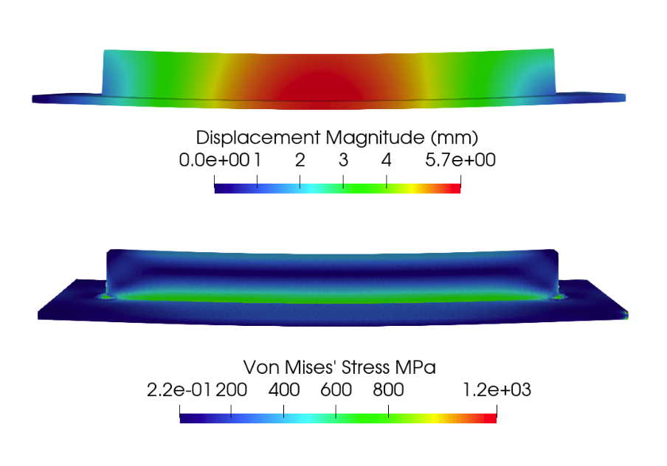
Figure 2: Displacement (top) and stress (bottom) profiles of the results from the thermo-mechanical distortion simulation applied to a two-bead wall test case.

Application to Process Optimisation
This digital twin provides a framework that could be used to perform process optimisation more efficiently than through experimental trials alone. As key process parameters, like laser power and wire feed rate, are parameterised within the high-fidelity models, they can easily be varied through automation. Running multiple instances of the digital twin with different process parameters in parallel allows for a much greater exploration of design spaces and therefore deeper understanding of the impact that changes to each process parameter can have on the final build. This enables faster and easier identification of conditions required to manufacture high quality parts, which is necessary for the industrialisation of the technology.

References
Abuabiah, M. et al. (2023). Advancements in laser wire-feed metal Additive Manufacturing: A brief review, Materials, vol. 16, p. 2030.
Giudicelli, G. et al. (2024). 3.0 - MOOSE: Enabling massively parallel multiphysics simulations, Software X, vol. 26, p. 101690.
Kummerländer, A. et al. (2023). OpenLB Release 1.6: Open Source Lattice Boltzmann Code. Version 1.6.
Liang, X. et al. (2018). A modified method for estimating inherent strains from detailed process simulation for fast residual distortion prediction of single-walled structures fabricated by directed energy deposition, Additive Manufacturing, vol. 23, p. 471-486.

