Enabling High-Rate Manufacture of Carbon Fibre Wings Through Simulation Driven Process Optimisation
Dr. A. Ballisat, Mr. L. Nolan
(CFMS, UK)
Abstract
The use of carbon fibre composites is growing in the aerospace industry due to their desirable strength and weight properties, however, manufacturing methods are less mature than those for traditional materials. In particular, the resin infusion process is under heavy development for producing components to be used in the next generation of aircraft wings. Complex physical phenomena, such as cure, racetracking, and void formation, make this a challenging process to design and operate consistently.
To accelerate the development of the process, a custom resin infusion model was built using the finite element framework MOOSE, generating a tightly coupled simulation. Temperature dependent resin properties were captured in the cure kinetics and rheology models, and an advection stabilisation scheme was implemented to fix these properties relative to the fluid flow. Shell elements, combined with an analytical formula for the effective permeability of small channels, were used to model the racetracks. Simulation of void formation via mechanical air entrapment was also investigated, through a two-phase model at the macro scale and analysis of the capillary number at the micro scale.
The model was validated against experimental infusions of aerospace wing components, reaching agreement within 1%, while also highlighting the sensitivity of the process to material property variation. It will be used in conjunction with parallel, high performance compute to explore the design space of process parameters. This enables sensitivity analysis to isolate crucial parameters and process optimisation to improve quality and repeatability. It can also be used to aid design of passive open-loop control systems, or integrated into an active closed-loop control system via a trained machine learning model. This would allow the process to be more finely tuned, ultimately resulting in higher quality, more consistent parts.

Model Development
This resin infusion model was developed in the Multiphysics Object-Oriented Simulation Environment (MOOSE) (Permann 2020), an open source Finite Element (FE) framework. MOOSE has an existing porous flow module (Wilkins 2020, Wilkins 2021), which already implements the majority of the physics, in particular Darcy’s law, required for a porous flow problem such as resin infusion. Extending this to composite manufacture required extensive development, including implementing a custom pressure-saturation relationship to enable a fully-unsaturated system such as a dry fibre preform. One of the key parameters in a porous flow model is the viscosity of the fluid. The rheology of the resin is highly complex, as it is a thermosetting epoxy; higher temperatures initially reduce the viscosity, but they increase the rate of cure, and an increased degree of cure increases the viscosity. A rheological and cure model described by Shin and Nutt (Shin 2020) was implemented, as they used the same resin as used in subsequent experimental trials. The exotherm behaviour described in the same paper was also implemented, as well as a stabilised advection scheme to allow resin properties such as degree of cure to track its movement. Racetracking phenomena are simulated using shell elements over the surfaces prone to racetracking, and an analytical formula for permeability of narrow channels. Large dry spots can be caused by resin flow locking off an area and trapping some air, due to the non-perfect vacuum throughout the part. Modelling this was achieved with a two-phase porous flow model, using low pressure air as the second phase. Smaller voids are caused by mechanical entrapment of air at the flow front, and are linked to how fast the flow is. This is one area of future development of this model.

Results
The simulation was validated against a range of analytical solutions for the flow front position in 2D cases with rectilinear and radial injection presented by Isoldi et al. (Isoldi 2012). Excellent agreement was achieved, with an error of approximately 1% across the cases. A flat panel with four stringers attached was used for a 3D demonstration with cure and ractracking included. Resin was injected from the left and right edges, with a racetrack on the front edge. The model behaved as expected, with the racetrack accelerating flow in that area, and the cure increasing viscosity over time. Following the 2D analytical verification and 3D demonstration, experimental validation was completed. This was done against a 1m flat panel, and a 1m panel with a stringer attached. Following some model calibration, a simulation was executed which matched the average resin arrival times at each sensor to within 1% for the flat panel case, as shown in Figure 1. The results of executing a sensitivity analysis across process parameters are shown in Figure 2 for coupled variations of +/- 2%. This demonstrates that the process is very sensitive to these parameters with the fill times varying significantly.

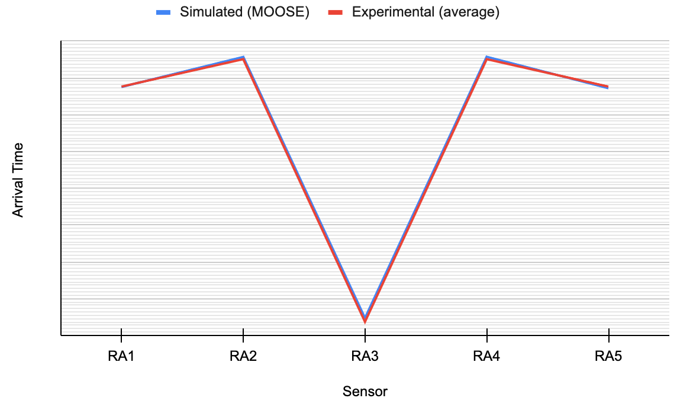
- Arrival times (scale removed) at each resin arrival sensor on a 1m flat panel, for experimental trials (averaged over 5 trials) and a calibrated simulation.
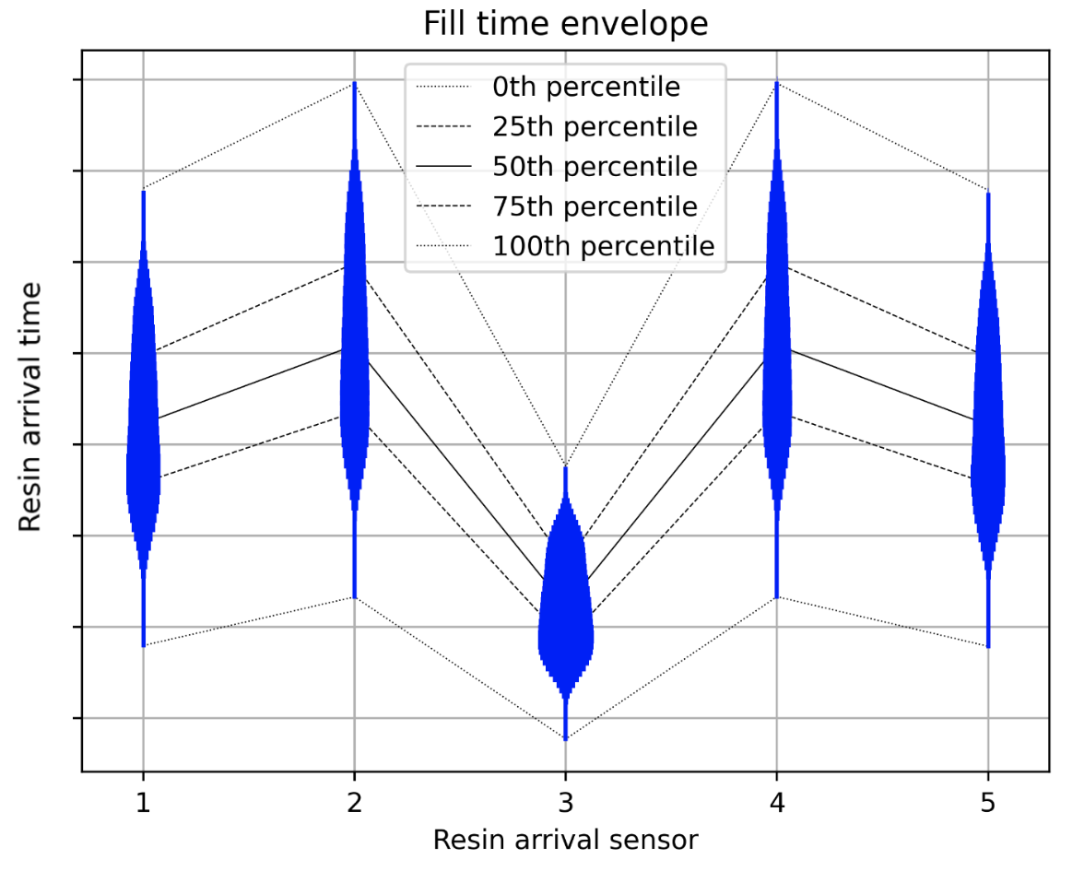
- Distributions and envelope of arrival times (scale removed) at each resin arrival sensor on a 1m flat panel, for a +-2% uniform variation of porosity, permeability, temperature, and racetrack thickness.

Discussion
As demonstrated in Section 2, the model which has been developed is capable of matching both analytical and experimental results to a very close degree. However, this is highly dependent on obtaining accurate material properties and experimentally determined parameters, with many of the latter especially required in the cure model. These properties and parameters are often difficult and time consuming to measure, and the results are often inaccurate, meaning the model can’t always be used for exact outcome prediction.
An area the model is more useful is process optimisation and sensitivity analysis. Optimisation can help determine the best process configuration to achieve goals such as minimising fill time or minimising defects. Effective design of experiments can highlight which parameters the process is most sensitive to, and thus need to be most tightly controlled for consistent high-rate manufacture, even if the exact values are unknown. This is invaluable for quantifying the degree of expected manufacturing variability.
Another use for the model is designing control systems for resin infusion, interfacing with systems such as the resin injection, and the vacuum ports. Passive (open-loop) control systems are related to the process optimisation discussed above, i.e. choosing a predetermined infusion strategy. Active (closed-loop) control systems could incorporate the model, or more likely a faster surrogate of the model, into the control loop. This would take input from sensors such as resin arrival and pressure sensors, and control the input to systems such as resin injection and vacuum ports in real time.

References
Giudicelli, G. ; Lindsay, A. ; Harbour, L. et al. (2024). 3.0 - MOOSE: Enabling massively parallel multiphysics simulations: SoftwareX, vol. 26. p. 101690.
Wilkins, A. ; Green, C. P. ; Ennis-King, J. (2020). PorousFlow: a multiphysics simulation code for coupled problems in porous media: Journal of Open Source Software, vol. 5, no. 55. p. 2176.
Wilkins, A. ; Green, C. P. ; Ennis-King, J. (2021). An open-source multiphysics simulation code for coupled problems in porous media: Computers & Geosciences, vol. 154. p. 104820.
Shin, J. H. ; Nutt, S. (2020). In situ resin age assessment using dielectric analysis and resin cure map for efficient vacuum infusion: Advanced Manufacturing: Polymer & Composites Science, 6(4). p. 212-225.
L. Isoldi, C. Oliveira, L. Rocha, J. Avila Souza, and S. Amico (2012). Three-dimensional numerical modeling of RTM and LRTM processes: Journal of the Brazilian Society of Mechanical Sciences and Engineering, vol. 34. p. 105–111.

