Improving Electric Vehicle Transmission System Lubrication using 3D Transient Multiphase CFD Simulations

Raghu Vamsee Godavarthi, Ashutosh Pandey,
Chinmoy K. Mohapatra, Dipak Maiti
Simerics Inc., India
Michael Clapp, Sean Horgan
Simerics UK
Abstract
Effective lubrication of any transmission system is necessary to enhance its overall efficiency, reduce wear of the contact surfaces and ensure long-term durability. For Hybrid and battery electric vehicles, it becomes even more desirable to have efficient lubrication to extend their operating range. Transmission systems consist of multiple bearings of different types (ball, roller, thrust etc.) in conjunction with gear systems and other rotating parts. Due to its structural complexity, it becomes extremely challenging to estimate the internal distribution of the automotive transmission fluid (ATF) to different parts of the transmission system using experimental methods. CFD simulations help in better understanding of the flow distribution in these intricate systems and provide detailed insights into the flow field. A three-dimensional CFD analysis of lubrication of a transmission system using a commercial software Simerics-MP+ is presented in this paper. The transmission system modeled consists of a casing that houses a planetary gear system with eight needle roller bearings and a thrust bearing. Transient simulations are performed capturing all the motions of the bearings along with the gear system using moving meshes. An explicit Volume of Fluid (VOF) formulation with a high-resolution interface capturing scheme is used to simulate the interaction of oil and air flow inside the system. Oil flow distribution to different rotating parts and the wetting of rollers for different rotational speeds are presented in this study. Churning loss due to oil flow around the gears and bearings is also predicted. The CFD methodology developed is being used by automotive OEMs to design efficient lubricant flow paths in their transmission systems.
- Introduction
The design of modern automotive transmission systems is primarily driven in pursuit of efficiency improvement with a major focus on lubrication of gears and bearings. The key challenge in lubrication of these mechanical systems is achieving a balance. Insufficient lubrication leads to increasing wear and tear while excessive lubrication leads to increased hydraulic losses [1]. Optimizing the power loss with effective management of heat generation can help downsizing and increasing power densities [2]. This is important in designing efficient battery electric vehicles (BEV) and extending their operating range. Thus, improving performance of BEV systems demands an optimized design of the lubrication system for rotating components such as gears and bearings aiming to reduce losses and achieve a longer operating life.

CFD analyses have emerged as a powerful tool in understanding the lubrication of transmission systems and accurately predicting power losses. CFD simulations provide detailed insights of lubrication and its effectiveness in these complex systems as they offer the distinct advantage of gathering the data at every location in the computational domain, which is expensive through experiments [3]. However, modelling the transmission system remains a complex task due to the presence of various rotating components, including gears, bearings and planetary gears. The present study focuses on investigating the three-dimensional unsteady, multiphase flow in a transmission system that contains a planetary gear system with eight needle roller bearings and a thrust bearing.

- Transmission System
The transmission system modelled in the present study is shown in Figure 1. The system consists of a casing that houses a planetary gear system with eight needle roller bearings and a thrust bearing. The components of the transmission system can be seen in detail from the cross-sectional views shown in Figure 2. The oil flow path inside the system is also highlighted. Oil comes through the shaft and enters the system through a passage near to the thrust bearings. Oil lubricates the thrust bearings which are positioned between the carrier and the sun gear and then goes on to lubricate the planetary gear system along with roller bearings. The oil then flows out through the opening shown at the top of Figure 2.
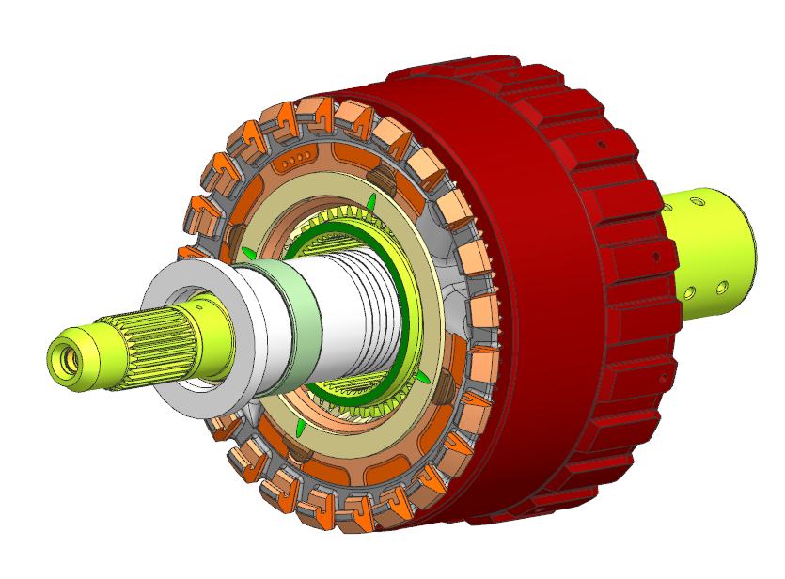
Figure 1: CAD Model of the transmission system
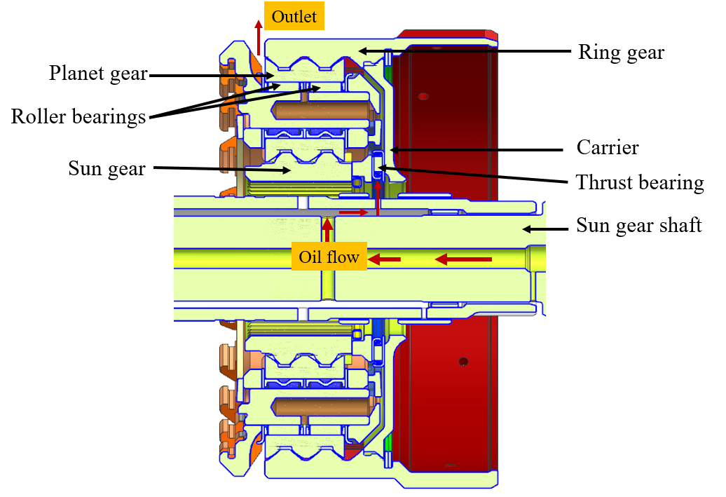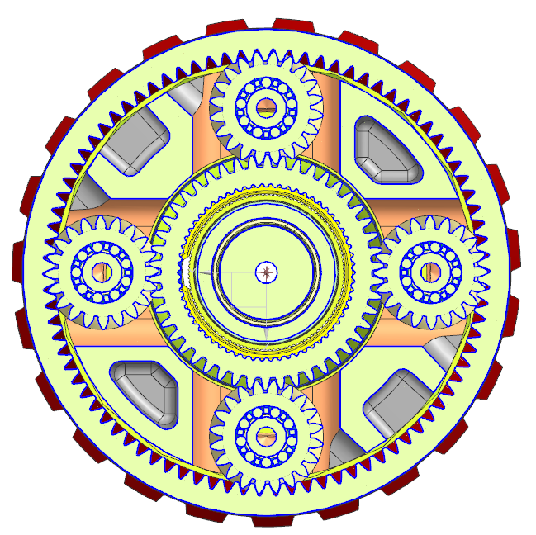
Figure 2: Y-plane and X-plane sections of the CAD Model showing different components and lubrication path

- CFD Methodology and Mesh Details
The CFD software, Simerics-MP+ used in this study solves the conservation equations of mass and momentum of a compressible fluid using the finite volume approach [4]. Along with conservation equations, turbulence physics is modelled using the standard two-equation k-𝞮 model. To account for oil and air interactions in the transmission system, the Volume of Fluid (VOF) model is used to capture the two phases and the interface between them. VOF solves a set of scalar transport equations representing the fraction of the volume each fluid component occupies in every computational cell. Additionally, both implicit and explicit methods can be used to solve the transport equation. A High-Resolution Interface Capturing (HRIC) scheme is used for the convective term in the transport equation to capture the sharp interface between oil and air. The details of the VOF model used in the current study have been extensively validated [5,6].
In the current study, a hybrid meshing method is employed. An automated body-fitted cartesian mesh is employed to mesh the bulk fluid volume and a portion of the bearing, using the Automated Binary-tree Meshing Algorithm in Simerics-MP+. The planetary gear system that includes sun gear, planet gears and the ring gear are meshed using the General Gear template which takes care of generating the mesh between all the gears, capturing micron level gaps. All the eight roller bearings and the thrust bearing are meshed using an automated script that generates a structured mesh to capture the thin gaps between the rollers, cages and races. The mesh generated for gears and bearings is shown in Figure 3. In the current study all the gears and bearings are rotated using the “volume remesh” feature in Simerics-MP+.

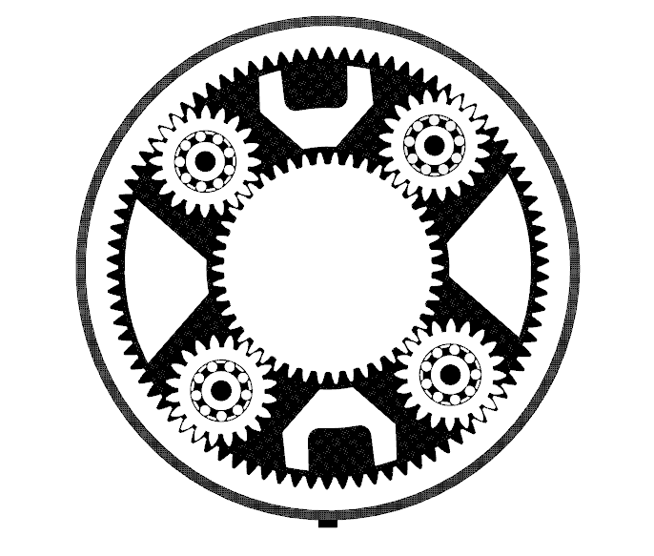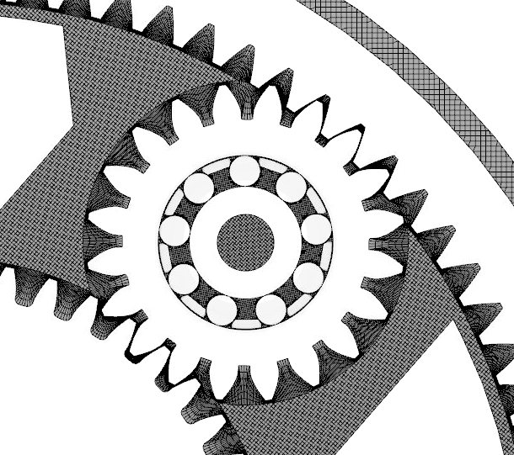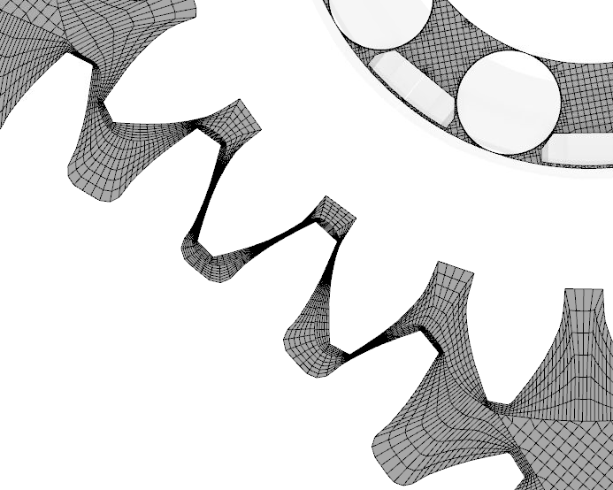

Figure 3: X-plane cross-section showing the mesh for gears and bearings along with a zoomed in view of the inter meshing zone

The simulation is run with a volumetric flow rate of oil at the inlet and a constant pressure boundary condition at the outlet. The model configuration involves specifying the rotational speed to the sun gear and carrier. The rotational speed of the ring gear and other components are determined using Willi’s equation.

- Results
Figure 4(a) shows the Oil distribution inside the transmission system by using an iso-surface of 50 % oil volume fraction. Oil flow inside the system is mainly driven by the centrifugal action of the rotating components. Hence oil is seen reaching everywhere inside the system. More detailed insights into the oil distribution shown in Figure 4(b) using a contour of oil volume fraction on the cross-section. From this contour, it is noted that the oil also reaches all the roller bearings that are rotating with the planet gears. The VOF solver adeptly captures the entrapped bubbles that form at various locations because of the centrifugal action of the rotating components.
(a)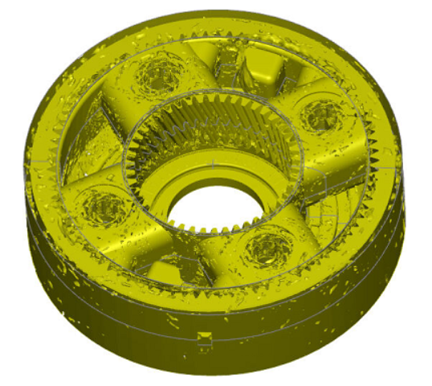(b)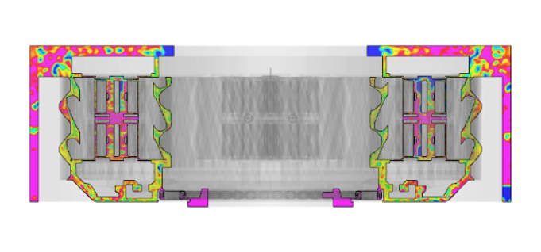

Figure 4: (a) Isosurface of oil volume fraction exceeding 0.5; (b) Contour of oil volume fraction on a Y-plane cross-section (pink color indicates oil volume fraction of 1 and blue color indicates oil volume fraction of 0)
Wetting fraction contours help in predicting the oil film formation on gears and bearings which is critical for ensuring smooth operation with reduced wear. Figure 5(a) shows the contour of oil volume fraction on the sun gear and Figure 5(b) shows the plot of average oil phase area fraction on all the planetary system gears. Considering the average wetting fraction values, Sun gear and ring gear are lubricated by 62% and 69% respectively. All the planet gears are lubricated by the same amount of 58%.

(a)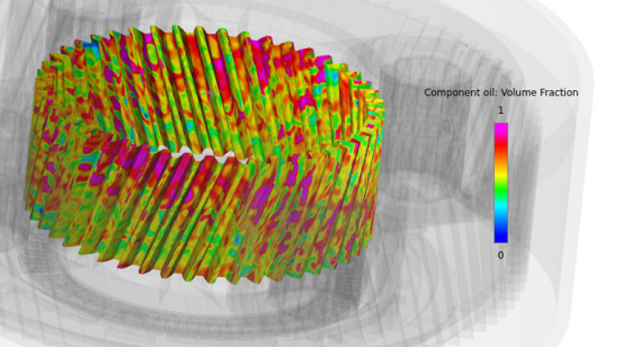(b)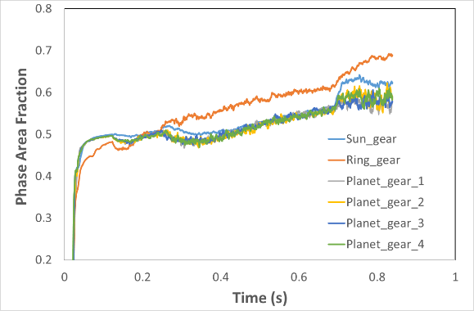

Figure 5: (a) Contour of oil volume fraction on sun gear (pink color indicates oil volume fraction of 1 and blue color indicates oil volume fraction of 0); (b) Variation of average oil phase area fraction on the planetary system gears with time

Further results on bearing lubrication and churning losses at different rotational speeds will be included in the presentation.

- References
[1] Niemann, G. and Winter, H., Maschinenelemente: Band 2: Getriebe allgemein, Zahnradgetriebe-Grundlagen, Stirnradgetriebe (Springer-Verlag, 2013)
[2] Mastrone, M.N., Hartono, E.A., Chernoray, V., and Concli, F., “Oil Distribution and Churning Losses of Gearboxes: Experimental and Numerical Analysis,” Tribology International 151 (2020): 106496.
[3] Maccioni, L. and Concli, F., “Computational Fluid Dynamics Applied to Lubricated Mechanical Components: Review of the Approaches to Simulate Gears, Bearings, and Pumps,” Applied Sciences 10, no. 24 (2020): 8810
[4] Ding, H., Visser, F.C., Jiang, Y., and Furmanczyk, M. "Demonstration and validation of a 3D CFD simulation tool predicting pump performance and cavitation for industrial applications." Journal of fluids engineering, Vol. 133 No. 1 (2011)
[5] Ding, H., and Jiang, Y., “CFD Simulation of an Oil-Flooded Scroll Compressor Using VOF Approach,” in International Compressor Engineering Conference, (2016)
[6] S. Dhar, R. Godavarthi, A. Mishra, S. Bedekar, et al., “A Transient, 3-Dimensional Multiphase CFD/Heat Transfer and Experimental Study of Oil Jet Cooled Engine Pistons,” SAE Technical Paper 2019-01-0154, (2019)

