Risk Reduction in Breeder Blanket Design Through the Integration of Model Based Systems Engineering and Automated Concept Analysis
David Pickersgill, Oliver Marshall, Michelle Tindall, James Bailey, Nicolas Mantel, Nicholas Otway, Anurag Saigiridhari, Yiqiang Wang, Oliver Crosby, Thomas Deighan, Thomas Barrett
UK Atomic Energy Authority, United Kingdom
Abstract
Many public and privately funded fusion reactors are due to begin operation around the middle of the 21st century, the vast majority of which will rely on a deuterium and tritium fuel cycle, with a lithium-containing breeder blanket responsible for providing a sustainable tritium supply. The tritium consumption of large (DEMO-scale) devices will be in the order of 100kg per full power year, several times the current global civil tritium inventory of approximately 35kg. Whilst tritium breeding in fission reactors has supplied experimental devices (the JET tritium inventory was limited to 90g), supporting a global fusion industry in this way is not a viable solution. Breeder blanket technologies are immature and are yet to be tested in operational tokamak environments, where tritium breeding and extraction requirements must be met whilst maintaining structural integrity under thermal and electromagnetic loads, plasma disruption events and high neutron fluences. Therefore, it is crucial that blanket design is approached using a methodology with a proven record for success, that minimises risk and ensures thorough exploration of the associated design space.
The aim of this work is to develop blanket designs by utilising industry-standard engineering processes and methodologies. These include requirements capture, requirements validation and verification, Model-Based Systems Engineering (MBSE), Failure Modes & Effects Analysis (FMEA) and concept generation and selection methodologies. An analysis workflow has been developed which links a reactor systems code, in this case Bluemira, to the blanket system requirements, which are then verified through a pre-conceptual multiphysics systems simulation. Additionally, the project has developed the methodology to continually understand risk as the blanket design progresses through FMEA, from pre-concept to detailed design. The output is a suite of down-selected concepts corresponding to minimal risk or exploring novel areas of design space, alongside the rationale which has led to the decisions.

Introduction
A key technology in realising commercial fusion is the ability to breed the requisite tritium to sustain the deuterium-tritium fusion reaction. Breeder blanket technology is immature, even the most advanced concepts which have been developed for the European DEMO reactor, are rated as TRL3-4[1], this is projected to increase to TRL5-6 once the experimental tokamak ITER is operational and the Test Blanket Module programme is completed. ITER is targeting deuterium-tritium operation in 2035 [2]. However, only 4 designs are planned to be tested in ITER [3], there are currently 9 candidate designs being assessed, these concepts do not cover the full design space for blanket technology, covering combinations of water/helium cooling and either solid pebble breeders (lithium based breeder with beryllium neutron multiplier) or a lithium-lead liquid breeder. Beyond the European fusion programme alternative designs are being proposed:
- For the ARC reactor which is being developed in the US, an ‘immersion’ blanket concept is being explored where the vacuum vessel is immersed in a tank of molten salt (FliBe) [4].
- The Chinese test reactor project CFETR, is looking at a supercritical CO₂ cooled lithium-lead blanket design [5].
- Kyoto Fusioneering have put forward a ‘self cooled’ liquid lithium-lead design (where the breeding and cooling functions are bother provided by the lithium-lead). This is manufactured with silicon carbide composite as an alternative to more traditional reduced activation steel designs [6].
This is not an exhaustive list of blanket concepts, detailed reviews on the blanket design landscape have been completed by others [7]. As can be seen by this brief list of blanket concepts, there are many design choices to be made, which often have to satisfy conflicting requirements. The primary function of the blanket is to breed tritium and extract thermal power from the fusion reaction, however alongside this there are many considerations such as – thermal efficiency, shielding capability (the blanket provides shielding to the surrounding superconducting magnets), material compatibility, safety considerations around handling lithium/beryllium, material availability, and cost of materials (helium, beryllium) and technology maturity/risk.
Alongside the multiple competing requirements in a blanket system, it is also an inherently multiphysics environment. Load assessments of a blanket must consider electromagnetic forces due to the plasma/magnetic confinement system (including disruption events which result in rapidly changing magnetic fields), high energy neutrons and thermal loading from the plasma and thermal-hydraulic design/performance. The systems which interface with the blanket are integrated with other reactor design decisions, such as the overall reactor fuel cycle and cooling of other reactor components, e.g. the divertor. Hence, designing such a complex system means that it is imperative that careful consideration is given to requirements capture and rigorous concept assessment processes to allow systematic concept down selection. In the following sections a brief overview on systems engineering practices which have been applied in this project will be given, as well as an overview of the concept selection analysis.

Systems Engineering
A Capella model of the breeder blanket system has been constructed, to be solution agnostic it is named the Nuclear Energy Conversion System. A reduced version of the systems architecture is shown in Figure 1. The model has been used to capture the functional definition of the system as well as boundary conditions and non-functional requirements. The interfaces between the functions are also captured. This model has been assembled through collaborative meetings amongst subject matter experts at UKAEA and will be further developed in a collaborative project with Kyoto Fusioneering. The functions captured in the system are the basis of a functional FMEA which has elicted further development of the functions of the system and the requirements set.

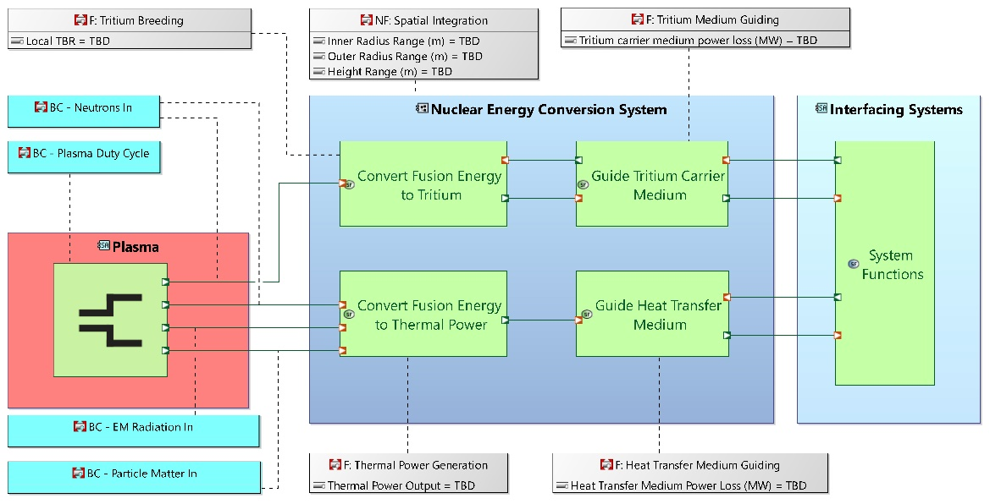
- Reduced version of systems architecture.

Concept Analysis
An overview of the concept analysis is shown in Figure 2. An automated process will be used to link the outputs of the concept analysis with the requirements captured in Capella. This significantly expands the number of concepts which can be assessed. Additionally, interfaces to the wider plant, for example spatial integration (which is captured in the systems architecture) are calculated from a simplified spherical tokamak model which has been defined in Bluemira [7] (a reactor systems code), this can also be integrated into the workflow. These processes will be used to progress to a series of down selected blanket concepts with a clear understanding of performance against requirements. 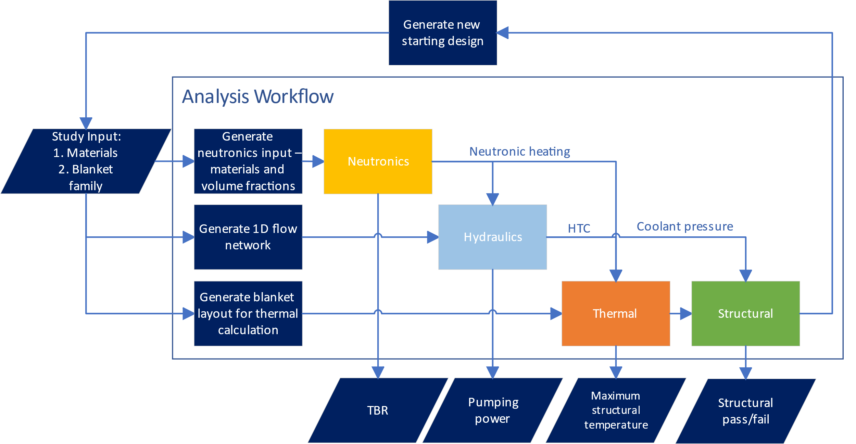
- Diagram view of breeder blanket concept analysis

References
[1] G. Federici, ‘Testing needs for the development and qualification of a breeding blanket for DEMO’, Nucl. Fusion, vol. 63, no. 12, p. 125002, Oct. 2023, doi: 10.1088/1741-4326/ad00cb.
[2] ‘ITER Council endorses updated project schedule’, ITER. Accessed: Apr. 15, 2024. [Online]. Available: http://www.iter.org/newsline/-/2588
[3] L. M. Giancarli et al., ‘Overview of recent ITER TBM Program activities’, Fusion Engineering and Design, vol. 158, p. 111674, Sep. 2020, doi: 10.1016/j.fusengdes.2020.111674.
[4] S. Segantin, R. Testoni, Z. Hartwig, D. Whyte, and M. Zucchetti, ‘Optimization of tritium breeding ratio in ARC reactor’, Fusion Engineering and Design, vol. 154, p. 111531, May 2020, doi: 10.1016/j.fusengdes.2020.111531.
[5] L. Chen et al., ‘Conceptual design of the supercritical CO2 cooled lithium lead blanket for CFETR’, Fusion Engineering and Design, vol. 173, p. 112800, Dec. 2021, doi: 10.1016/j.fusengdes.2021.112800.
[6] R. Pearson, C. Baus, S. Konishi, K. Mukai, A. D’Angiò, and S. Takeda, ‘Overview of Kyoto Fusioneering’s SCYLLA© (“Self-Cooled Yuryo Lithium-Lead Advanced”) Blanket for Commercial Fusion Reactors’, IEEE Transactions on Plasma Science, vol. 50, no. 11, pp. 4406–4412, Nov. 2022, doi: 10.1109/TPS.2022.3211410.
[7] ‘Fusion-Power-Plant-Framework’. Accessed: Apr. 16, 2024. [Online]. Available: https://github.com/Fusion-Power-Plant-Framework

