Macro and Micro–mechanical Investigation of the Mechanical Behaviour of Chocolate Using Finite Element Simulations
Dipl.-Ing. T. K. Elezoglou, Prof M. Charalambides
(Imperial College London, UK);
Dr S. Rana
(Mondelez, UK)
Abstract
Chocolate is a highly complex, multi-phase composite. Its mechanical behaviour strongly depends on the applied strain-rate. This study determines the behaviour at ambient temperature across a wide strain rate range (0.001 m/s to 6 m/s) to reflect the need for calibrating constitutive models required in simulations for predicting fragmentation during the first oral bite, as well as during normal handling and transportation of the product. Firstly, numerical simulations of the uniaxial compression and tension tests were performed in order to investigate the impact of dynamic effects at the high-rate tests. The chocolate specimen was modelled as a 2D axisymmetric model consistent with the shape used for the uniaxial compression experiments. The elastic range of the chocolate’s behaviour was modelled using Isotropic Elasticity while the elastoplastic part was modelled using four different models, namely Multilinear Isotropic Hardening, Mohr-Coulomb, Drucker-Prager, and Drucker-Prager Hardening. The results show good agreement with the experimental data, while the Drucker-Prager hardening model captures adequately and in a unified way the different behaviour of chocolate in compression and tension. Secondly, micromechanical modelling of chocolate was also performed depicting the cocoa butter (matrix) and the constituent particles of cocoa solids, sugar, and milk solids. The micromechanical modelling was based on two confocal microscope images of chocolate. The finite element analysis was performed using isotropic elasticity and four different models for each image were examined with varied properties of the constituent ingredients. Comparison with analytical models was also performed, and the results from both numerical and analytical models are close to the experimental Young’s Modulus evaluated from uniaxial compression unloading.

Numerical simulation of monotonic uniaxial tests
Simulation of the monotonic uniaxial tests was conducted to investigate inertial effects present in high-speed test, numerically. The investigation of constitutive laws such as Mohr-Coulomb, and Drucker-Prager in more detail was another motivation for conducting numerical modelling on chocolate. The speeds of the tests in the analyses included 0.001 m/s, 0.01 m/s, 0.1 m/s, 1 m/s, 4 m/s, 5 m/s and 6 m/s for compression and 0.001 m/s, 0.01 m/s for tension and the results were compared with the respective experimental data.
The analysis was performed on a 2D axisymmetric model of the chocolate specimen (Figure 1) with isotropic elasticity up to the nominal yield point which was defined as the end of the linear range of the true stress-true strain curves. The behaviour from the yield point up to the point of maximum true stress was modelled using Multilinear Isotropic Hardening, Mohr-Coulomb, Drucker-Prager, and Drucker-Prager Hardening calibrated using experimental data.
Similarly to the experimental data, the stress-strain curves from the numerical analyses at high speeds exhibit oscillations due to inertial effects. Interestingly, the amplitude of these oscillations is greater as the mesh becomes finer without, however, affecting the final smoothed curves, so the mesh size did not appear to impact the results. The confidence in the validity of the high-rate test data was supported by the numerical finite element model.
Furthermore, the Drucker-Prager hardening model captures adequately and in a unified way the different behaviour of chocolate in compression and tension.

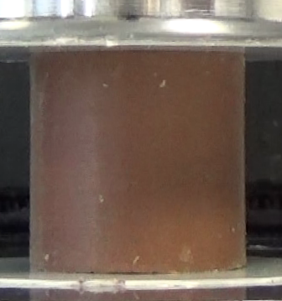
A
Bottom face fixed in Y, free in X.
Top face free to move in X, constant displacement, or constant speed in Y.
Y
X
- The 2D axisymmetric model used in the numerical analyses in relation to the chocolate specimen.

Micromechanical modelling of chocolate
Micromechanical modelling of chocolate using confocal microscope images provided by Mondelez UK was also performed (Figure 2). Simple linear isotropic elastic analysis was used to estimate the Young’s Modulus of chocolate.
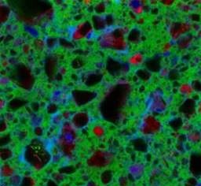
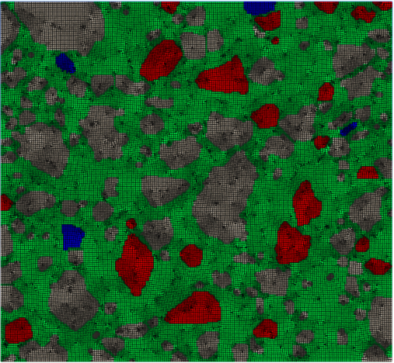
The mechanical elastic properties of sugar and cocoa butter were taken from the literature (Molenda et al., 2006; Ramos and Bahr, 2007; Reinke et al., 2016). The respective properties for milk and cocoa solids were not available in the literature, and thus, four different cases were investigated to cover a range of different scenaria. More specifically, in the first case all particles were given properties of sugar; in the second case, all non-sugar particles (cocoa solids and milk) were assigned the same Poisson’s ratio as sugar but 1/10 of the Young’s Modulus of sugar; in the third case, all particles are assumed to have the properties of the non-sugar particles mentioned above, and in the fourth case all particles were given the same Poisson’s ratio as sugar and a Young’s Modulus 10 times higher than that of sugar. The results show that the Young’s Modulus calculated from the Finite Element Models ranged from 383 MPa to 594 MPa, which is close to the Young’s Modulus calculated from the unloading path of the experimental curve (350±39 MPa).
Top face: 50 μm displacement in -Y direction (free to move in X)

Bottom face: free to move in X direction

Bottom left corner: fixed

Sugar particles (black)
Cocoa solids (blue)
a
b
Cocoa butter (green)
Milk particles (red)
Examples of unclear particle identity
- Confocal microscope image of chocolate used to simulate the uniaxial compression test. (a): Obtained image depicting the ingredient that each particle represents, (b): model image in ANSYS illustrating the boundary conditions. (Raw image from Mondelez UK). Axes as in Figure 1.

Conclusions
The results from the numerical simulations of monotonic uniaxial tests were compared with the respective experimental and in general, there is a good agreement.
Furthermore, results from micromechanical modelling of chocolate in terms of Young’s Modulus were compared with experimental data as well as analytical models, and they are close to the experimental Young’s Modulus evaluated from uniaxial compression unloading.

References
Molenda, M. et al. (2006) ‘Testing mechanical properties of food powders in two laboratories - degree of consistency of results’, International Agrophysics, 20(1), pp. 37–45.
Ramos, K. J. and Bahr, D. F. (2007) ‘Mechanical behavior assessment of sucrose using nanoindentation’, Journal of Materials Research, 22(7), pp. 2037–2045. doi: 10.1557/jmr.2007.0249.
Reinke, S. K. et al. (2016) ‘Synchrotron X-Ray microtomography reveals interior microstructure of multicomponent food materials such as chocolate’, Journal of Food Engineering. Elsevier Ltd, 174, pp. 37–46. doi: 10.1016/j.jfoodeng.2015.11.012.

