Adjoint Solver-Based Shape Optimization for a Venturi Mixer
Akram Radwan*
(Ansys Germany GmbH, Birkenweg 14A, 64295 Darmstadt, Germany)
Min Xu
(Ansys, Inc., 10 Cavendish Ct., Lebanon, New Hampshire, 03766, USA)
Yu Xia
(Ansys UK Ltd., Springfield House, Horsham RH12 2RG, United Kingdom)
Abstract
In this study, we utilize an adjoint solver within Ansys Fluent® [1] to analyse and to optimize the shape of a Venturi mixer within a domestic burner. The numerical simulations integrate the Eddy Dissipation Model (EDM) [2] for reacting flow, and the generalized $k$-$ω$ (GEKO) model [3] for turbulence. By solving adjoint equations, we effectively compute the shape sensitivity for various cost functions, including the pressure drop, the outlet fuel variance/uniformity, the air and fuel mass flow rates, and the outlet CO mass fraction, etc. The shape sensitivity analysis uncovers the interplay between these observables, and the appropriate weights for multi-objective shape optimizations. Then we perform gradient-based optimizations to enhance the mixer's performance, employing both shape sensitivity and mesh morphing techniques. We conduct a series of studies on both cold and reacting flows. The optimization of cold flow provides an in-depth exploration of various optimization strategies, encompassing single and multi-objective optimizations with diverse weight combinations. Following this, the optimization of reacting flow enhances the mixer's functionality under combustion conditions, emphasizing the reduction of emissions and the increase of combustion efficiency. Our findings showcase the potential of the developed adjoint-based optimization workflow in designing Venturi mixers that are efficient and emit lower levels of pollutants.

Introduction
The quality of the primary mixing of air and fuel is important for premixed burners. A Venturi mixer is often used for such primary mixing, which controls the mixing process by using an adjustable needle. The optimization of Venturi mixers is critical for enhancing combustion efficiency and minimizing emissions in the burners [4]. To improve the effectiveness of the mixing, the shapes of the needle, the case and even the nozzle of a Venturi mixer can be chosen freely. One way to improve the mixer’s shape with numerical methods is the so-called “adjoint-solver driven shape optimization”.
The 2D Venturi mixer studied in this work is provided by Bosch Thermotechniek, as shown in Fig. 1.
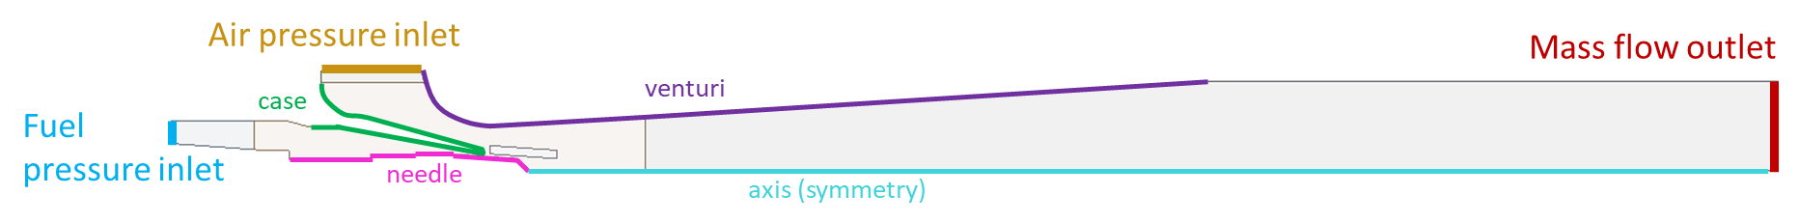

Figure 1: Geometry of the 2D planar Venturi mixer studied.
A planar 2D assumption is applied for this geometry to develop the workflows and to evaluate the methodology to limit the invested computational time. This prevents comparisons with the experimental data as the real geometry is 2D axisymmetric. Expanding the workflow to a 3D case is for the future work.
By adding the Eddy Dissipation Model for reacting flow and increasing the inlet flow temperature, we can also turn the mixer into a burner to evaluate the applicability of the optimization for reacting flows.

Cold Flow Optimizations
For the cold flow, the cost functions are: (1) the normalized pressure drop of the air flow, (2) the normalized uniformity deviation of the fuel at the outlet, and (3) the deviation of the ratio of the air and fuel mass flow rates (MFR) from its initial value. To better understand the interplay between the first two functions, we analyse the shape sensitivity fields on the mixer’s needle surfaces (see Fig. 2). This is not possible for (MFR-MFR_{initial}) because its starting value is zero.
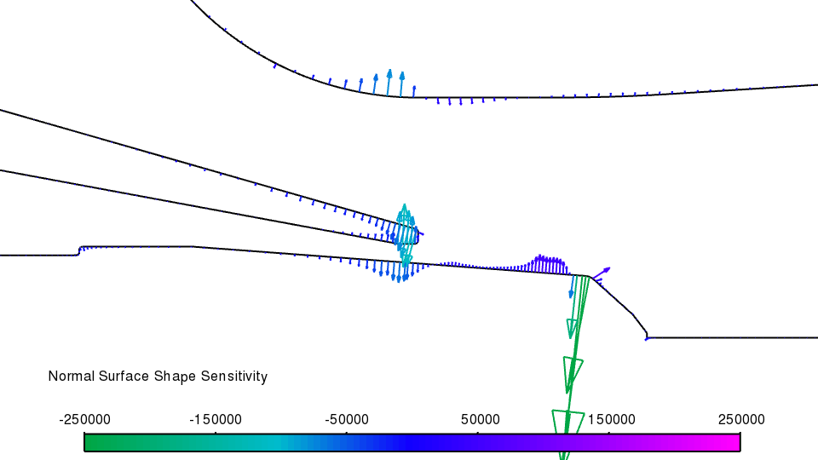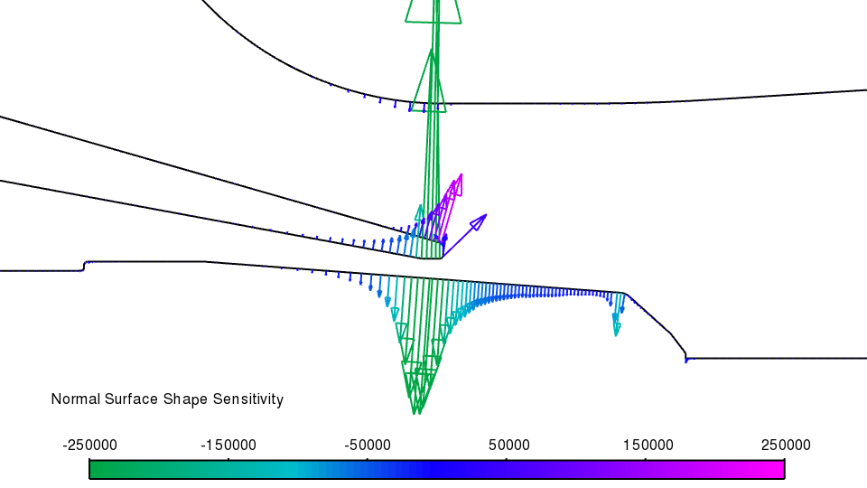

Figure 2: Surface shape sensitivity of pressured drop (left) and uniformity deviation (right).
The sensitivity fields are collaborating partially but there are a few regions on the venturi nozzle, the case and the needle where they are opposing each other. This can make the optimization challenging and it is uncertain if optimizing for only one of these cost functions would also improve the other. Comparing the two plots in Fig. 2 also indicates possible initial values of scaling for both fields to obtain useful results during the following optimization.
As shown by above sensitivity analysis, optimizing for just one cost function may not improve the other. An initial optimization over several design changes (see Fig. 3) shows that it is possible to improve pressure drop and uniformity deviation, but the MFR value deviates from unity which is not acceptable.
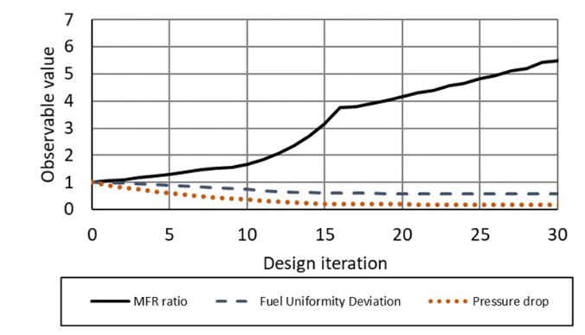

Figure 3: Design changes of all three cost functions when optimizing only pressure drop.
To consider all three cost functions, we have investigated two approaches. Firstly, by introducing the scaling coefficients, it is possible to calculate a compound cost function: $J=c_{0}J_{Δp}+c_{1}J_{uniformity}+c_{2}J_{MFR}$, where $J$ is the cost function and $c$ the weighting factors. The initial scale of the three factors can be derived from the sensitivity study and the importance of the individual functions. The advantage of this approach is the low computational effort for running just one adjoint calculation for each design change. However, this comes at the additional cost of limited control over the components of the cost function.
The second approach calculates a sensitivity field for each of the three cost functions and they are weighted implicitly by specifying the target changes, $t$, for each of them. This requires more computational time because it needs one adjoint calculation for each cost function and design change, but it gives the advantage of having separate sensitivity fields which can offer more control.
For the compound function, $J$, the strong weighting of the MFR pushes the design back to its initial shape. All attempts with different scaling coefficients have a similar result when MFR is kept at unity. Although being more expensive, the second approach shows a more promising behavior. Despite the increase of the pressure drop, the more important cost function for uniformity improves considerably and the MFR stays at the desired value. Figure 4 shows the optimized geometry using the second approach.

Figure 4: Surface geometry before (grey) and after (green) optimization with separate targets design changes (i.e., 2nd approach).

Reacting Flow Optimizations
The optimization of reacting flow enhances the mixer's functionality under combustion conditions, emphasizing the reduction of emissions and the increase of combustion efficiency. The boundary conditions have been changed to auto-ignite the fuel/air mixture inside the burner. An appropriate objective for the optimization is the reduction of CO mass fraction at the burner outlet.
A single design change has been calculated with a -10% target for CO mass fraction at outlet. The optimization achieves a -10.57% actual reduction and the fuel/air equivalence ratio drops by 50.8% from 2.713 to 1.335. This indicates a shift towards the stochiometric state. The geometry change after the optimization is shown in Fig. 5. These results have been confirmed using a finer mesh that the observed CO reduction is the outcome of the geometry change itself, not related to any mesh change.
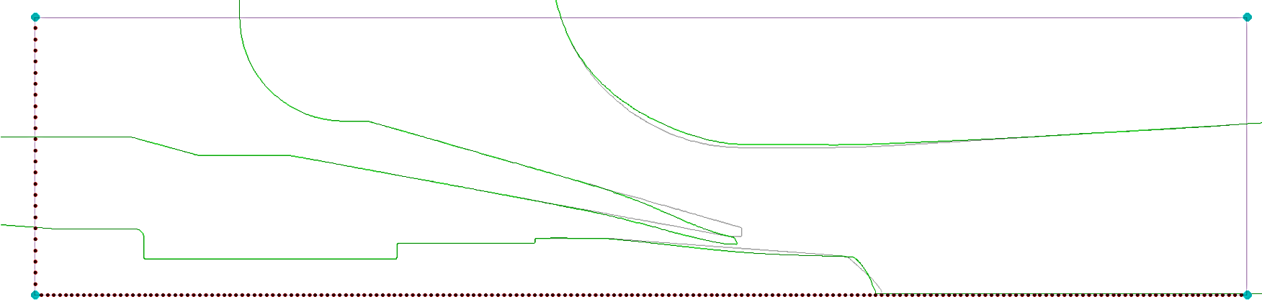

Figure 5: Surface geometry before (grey) and after (green) optimization for reacting flow.

4. Conclusions
In this study, we have demonstrated the effective and efficient use of adjoint-based gradient optimization methods to optimize a 2D Venturi mixer/burner. The knowledge gained can be transferred to the shape optimization of other more complex burners or even gas turbine combustors.

References
- Ansys Inc. (2024) Ansys Fluent® Theory Guide 2024R1. Canonsburg, USA.
- Magnussen, B. F., and Hjertager. B. H. (1976) On mathematical models of turbulent combustion with special emphasis on soot formation and combustion. In the 16th Symposium (International) on Combustion, MIT, Cambridge, MA, USA.
- Menter, F. R., et al. (2020) Development of a generalized k-ω two-equation turbulence model. Notes on Numerical Fluid Mechanics and Multidisciplinary Design, 142.
- Danardono, D., et al. (2011) Optimization the design of venturi gas mixer for syngas engine using three-dimensional CFD modeling. Journal of Mechanical Science and Technology, 25, pp. 2285-2296.

