SMOOTHED PARTICLE HYDRODYNAMICS (SPH) ENGINEERING SIMULATION FOR MICRO-SCALE APPLICATIONS
Stylianos Kanellopoulos
(BETA CAE Systems S.A., Greece);
Dionisis Pettas
(BETA CAE Systems S.A., Greece);
Theodoros Athanasiadis
(BETA CAE Systems S.A., Greece);
Abstract
The Smoothed Particle Hydrodynamics method (SPH) is a meshless technique that can solve free-surface flow problems. Over the last few years, it has drawn interest due to its broad spectrum of applications and scalability [1]. The inherent adaptivity of the method allows the simulation of various complex phenomena, including single-phase and multi-phase flows. In addition, it has been shown to have several applications in microfluidics (for example thin films and flow inside porous media) [2]. Recently, ANSA has introduced a dedicated SPH solver in its workflow, providing an efficient and accurate way to solve free-surface flow phenomena. In this work, we focus on micro-scale applications of the SPH solver and study theoretically a film flowing down a fiber along with the corresponding flow instabilities. The instabilities range from wavy-shaped up to “bead-on-fiber” formations [3]. Furthermore, we demonstrate that the results calculated with the new ANSA’s innovative surface tension model agree with experimental data found in the literature [4]. Additional features of the ANSA SPH solver, such as the two-way coupling with rigid body simulation, will be presented. Overall, the ANSA SPH solver demonstrates the required accuracy for most practical applications.

Model and Process Description
The goal of this study is to replicate the non-linear waves that appear in the flow around fibers during the development of instabilities, using the SPH method [5], which is a Lagrangian method for computing the mass and momentum conservation equations. In this study the thin film will be set up and simulated using the ANSA SPH solver. A short description of the problem is given below:
A Newtonian fluid with viscosity $μ$, density $ρ$ and surface tension $σ$ flows vertically with respect to gravity, g, over a fiber with a diameter $D_{i}$ as shown in Figure 1. The air surrounding the model is considered to be inviscid and its motion is negligible.
- Arrangement used to calculate interfacial instabilities. (b) Top view of a fiber showing nozzle and its corresponding diameters.
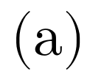
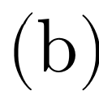
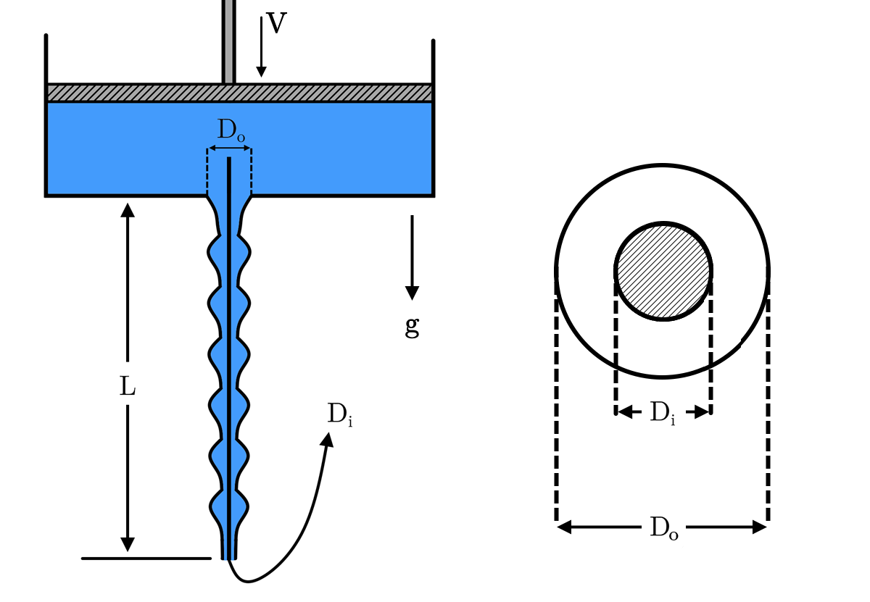
At $t=0$ the piston starts to move downwards at a speed, $V$, so that the fluid is extruded from the nozzle of the tank, which has a cross-section$D_{o}$. The volumetric flow rate is considered constant and its value is$Q=A V$, where $A$ is the piston surface. As the fluid exits the reservoir, the fluid rearranges itself up to a distance, named “inlet length”. After the transition region, instabilities appear.
In the context of this work, multiple fluids were studied with the viscosity, $μ$, and surface tension, $σ$, range 1$-1000 mPa⋅sec$ and $30-70 mN/m$, respectively. The cross-section diameter is equal to $D_{o}=1.15mm$ and the fiber length has been set to be$L=0.40m$, unless stated otherwise. The flow is 3D without any particular spatial assumption. Therefore, any axisymmetric arranges arise naturally by the flow conditions.

Numerical method
For simulating the flow in the ANSA SPH solver, we apply in each particle the conservation of momentum and mass in the Lagrangian form [1]. The composed scheme is considered semi-implicit, in which the velocity and the position of each particle are updated using an explicit scheme whereas the pressure field is solved using a linear system to conserve the incompressibility. Fluid-solid interaction is achieved by sampling the solid surfaces with particles, which are densely packed to ensure boundary tightness and impede particle penetration. To ensure the no-slip and no-penetration conditions, we apply zero velocity at the surface of the boundaries. For more information, the reader may refer to the work of Akinci et al. [6].
The surface tension is imposed following the work of Tartakovsky & Panchenko [7]. Contrary to other methods, the surface tension is not applied on the free surface of the fluid but is calculated implicitly by imposing inter-particle forces in the equation of motion as derived from the fundamentals of intermolecular theory. Finally, the viscosity terms are approximated according to Morris et al. [8].

Results
Figure 2 (a) depicts the observed bead symmetry while Figure 2 (c) represents the bead asymmetry of the fiber, while Figure 2 (b) and (d) correspond to a close-up view of a bead on the fiber. Interestingly, the viscosity $μ$, the volumetric flow rate $Q$ and the nozzle diameter $D_{0}$play a minimal role in determining the final regime of the flow and, therefore, the transition points for each instability remain relatively unaffected. Consequently, the latter variables seem to be invariant of the system.
- Flow formations around a thin fiber. In Figure (a, c) a symmetric formation is shown for $D_{i}=0.25 mm$ and (b, d) an asymmetric formation is presented for $D_{i}=0.50 mm$. The liquid properties are $μ=0.25 Pa⋅sec$ and $σ=30 {mN}/m$. The volumetric flowrate is $Q=12 {mm^{3}}/{sec}$.
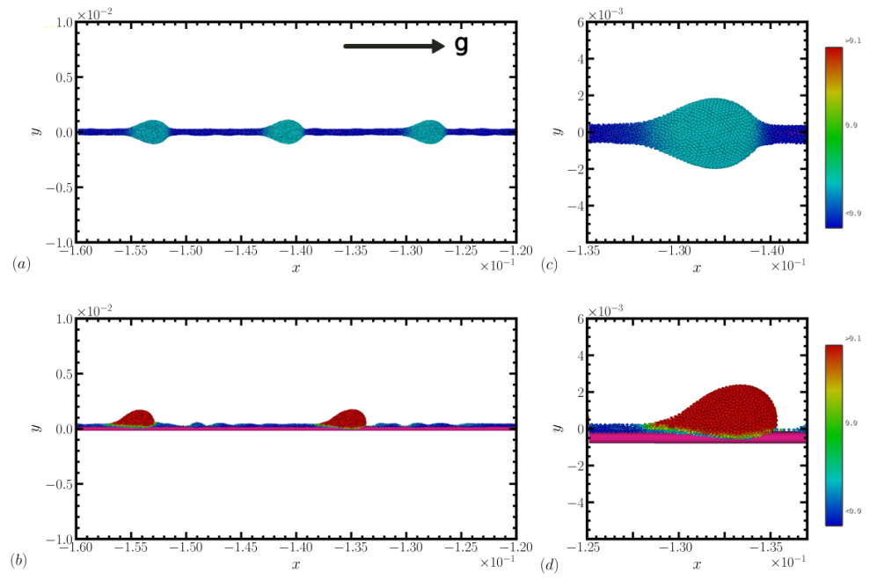
The impact of fiber diameter and surface tension on the bead symmetry is in agreement with the experimental observations of Gabbard & Bostwick [9]. We showed that (i) under constant fiber diameter, the transition from symmetric to asymmetric instability takes place as the surface tension increases while (ii) under constant surface tension, the transition from symmetric to asymmetric states occurs as the fiber diameter increases. In cases of small fiber diameters, only symmetric formations appear, which is consistent with the experimental observations, see [9-10].

Conclusions
The main purpose of the work was to study the wavy formations of the flow field during the coating process of fiber using the ANSA SPH solver. The results are in qualitative agreement with experimental data.

References
[1] Koschier, D., Bender, J., B., & Teschner, M. (2020). https://doi.org/10.2312/egt.20191035
[2] Nair, P., & Pöschel, T. (2018). Chemical Engineering Science, 176, 192–204. https://doi.org/10.1016/j.ces.2017.10.042
[3] Duprat C., Ruyer-Quil C., Kalliadasis S. and Giorgiutti-Dauphiné F. (2007) “Absolute and convective instabilities of a viscous film flowing down a vertical fiber” Phys. Rev. Let., 98(24). https://doi.org/10.1103/PhysRevLett.98.244502
[4] Gabbard, C. T., & Bostwick, J. B. (2021) Physical Review Fluids, 6(3). https://doi.org/10.1103/PhysRevFluids.6.034005
[5] Lucy L. B. (1977) “A numerical approach to the testing of the fission hypothesis” Astron. J., 82, 1013. https://doi.org/10.1086/112164
[6] Akinci N., Ihmsen M., Akinci G., Solenthaler B. and Teschner, M. (2012), “Versatile rigid-fluid coupling for incompressible SPH”. ACM Trans. Graph., 31(4), 1–8. https://doi.org/10.1145/2185520.2185558
[7] Tartakovsky A. M., and Panchenko A. (2016), “Pairwise Force Smoothed Particle Hydrodynamics model for multiphase flow: Surface tension and contact line dynamics”. J. Comp. Phys., 305, 1119–1146. https://doi.org/10.1016/j.jcp.2015.08.037
[8] Morris J. P., Fox P. J. and Zhu Y. (1997) “Modeling Low Reynolds Number Incompressible Flows Using SPH”. J. Comput. Phys., 136(1), 214–226. https://doi.org/10.1006/jcph.1997.5776
[9] Kiakhandlerl I. L., Davis S. H., and Bankoff S. G. (2001), “Viscous beads on vertical fiber. J. Fluid Mech. 429, 381–390. https://doi.org/10.1017/S0022112000003268
[10] Gabbard C. T. and Bostwick J. B. (2021), “Asymmetric instability in thin-film flow down a fiber”. Phys. Rev. Fluids 6, 3. https://doi.org/10.1103/PhysRevFluids.6.034005

