An Approach for Automated Hex Meshing of Complex Engineering
Shakeel Seebooa
(ITI, United Kingdom)
Abstract
High-fidelity analysis, such as non-linear contact analysis, necessitates the use of high-quality structured hexahedral meshes. However, the creation of these meshes represents a significant challenge within the design to simulation cycle. The difficulty involved in producing highly structured hex meshes often becomes a critical bottleneck. The guarantee of a high-quality mesh structure typically relies on labour-intensive manual partitioning of the model. To streamline this process and reduce the reliance on manual intervention, we have developed a suite of automatic and semi-automatic tools designed to efficiently partition complex models into smaller, more manageable regions that are suitable for hex meshing. This advancement aims to significantly reduce the manual steps traditionally involved in the meshing process, thereby enhancing efficiency and effectiveness in simulation preparation.

Geometry Partitioning
Geometry partitioning is an important step in transforming the model into a cellular structure optimised for sweep meshability. The automatic partitioning tools detect geometric features, concavities in particular, that require subdivision and execute the necessary splits. Concavities within a model often provide ideal starting points for initiating splits that partition the model effectively. The deployment of the automatic and semi-automatic partitioning tools leads to a systematic segmentation of the model which results in partitions which are either ready for hex meshing or significantly simplified and ready for further partitioning.
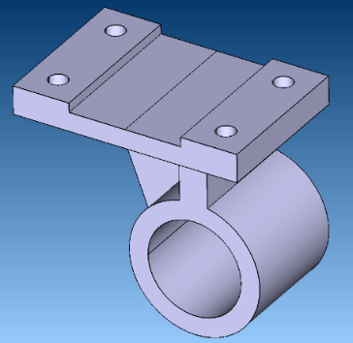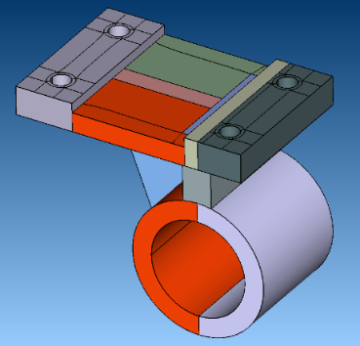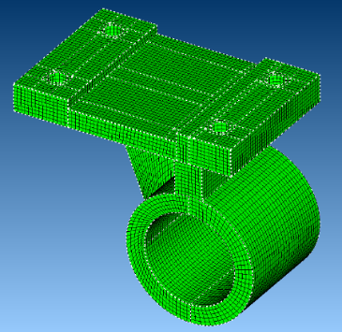
- Automatically identify features, create splitting geometry, partition and mesh.

To ensure a conformal mesh, the partitions are held as a non-manifold cellular model, where the splitting geometry forms the shared faces between the components.

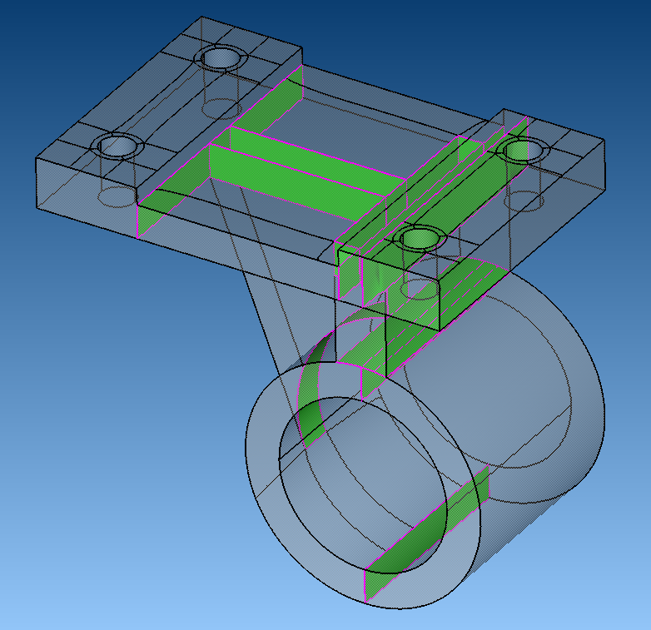
- Non-manifold cellular model with shared faces.

Loops
An automatic split is generated around a closed or semi-closed loop of concave edges.

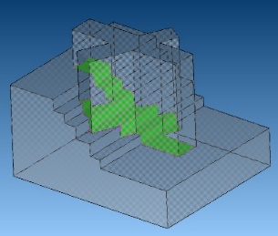
- Closed loops identified and splitting geometry created automatically.

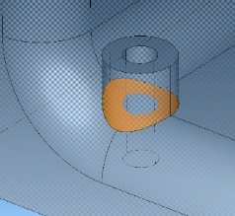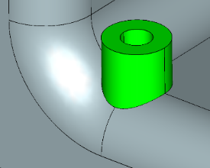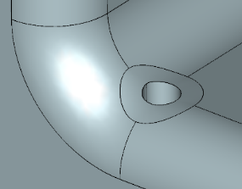
- Intersections are automatically detected and resolved.

3D Medial Axis
The medial axis technique enables the 'parameterisation' of the volume within boundary representation (BREP) models. This process facilitates the identification of optimal seeds for initiating splits, while also automatically detecting and rectifying near misses. The incorporation of this smart snapping technology is essential for preventing sliver partitions, which can significantly compromise mesh quality.

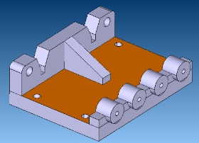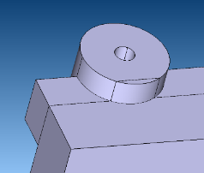
- Misalignments can result in poor quality partitions.

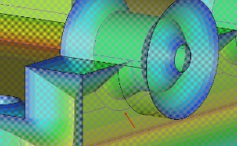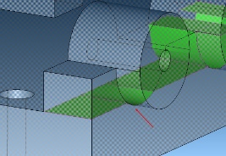
- Smart snapping technology automatically detects and resolves misalignments

Quad-Splitting
Following the division of a model into sections ready for sweep meshing, creating a compatible structured quad mesh on the template surfaces of these sections is essential. Traditional quad meshing techniques like pave meshing, 2D medial axis rail tracks, and Crossfield methods each present unique difficulties, such as boundary layer issues, expansion factor inconsistencies, and challenges with singularity placements. In response, we've developed a new quad splitting algorithm named Singularity Cages, which merges the best features of Crossfield and medial axis methods. This algorithm is tailor made to form a buffer zone around face boundaries to ensure mesh elements are perpendicular, strategically localise singularities for enhanced structure in distant areas, and effectively link singularities to eliminate spiralling and resolve mesh sizing issues.

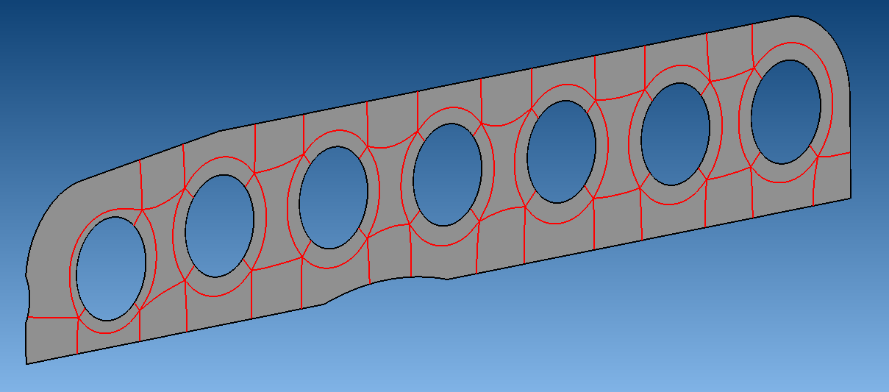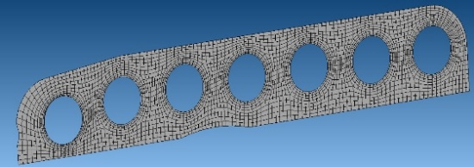
- Example of a singularity cage partitioning with a buffer zone for mesh alignment with the holes, and connected and localised singularities for an efficient mesh.

Introduction of Mesh Recipe Technology
Given a partitioned model there still remain two significant challenges to generating a hex mesh: mesh sizing and mesh generation in a highly non-manifold cellular model. To tackle this, a new orchestrating technology has been developed based on a SQL-like approach that supports very flexible mesh sizing variations across a model, coupled with automatic sequencing of the mesh generation process. The complete sizing and generation logic can be recorded as a meshing recipe for further tuning or re-used on other similar models.

Mesh sizing
Finally, the crucial topic of determining appropriate mesh sizing from geometric features, attributes, and model metadata with minimal user input is addressed with recent advances in a new “mesh recipe” technology that enables localisation of mesh properties across a model via a rich model-aware query language and supports hex mesh generation within an automatic simulation workflow.

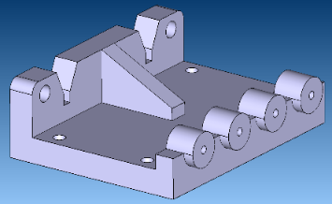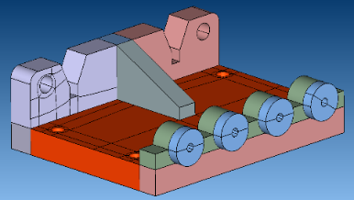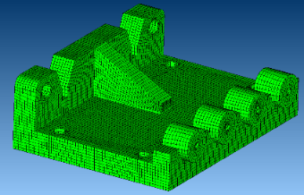
- Same mesh recipe as fig 1 applied.

Mesh generation
To facilitate hex mesh generation across a non-manifold assembly of sweepable bodies, it's crucial to match edge divisions with specific constraints, such as ensuring opposing sweep wall faces have matching element counts. This alignment, achieved through integer programming solver, is essential for mesh quality, promoting uniform distribution and right angles at face boundaries. Sweep meshes are created sequentially, with each body's mesh potentially serving as the template for the next, necessitating multiple meshing rounds until completion. Additionally, any cycles in swept bodies, where a body's template depends on its target, are specially managed.

Conclusion
This work has introduced a suite of automatic and semi-automatic tools designed to streamline the labour intensive task of highly structured hex mesh generation. By intelligently partitioning complex models into smaller, more manageable regions suitable for hex meshing, we significantly reduce manual intervention. The tools have been developed on the CADfix platform.

References
[1] | T. Blacker and R. Meyers, "Seams and wedges in plastering: A 3-D hexahedral mesh generation algorithm," Engineering with Computers, 1993.
[2] | L. Maréchal, "Advances in Octree-Based All-Hexahedral Mesh Generation: Handling Sharp Features," in 18th International Meshing Roundtable, Salt Lake City, Utah, 2009.
[3] | Y. Li, Y. Liu, W. Xu, W. Wenping and G. Baining, "All-Hex Meshing using Singularity-Restricted Field," in Proceedings of ACM SIGGRAPH Asia 2012, 2012.
[4] | H. Blum, "A transformation for extracting new descriptors of shape," Models for the perception of speech and visual form, 1967.
[5] | T. Robinson, R. Fairey, C. Armstrong, H. Ou and G. Butlin, "Automated Mixed Dimensional Modelling with the Medial Object," in 17th International Meshing Roundtable, 2008.
[6] | M. Price and C. Armstrong, "Hexahedral mesh generation by medial surface subdivision: Part II. Solids with flat and concave edges," Numerical Methods in Engineering, 1997.
[7] | W. R. Quadros, "LayTracks3D: a new approach to meshing general solids using medial axis transform," in 23rd International Meshing Roundtable, London, 2014.
[8] | J. Bucklow and R. Fairey, "CFD Meshing By Automatic Partitioning With The 3D Medial Object," in NAFEMS World Congress, San Diego, 2015.
[9] | J. Bucklow, 3D medial object computation using a domain Delaunay triangulation, 2014.
[10] | International TechneGroup Ltd, "CADfix: CAD translation, healing, repair, and transformation," 2018. [Online]. Available: http://www.iti-global.com/cadfix/.
[11] | Fogg, Harold J. & Sun, Liang & Makem, Jonathan & Armstrong, Cecil & Robinson, Trevor. (2018). Singularities in structured meshes and cross-fields. Computer-Aided Design. 105. 11-25. 10.1016/j.cad.2018.06.002.
[12] | Fogg, Harold J. & Armstrong, Cecil & Robinson, Trevor. (2014). New Techniques for Enhanced Medial Axis based Decompositions in 2-D. Procedia Engineering. 82. 10.1016/j.proeng.2014.10.381.

