The Elements of Simulation
Dr. T Elson
Element Digital Engineering
Abstract
With developments in commercial software and computing power, simulation is becoming increasingly ubiquitous. The challenge now is not just being able to conduct a simulation, but also how to choose the right fidelity simulation to answer the right questions. This will become more important as the popularity of data science methods, such as artificial intelligence and machine learning, grow. This will necessitate effective use of simulation to harness the power of both disciplines to accelerate product development.
Element Digital Engineering have many years' experience using simulation for a range of problems in a range of industries. This includes the early adopters such as Aerospace and Nuclear, and the relatively more recent Oil & Gas and Food industries. All of whom use simulation in different shapes and forms. This variety of experience provides Element Digital Engineering with a unique perspective on the implementation, power and pitfalls of simulation.
The paper will focus on computational fluid dynamics and heat transfer applications as the vehicle to demonstrate the key arguments. Firstly, is a discussion on the relative merits and limitations of 1D hand calculations, computational analysis and experimental test campaigns and how they can work in harmony together. With simple examples, it's highlighted how parametric and topological optimisation can be used to accelerate through a design space to speed up development times. Then, the paper demonstrates that 3D simulation can be used to augment wider 1D system simulations and how machine learning can aid this. Finally, it's shown there can be a benefit for the appropriate high-fidelity model, providing unique insights and interactions of the key physics involved.
Ultimately, this paper aims to inform the reader of the wide applications possible for simulation and how to utilise it. This is articulated through the lens of computational fluid dynamics and thermal systems design.

Extended Abstract
Computational Fluid Dynamics has progressed from its genesis of Lewis Fry Richardson’s weather prediction methods to Fortran punch cards of potential flow solutions all the way to today’s high fidelity simulations of whole products augmented by machine learning.
Simulation methods are now ubiquitous in many engineering processes and this uptake in usage and computing power has changed the landscape in how to effectively use simulation. It is now a case of not just being able to conduct simulations, which used to be the proviso of dedicated mathematicians and software developers, but how to use them effectively to maximise its usefulness to minimise product development times. This is especially important today with the roaring popularity in Machine Learning and Data Science methods. A clear strategy of what methods are available and beneficial is therefore critical.
This presentation utilises the Author’s and Element Digital Engineering’s vast and varied experience in using CFD across a number of industries including Oil and Gas, Aerospace, Nuclear, Consumer products and the ever growing usage in the Food and Drinks industry. The applications discussed are not limited to heat transfer and thermal design challenges but are used as a vehicle to demonstrate the key concepts.
Before delving into how to effectively implement a simulation strategy, the relative merits of 3D simulation methods such as CFD versus experimental test campaigns and 1D hand calculations are discussed.
Relative merits of simulation, experimental campaigns and 1D tools
Experimental testing can provide huge value at various stages of the product life cycle and can provide the most accurate snapshot of the real world physics. An additional benefit is the process of designing and conducting an experiment requires real thought and this can directly benefit the design process. The drawbacks of experiments are typically the time and cost to conduct them, facility costs, staff training and measurements points are often limited and intrusive – especially in fluid mechanics and heat transfer.
Particularly in the design of heat exchangers, 1D hand calculations are often used. The advantage of these include their flexibility, turn around time to evaluate different designs and, in the process of developing these methods, forcing an understanding of the key physics and equations. The drawbacks include version control issues, additionally if the tools are already developed the user can be remote from the key physics and their application can be limited to similar designs in which the original correlations were developed for. This can limit their applicability for new and novel designs configurations.
The key advantages of simulations include the insight into the key physics, the variety of physics available, design optimisation and constituting part of a wider system model. The disadvantages are the required user knowledge and training to ensure model quality. A confidence on the output of the models must be gained, which is usually based on benchmark test data or reference calculations.
Physics Insight
The insights gained from a simulation can be pivotal in accelerating product development and can be a powerful tool for communicating key physics to personnel with different expertise. To highlight this point a simple example of a plane fine heat sink is used.
These would typically be designed using a 1D sizing tool where the constraints are a balance of mass, heat duty, space envelope and pressure drop. However, if simulation is used, the design can be both optimised for those parameters and post processed to provide valuable insight.
With reference to Figure 1, which has two images. The image on the left shows the total pressure field on a plane highlighting entrance and exit effects, which are a key contributor to the pressure drop - also evident is the viscous boundary layer. The image on the right displays contours of the local heat transfer coefficient and its variation highlights that the mean heat transfer coefficient is an approximation. This variation is due to localised physics such as flow impingement and the development of 3D vortical structures due to edge separation. The postprocessing is a clear example how the key physics can be clearly visualised and understood, which would be harder to articulate with a test campaign or 1D sizing tools. The full presentation also extends this point, visualising the effect of thermal conductivity on the fin efficiency due to thermal resistance effects.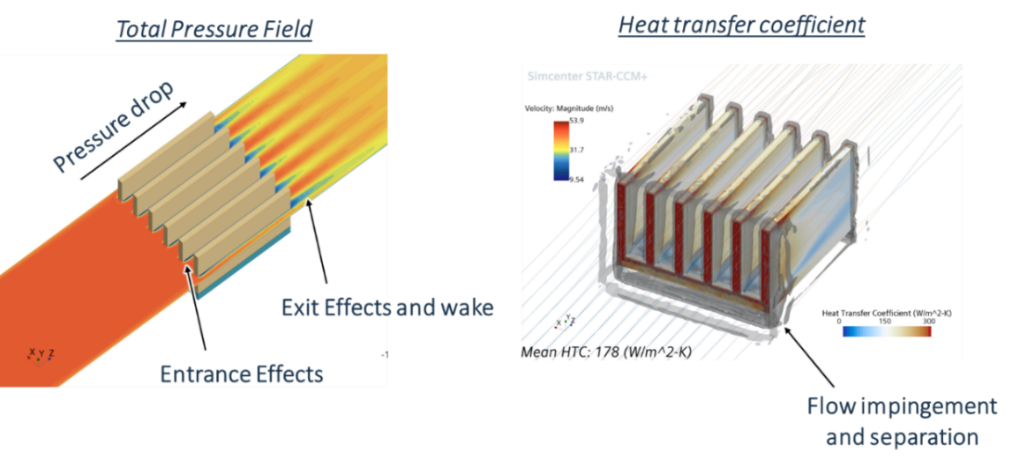
- Physics insights gained from CFD analysis of a plane fin heat sink
Design Optimisation
Another application of simulation is for design optimisation studies. This generally comes in two forms: parametric and topological. Parametric optimisation allows to sweep through the likely geometric dimensions and conditions to find the optimum combination. For the simple plane fin heat sink example this would be the fin number, height, thickness, pitch, length and material for example. A typical process would be to perform a relevant Design of Experiments (DoE) architecture to sweep through the parameters and then generate a response surface. The response surface is then used to calculate the optimum combination of parameters which meet the design goals.
The plane fine heat sink example is a dummy model to demonstrate key concepts. A real life scenario for an aerospace application is presented, where space and mass are critical so heat transfer surface optimisation is a massive benefit. The first step was a validation campaign to give confidence in the methodology across a range of Reynolds numbers. Then a parametric DoE was used to optimise the Darcy friction, f, and Colburn, J, factors based on the surface geometric parameters. Example results are presented in the surface response map in Figure 2.
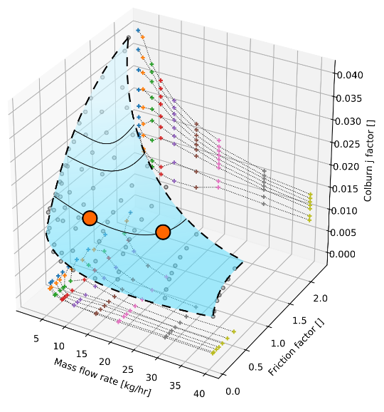
- Example of a response surface from a heat transfer surface optimisation study
Topological optimisation does not require predefined surface parameters but uses the solution residuals based on key observables to suggest an optimal design. Mesh morphing can be used to evaluate its effectiveness. This process is iterated until an optimal solution is found. An example topology optimisation of a flow manifold is presented to show its power – particularly if using 3D printing methods to fabricate the solutions. Topology optimisation can also be used to add the finishing touches to a design where the local optimum was found by a parametric optimisation.
Augmenting System Models
For many applications particularly with regards to heat transfer and HVAC systems, system models are of major benefit to the design process with their flexibility and turnaround times. However, they can benefit from CFD - for example, heat transfer components will often need a heat transfer coefficient and fluid streams often require pressure drops. Bespoke CFD sub models are ideal ways of doing this in the absence of test data or literature for new designs.
Another alternative is to make use of Machine Learning, where snapshots of the flow solution are taken and methods such as singular value decomposition are used to create a Reduced Order Model. This Reduced Order Model can then be exported as a Functional Mock Up Unit (FMU) and integrated into the larger system models to provide higher resolution data than correlations, which are typically mean values.
A similar benefit is to use complex system models to drive the inputs of a CFD model using an FMI co-simulation leveraging the wider system knowledge of key inputs with the detailed physics of a 3D CFD simulation.
High complexity models
Finally, some example cases are presented where simulation is used to tackle complex geometries and physics. This can be used to augment test campaigns and highlight the key interactions between components which can often be missed out when linking idealised components together in big system models.
Conclusions
These are all possible strategies engineers can use to harness the power of simulation to accelerate product development. Different companies will have different requirements and uses for it – but most can benefit in some way from an effective simulation strategy.

