The Current Challenges and Benefits of Continuous Data Management
Risikesan Mahendran
(Dassault Systemes, United Kingdom);
Abstract
One of the prominent industry challenges is managing data generated by many engineers using different tools and systems. Generally, businesses need to manage versions, revisions, configurations and alternatives of design and simulation data generated throughout a product’s life. It can be invaluable to undertake simulation throughout the design process; the final product may be only one of many analysed variants. However, incorporating change and reusing simulation processes can be challenging in many conventional tools. Managing native and third-party simulation data and processes in different systems brings further challenges. Disconnected simulation data management leads to a lack of traceability: managing versions, revisions, configurations, and alternatives becomes problematic. A unified data management tool can improve engineering efficiency, leading to significantly shorter design cycles, fewer iterations, and fewer errors. The complete traceability of design and multiscale simulation data throughout the product lifecycle is critical to success.
The 3DEXPERIENCE Platform, which has a single source of truth for engineering data, will allow concurrent design and simulation. Individual engineers and teams will have the tools and methods to efficiently find and retrieve the data relevant to their activities. Streamlined communication is established on the data and models between stakeholders, achieving full digital traceability. In any such framework, it is essential to integrate existing processes and bring in data, geometry, models, etc., from various third-party commercial and bespoke solutions, thus connecting all stakeholders and ensuring efficient collaborative engineering.
This paper will share our practical lessons in implementing a continuous data management platform.

Industry Challenges and Benefits
In many discussions with clients and customers, we hear the same pain point articulated repeatedly when data is generated by many engineers using many different tools and systems. Having the right tools to find and reuse this data meaningfully is critical. Generally, customers need help managing versions, revisions, configurations, and alternatives generated throughout a product's life. The final product is almost certainly only one design that was analysed. While other variants might have been rejected for some reason, the work that went into them might still be invaluable when working on future products. It would not be wise to lose all that to the annals of time. Creating a simulation model and ensuring it is robust takes time and effort. It is inefficient if all that effort needs to be repeated when the underlying model or configuration is changed. However, in many conventional toolchains, taking those changes into account and reusing the downstream simulation process can be challenging.
We address all of these challenges with the solution that we are proposing here. The benefits would be improved engineering efficiency, leading to significantly shorter design cycles, fewer iterations and fewer errors in the process. The complete traceability of design and multiscale simulation data throughout the product lifecycle is vital. Any proposed changes need to be tracked so that we know exactly why certain design decisions were made. This is crucial for regulatory compliance and gaining knowledge for the future. The industry challenges and the benefits of Continuous Data Management are summarised in Table 1.
Table 1 Continous Data Management Industry Challenges and Benefits
Industry Challenges | Benefits
Managing native and 3rd party multi-scale simulation data from different systems | Improved engineering efficiency  - Shorter design cycle iterations and fewer errors
Managing versions, revisions, configurations and alternatives | Make better-informed decisions  - Full traceability of design and multiscale simulation data back to requirements and test plan
Poor collaboration between Design and Simulation teams (for example, Inefficient design reviews and re-integration) | More effective and efficient change management process  - Increased ability to assess the multi-disciplinary impact of proposed design changes
Let us consider a simplified engineering process, as shown in Figure 1. At the beginning, we had the program manager, who was responsible for the smooth operation and overall execution of the program. Then, a Model Manager manages the simulation model environment, such as a specific product or CAD geometry. This model is then distributed to the various departments that work in parallel, ensuring that the product performs well in their respective discipline. The analysts would set up highly specialised simulation models to answer specific questions and meet all KPIs. They would also execute the analysis and give corresponding feedback to the Release Engineer. The Release Engineer would be responsible for consolidating all the design changes proposed by the various disciplines. For example, a Structural Analyst might propose stiffening up a product's housing to ensure it doesn’t deform in operation. The Program Manager will sign off on all those design changes and the overall project at the end of the process.
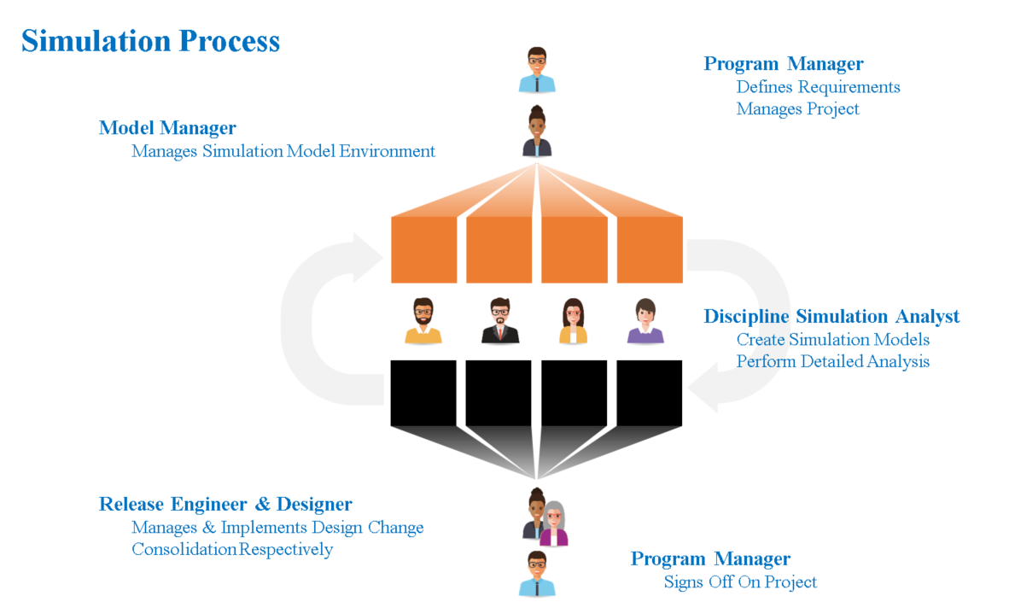
Figure 1 A Typical Simulation Process
The As-Is scenario in many companies is shown in Figure 2. All the various stakeholders are siloed and exchange data through conventional means such as geometries sent by email or simulation data stored on network drives. There is limited traceability, and different people are likely to work on disparate data versions that are only partially in sync. In contrast with the 3DEXPERIENCE platform, communication between stakeholders is streamlined, traceability is ensured throughout, and everyone can work on live, up-to-date data & models. The 3DEXPERIENCE platform is also open to integrating into existing processes and bringing data, geometry, models, etc., from various third-party commercial and non-commercial solutions.
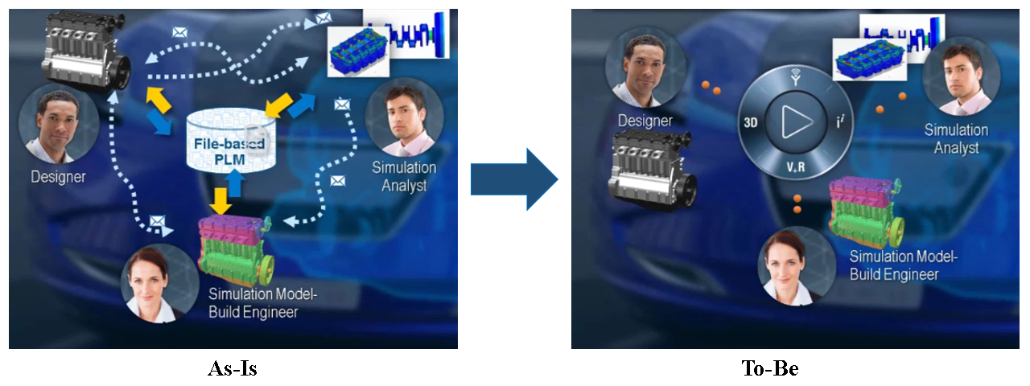
Figure 2 The As-Is and To-be Scenario.

Model Configuration (Part Selection) and Simulation Model Environment Creation
Managing different configurations of products, systems, and subsystems is essential. An example of a simple electric motor with two variants (8-slice and 4-slice) is shown in Figure 3. Both variants have a variety of standard components that are used across both variants. Specifically, the two variants differ in their rotor design. Setting up these configurations is relatively straightforward for such a simple assembly. Still, it can become involved and more complicated for large systems. That said, the analyst will typically not have to worry about creating the configurations; they can easily switch between different model configurations in 3DEXPERIENCE, as shown in Figure 4. Filters make it easy to narrow down the product tree, which contains all the parts of all configurations. A further important step in creating a simulation model environment is the model simplification. Depending on the analysis, the analyst can reduce the model complexity without adversely affecting the accuracy of the simulation, for example, by removing bevels and small features that significantly increase the mesh size without making much difference to the analysis.
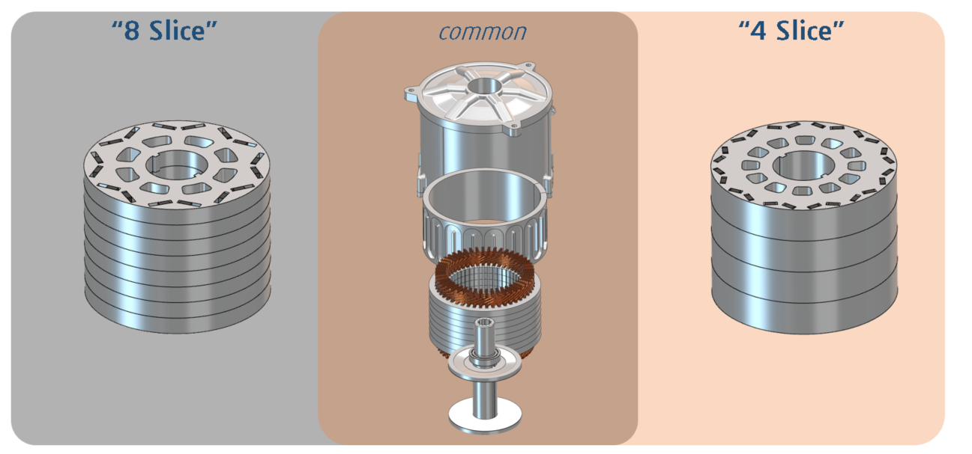
Figure 3 Different Configurations
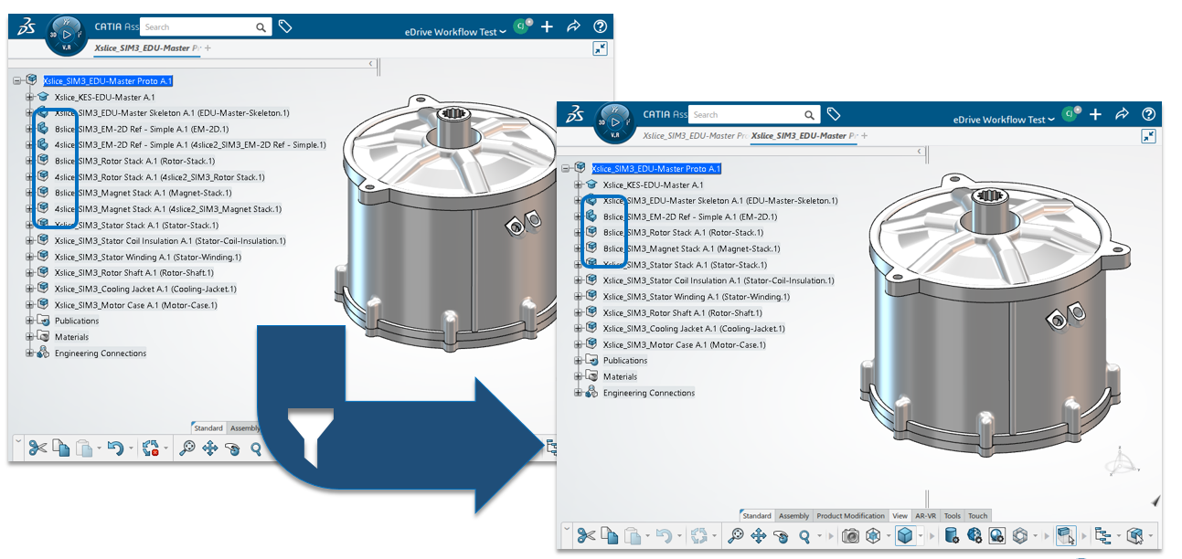
Figure 4 Different Model Configurations
As mentioned, different models with different degrees of simplification can be created for various disciplines. The respective Simulation Analysts might do additional fine-tuning of the model simplification and then set up the full simulation models.
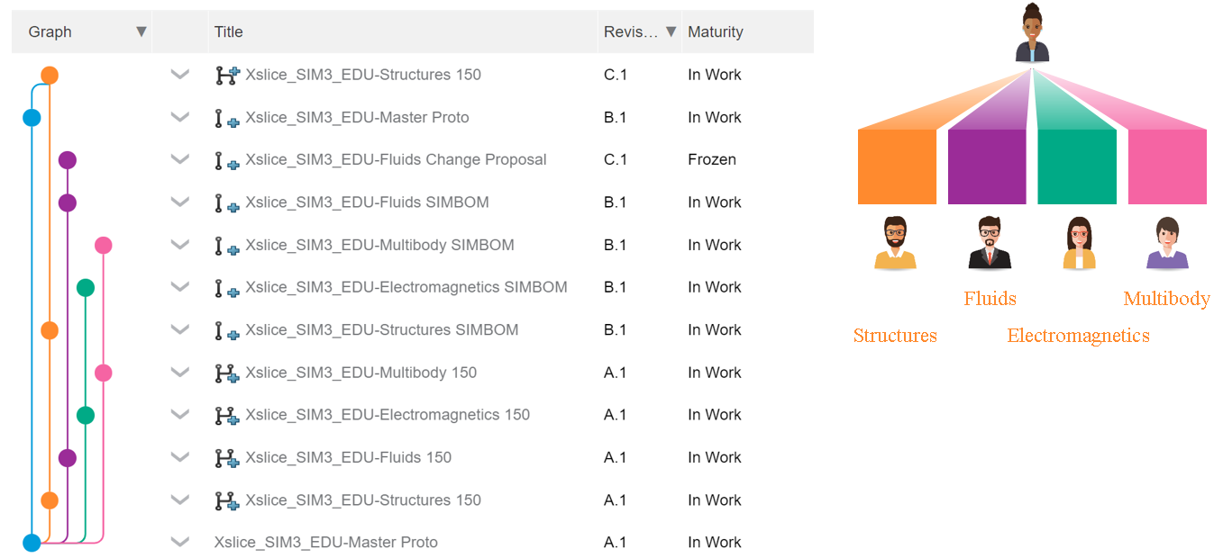
Figure 5 Configuration Management
Figure 5 shows the Configuration Management application's so-called subway rail track chart. In blue, the master model has been finalised. Branches of the model are created for the various domain groups to work on. The analysts on the multiple tracks can now work and execute their highly specialised analysis on their own branch without adversely affecting anyone else. The analysts can generate revisions and test different changes needed to meet their respective requirements, all the way to a product that satisfies all of their needs and is ready to be released. Any changes to the master model can be propagated into the individual tracks, allowing changes to be taken into account without having to repeat the entire simulation process again from scratch. Changes in the domain branches can also be fed back into the master model.

Design Change, Review & Proposal
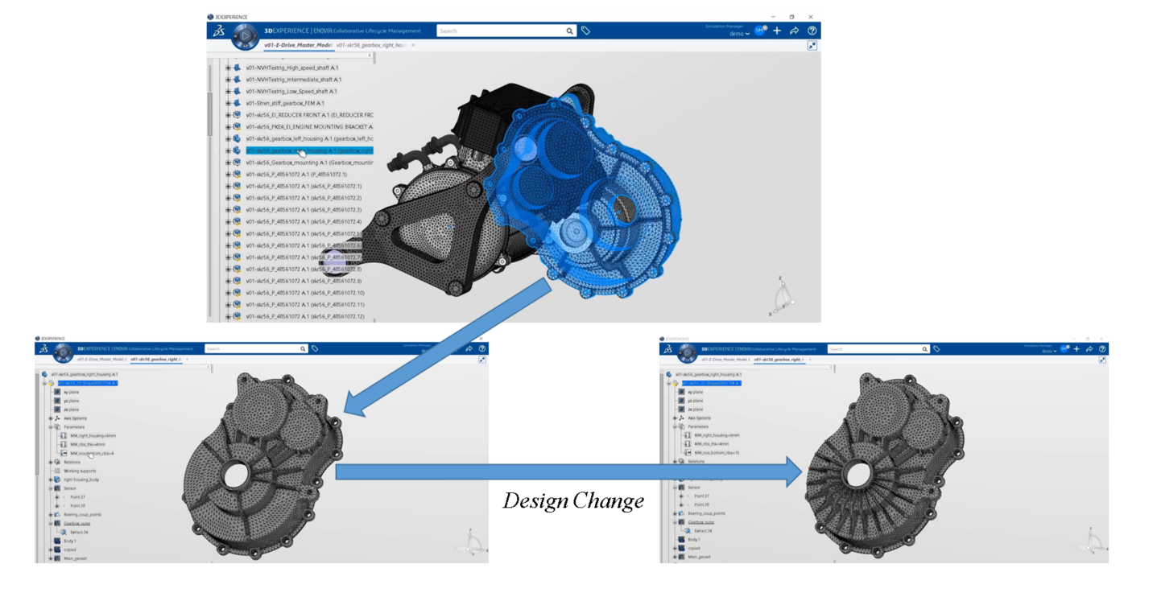
Figure 6 Proposing a Design Change
So, different disciplines test and analyse the product with their physics requirements in mind. For example, an electric drive assembly, shown in Figure 6, shows that after the structural analysis, the analyst determined that the housing was not stiff enough. The analyst tested the product with various configurations of the ribs and determined that more ribs are needed to fully satisfy the strength and stiffness requirements.
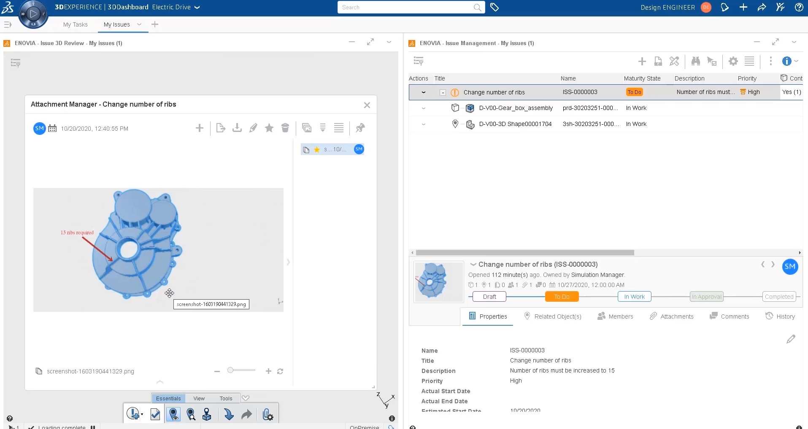
Figure 7 Issue Management Application
An issue is created using the Issue Management application, shown in Figure 7, directly referencing the native 3D model with full corresponding traceability. The issue can be embellished with additional information, comments, annotations or attachments to ensure all the relevant information is shared. Upon creation of the problem, a notification is sent to the respective Release Engineer or Product Owner, and they can now directly open the issue and view it in conjunction with the underlying model to fully understand what the problem is and how the analyst suggests solving the problem, in this case by increasing the number of ribs.
Each discipline will likely make change requests and proposals based on the simulation results. These design changes might not affect other system parts, but some might directly conflict with other change requests. The Release Engineer or the Product Owner can consider all these change requests and combine the design proposals seamlessly within 3DEXPERIENCE to generate a finalised model that satisfies all domain-specific requirements.
This final model is usually sent to the domain specialists for final validation. Assuming everything goes according to plan, we now have a fully featured and operational electric drive assembly that satisfies all the domain-specific requirements that were set out initially.

Summary
This paper describes the challenges and benefits of Continuous Simulation Management and how the 3DEXPERIENCE Platform can be the single source of truth for engineering data during concurrent design changes and simulation studies.

