Advancements in Computational Fluid Dynamics: An Exploration of GPU Solver Capabilities in Gas Turbine Combustion and Turbomachinery applications
George Klavaris, Yu Xia
(Ansys UK Ltd., Springfield House, Horsham RH12 2RG, United Kingdom)
Abstract
The present study highlights performance evaluations of the GPU-based Ansys Fluent™ solver, providing detailed Verification and Validation (V&V) efforts on computationally demanding test-cases in the fields of Gas Turbine Combustion and Turbomachinery. These evaluations have been performed on the DLR PRECCINSTA burner (a gas combustor model with characteristics designed to mimic industrial power generation combustors), and the Purdue GUIde-3 axial compressor. Simulations were conducted in both steady-state and transient-state unveiling the full potential of the new GPU solver which is verified against solutions from the flagship Fluent-CPU-based solver and validated against experimental data. A notable highlight is the GPU solver's acceleration potential. This breakthrough not only underscores the solver's computational efficiency but also opens new frontiers for high-fidelity CFD simulations on levels of mesh refinement previously considered impractical on CPU-based platforms.

Introduction
The escalating demand for faster solutions for complex scientific and engineering problems within Computational Fluid Dynamics (CFD), is driving the development of numerical methods that leverage modern computer hardware. While traditional methods for simulating fluid flows relied on vector and parallel CPU architectures, the advent of GPU computing marks a transformative era, promising throughput boosts for CFD simulations. Motivated by the pursuit of enhanced computational efficiency, the native-GPU implementation of Ansys Fluent CFD solver is at the forefront of this revolution. This development effort is underpinned by extensive testing and validation to meet the quality standards set by the flagship Fluent-CPU-based solver. This paper aims to assess the accuracy and performance of the Ansys native-GPU solver for CFD applications. Focusing on industrial test-cases involving turbomachinery aerodynamics and combustion modelling, the study seeks to verify the Fluent-GPU-based CFD code against its well-established CPU-based counterpart and explore the full acceleration potential that GPU solvers offer in terms of computational efficiency.

Numerical Setup
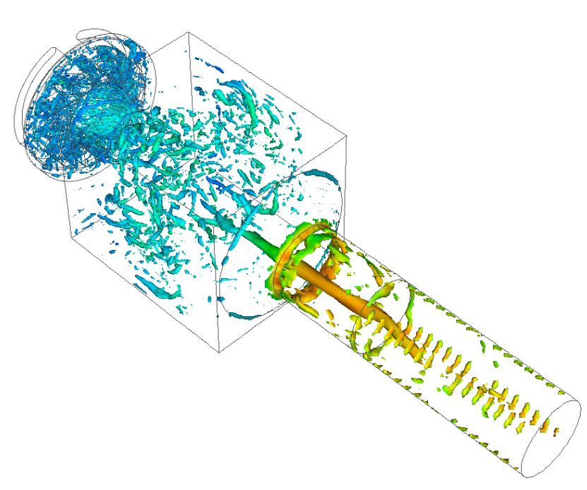
All simulations employed the pre-release version of Ansys Fluent 2024R2, utilizing the Pressure-Based Navier-Stokes (PBNS) solver with Finite Volume (FV) formulation for both steady and transient simulations. Steady simulations served as a precursor to transient simulations and provided an initial comparison between the GPU solver and standard CPU-based Fluent. The Coupled algorithm was used for coupling of the pressure-velocity equations and Least Squares Cell Based scheme for gradient computation. The governing equations were discretized using the 2nd Order Upwind scheme. Transient analysis employed the segregated algorithm (SIMPLEC) for pressure-velocity coupling, with 2nd order discretization in time.

GPU for Combustion
The DLR PRECCINSTA Burner [1] has been meshed using an octree approach, generating 1.7 million cells ranging from 0.5 mm to 2 mm. The burner uses gaseous methane (CH₄) as the fuel and is operated at 4 MPa. The air inflow has a mass flow rate of 0.2 kg/s, and an inlet temperature of 500 K, which is partially mixed with the fuel (0.0015 kg/s at 300 K) before ignition. Large Eddy Simulation (with WALE model [2] for sub-grid modelling) and Finite Rate Closure (FRC) model [3] are used for turbulence and combustion, respectively. The incompressible ideal gas law is used for the fuel/air mixture. The fixed time step is 1e-5 s, with 5 sub-iterations per time step. Figure 1 presents the flame and the turbulent structures in the entire combustor, both computed by Fluent-GPU. The flame surfaces and the turbulent eddies are all reasonable and well-captured by the GPU solver.
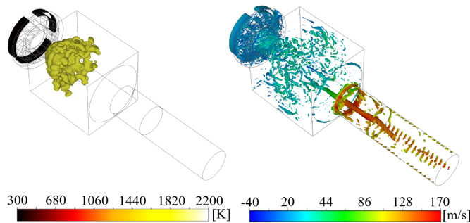
Figure 1: Flame structures (left, iso-surface of 1900 K and coloured by temperature) and turbulent structures (right, normalized Q-criterion of 1e9 and coloured by axial velocity), both computed by Fluent-GPU.
Figure 2 presents the radial profiles of the time-averaged axial velocity and temperature on the combustor’s mid-plane, compared between the Fluent-CPU and Fluent-GPU simulations. It is confirmed that both solvers give generally close results.
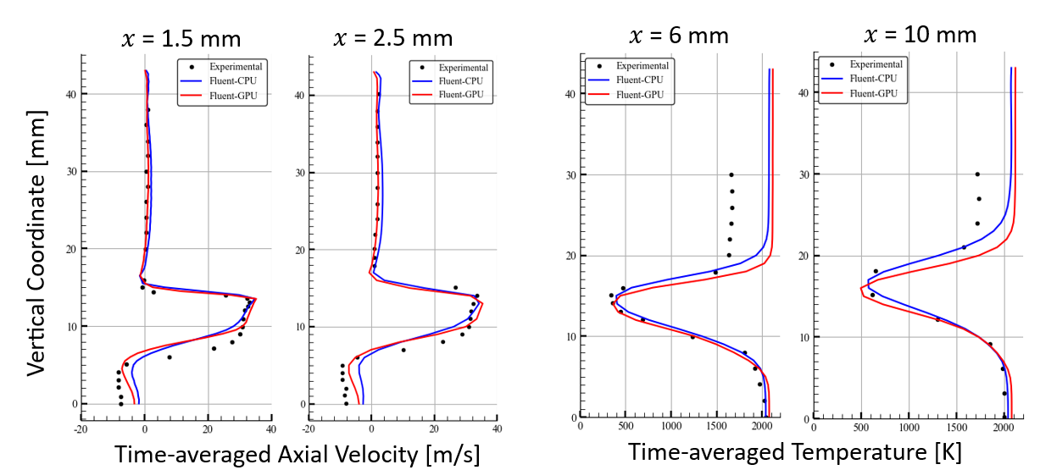

Figure 2: Time-averaged radial profiles of (left) axial velocity and (right) temperature, at different measurement locations, compared between Fluent-CPU (blue) and Fluent-GPU (red).

GPU for Turbomachinery
The study focused on the Purdue GUIde3 1.5stage transonic compressor described in [4], comprising 20 Inlet Guide Vanes (IGV), 18 Rotors (R1), and 16 Stators (S1). The computational grid, generated in Ansys TurboGrid™, comprised ~1.4M hexahedral cells per passage, totalling ~30M cells in a full-annulus configuration as depicted in Fig. 3. Flow was assumed to be fully turbulent and was modelled using the k-ω Shear-Stress Transport (SST) turbulence model by Menter [5]. Steady-state simulations utilized the frozen-rotor assumption while in transient simulations the sliding mesh technique was used in the rotating frames. Air properties with ideal gas law for density were assumed. Inlet boundary conditions were defined using total pressure and total temperature, while a static pressure boundary was specified at the outlet of the compressor. No-slip and adiabatic conditions were applied to all walls. The compressor operated at its maximum design speed of 20000 RPM. The approach used in the setup of turbo cases has been found previously to provide accurate results with Fluent CPU. As shown in Figure 3, the GPU results mimic the reference solution quite accurately.
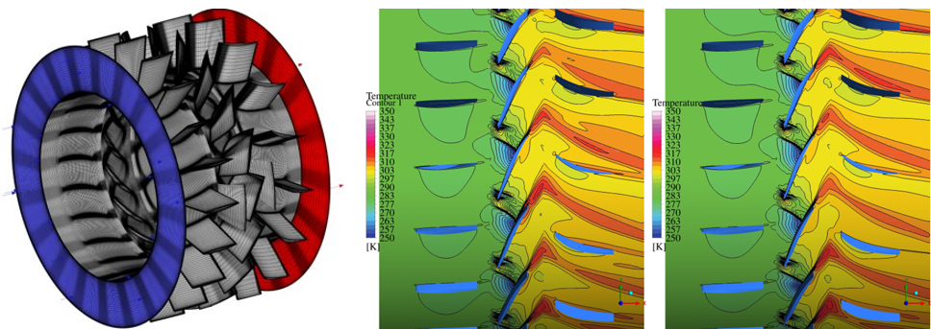
Figure 3: Compressor geometry and Temperature contours at 85% spanwise distance from the hub as obtained from steady-state simulations on the Purdue GUIde3 1.5 stage axial-compressor. Fluent-CPU based results (left) vs Fluent-GPU based results (right).
A quantitative analysis was also performed to prove the accuracy of the GPU solver. This is shown in Table 1, where important quantities of interest such as, surface integrals of the mass-flow rate at the outlet, the total-pressure ratio, and the isentropic efficiency were used as convergence criteria. The absolute difference signifies the minor discrepancies between CPU and GPU-based CFD solutions.
Table 1: Steady-state results comparison of Fluent-CPU and GPU at a single design point on the speedline of Purdue GUIde3 1.5 stage axial compressor (20000 RPM).
Solver | Mass Flow  [kg/s] | Total  Pressure Ratio | Isentropic  Efficiency
Fluent-CPU | 5.571 | 1.259 | 86.362
Fluent-GPU | 5.568 | 1.261 | 86.095
Diff [%] | 0.06 | 0.16 | 0.31
To assess the accuracy of the GPU solver transient simulations, static pressure integral at one of the rotor blades was monitored as shown in Figure 4. Spectral analysis was conducted using Fast Fourier Transform (FFT). GPU solution showed very close agreement with CPU, with both solvers being capable to identify dominant blade passing frequencies from pressure integral data, within a specified time-step window in the transient solution's converged range.
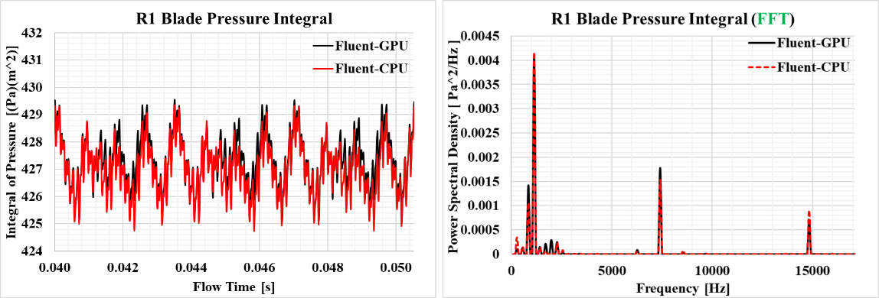
Figure 4: Left: Transient progression of mass-weighted average of static pressure integral on the rotor-blade surface. Right: Amplitudes of frequencies excited on the rotor blade, derived from the pressure integral and calculated for the time-step window shown on the left using FFT.

GPU Performance
All CPU-based simulations were performed on HPC clusters using Intel® Xeon® Gold 6242 @ 2.6GHz, whereas GPU-based simulations utilized the NVIDIA® A100 cards for the first case study and the NVIDIA® L40 cards for the second one. The GPU acceleration potential is shown in Table 2 where the Average Wall clock time per Iteration indicates the GPU speed-up compared to its CPU counterpart.

Table 2: Computational speed comparison Fluent-CPU and Fluent-GPU for the 2 cases investigated.
Case  Study | Mesh  Size | Solver  Accelerator | Average wall clock time per iteration [s] | Equivalent number of CPUs per GPU [-]
DLR-PRECCINSTA Burner | 1.8M  (Octrees) | $$128 × CPUs$$ | 1.598 |  | 129
 |  | $$1 ×A100 GPU$$ | 1.588 |  | 1
Purdue Compressor | 30M  (Hexes) | $$192 × CPUs$$ | 0.858 |  | 76
 |  | $$4 × L40 GPUs$$ | 0.568 |  | 1

Conclusions
This work highlights the significant advancements of Ansys Fluent™ GPU-based solver in CFD, particularly in gas turbine combustion and turbomachinery applications. Through detailed V&V efforts, it demonstrates the remarkable computational efficiency and accuracy of the GPU solver, validated against experimental data. The showcased GPU acceleration underscores the transformative impact of modern computing hardware on high-fidelity CFD simulations, paving the way for enhanced engineering design and analysis productivity in the era of GPU computing.

References
1. Meier W., Weigand P., Duan XR., Giezendanner-Thoben R. Detailed characterization of the dynamics of thermoacoustic pulsations in a lean premixed swirl flame. Combustion and Flame. 2007; 150(1–2). Available at: DOI:10.1016/j.combustflame.2007.04.002
2. Nicoud F., Ducros F. Subgrid-scale stress modelling based on the square of the velocity gradient tensor. Flow, Turbulence and Combustion. 1999; 62(3). Available at: DOI:10.1023/A:1009995426001
3. Ansys Fluent® Theory Guide. Canonsburg, USA: Ansys Inc. (2024); https://ansyshelp.ansys.com/account/secured?returnurl=/Views/Secured/corp/v241/en/flu_th/flu_th_chp_finrate_chemistry.html
4. Sanders AJ. Multistage interaction and transonic flow effects in a high-speed axial compressor. Purdue University; 1999.
5. Menter FR. Two-equation eddy-viscosity turbulence models for engineering applications. AIAA Journal. 1994; 32(8). Available at: DOI:10.2514/3.12149

