Coupled vibro-acoustic finite element analysis for the assessment of acoustic induced vibration in process equipment
Charles Barrell
(Element Digital Engineering, United Kingdom)
Abstract
Vibration and fatigue of process equipment was found to be responsible for approximately 20% of all accidental offshore hydrocarbon releases between 2001 and 2008. A major contributing factor to approximately 40% of these incidents was insufficient or inappropriate analysis or testing during the design phase. Acoustic Induced Vibration (AIV) is a safety critical consideration for process systems and is a particular concern when deploying pressure-reducing devices such as relief/safety/control valves and orifice plates. This paper outlines the findings from deployment and validation of a structural simulation framework for assessing acoustic induced vibration, conducted by Element Digital Engineering using coupled vibro-acoustic FEA simulation, extending beyond uncoupled methods from previous similar studies.
An acoustic and structural finite element model was constructed, with vibroacoustic fluid-structure interaction mapping between the two domains. A uniform acoustic load sweep was applied, corresponding to a PSV noise spectra characterized using appropriate valve noise codes, and the frequency response functions were scaled by the excitation power spectral density. Based on the predicted vibration and stress response, the fatigue life of the structure was then predicted through frequency domain fatigue methods. To validate the method, a published experimental case (GT2016-57800) was recreated, utilising captured PSV noise spectra and comparing header vibration strain responses and post-modification strain reduction percentages. This analysis was repeated for post-modification geometry to assess remediation efficacy.
Simulation outputs demonstrated close agreement with previously published experimental values for stress and strain measurements across the equipment. Post-design modification results again showed close agreement with the published experimental data on strain reductions. This demonstrates the feasibility of coupled vibro-acoustic simulation for the assessment of design, prediction of failure, and analysis of remediations when reviewing AIV.

Acoustic Induced Vibration
System vibration is one significant driver of damage and fatigue failure that must be considered during this design phase. Vibration and fatigue of process equipment was found to be responsible for approximately 20% of all accidental offshore hydrocarbon releases between 2001 and 2008 [1]. A major contributing factor to approximately 40% of these incidents was insufficient or inappropriate analysis or testing during the design phase [1].
Process system vibrations are typically characterized by either frequency or origin. High frequency vibration originating from within the flow is termed “acoustic induced vibration”, or AIV, and is typically produced by the rapid expansion and contraction of high-pressure vapour or gas flows when passing through pressure-reducing devices. Pressure fluctuations generate acoustic energy that propagates through the piping system, impinging on and exciting pipe wall structures. If excited at the local structure’s natural frequencies, resonance will occur, amplifying local stresses in stress concentrations around the structure, such as pipe fittings, connections and welds, resulting in damage and possible fatigue failure. For high pressure equipment used in the processing or transport of crude oil, natural gas, or potentially harmful chemicals, any such occurrence could present potentially catastrophic lethal, environmental, or financial consequences. AIV is therefore a safety critical consideration for process systems when deploying devices such as relief/safety/control valves and orifice plates.
Modelling and simulation can provide significant insight into the sources and propagation of such vibrations, and may be used to facilitate informed decisions on remediation strategies through exploratory design adjustments aimed at reaching desired durability goals. This paper outlines the findings from deployment of a structural simulation framework for assessing acoustic induced vibration using coupled vibro-acoustic FEA simulation, extending beyond uncoupled methods from previous similar studies. To validate the method, a published experimental case (GT2016-57800 [2]) has been recreated, utilizing measured PSV noise spectra, and comparing header vibration strain responses and post-modification strain reduction percentages.

Acoustic Energy Prediction
To assess acoustic-induced vibration through simulation, a prediction of acoustic energy and corresponding sound power level are required. Typically, quantifications of sound power sources can be generated from industry valve noise codes. The IEC 60534-8-3 method predicts a sound power level of 192 dB for the recreated case (GT2016-57800 [2]).
However, studies [3] in this area have found that PSV noise spectra are typically flat and broadband. IEC noise spectra would give accurate total acoustic power but inaccurate frequency composition and therefore spectra produced using this standard or similar methods are likely unsuitable for this specific application. In place of these spectra, total power has been used to derive a flat and broadband spectrum.

Vibro-acoustic FEA Simulation
An acoustic and structural finite element model was constructed, with a vibroacoustic fluid-structure interface defined at the interior wall boundary of the structural domain to facilitate the required two-way coupling between the fluid acoustic response model and the structural stress response model. Non-reflecting acoustic boundaries were implemented at both ends of the header in the acoustic domain. A noise source representing the pressure safety valve was applied at the end of the header tail pipe. A uniform acoustic load sweep was applied – power spectral density scaling corresponding to the pressure safety valve noise spectra characterized previously is then applied at the point of fatigue calculation.
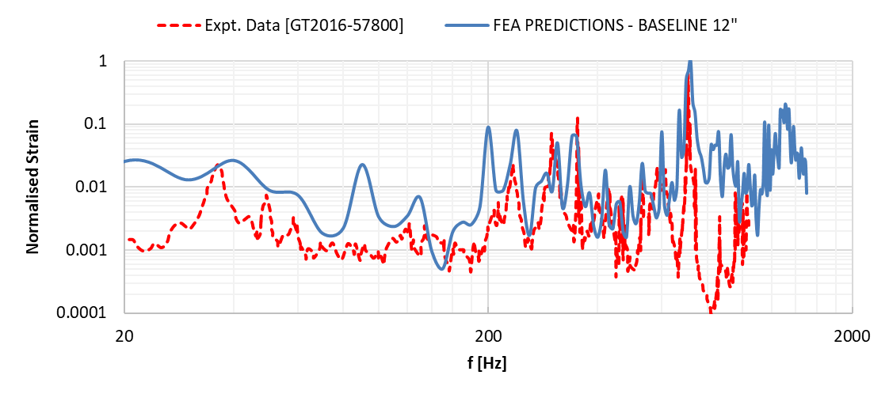
Figure 1 Normalised strain responses for experimental (red) and FEA (blue) data
Normalised experimental surface strain response measurements and normalised FEA equivalent strain predictions shown in Figure 1 demonstrated good agreement at peak resonance frequencies. Some discrepancies in results were deemed likely to originate from differences in sensor locations and strain normalisations. Header restraint condition differences may have also contributed to discrepancies at the lower applied frequencies. Both FEA and experimental data show significant low frequency responses, highlighting that AIV is not restricted to shell mode responses and may be accompanied by low frequency beam modes.
With the addition of stiffening clamps, the vibro-acoustic FEA model predicted an RMS strain reduction of 14.6%, showing good agreement with the experimentally derived result of 15.8% [2].

Fatigue Prediction
Following calculation of the harmonic response with a uniform load sweep, the results were scaled by the excitation PSD. In combination with an S-N curve for pipe welds exposed to air, the Dirlik frequency domain fatigue damage method was used with a 1-hour exposure duration to predict the fatigue life of the original and modified geometries. This method predicted a fatigue life of approximately 167 hours for the original geometry. With minor alterations to the FEA model made to reflect the addition of stiffening clamps, the fatigue life rose to 306.5 hours.

Conclusion
A vibro-acoustic finite element analysis model has been developed, recreating a published experimental case investigating acoustic-induced vibration in a 12 inch header resulting from gas venting through a pressure safety valve.
The simulation outputs closely matched previously published experimental strain measurements throughout the equipment. This alignment provided a deeper comprehension of the system's vibro-acoustic responses. A subsequent repeat of the analysis following design modification also exhibited a strong correlation with the experimental data, reaffirming the viability of deploying coupled vibro-acoustic simulations for assessing designs, predicting potential failures, and analysing remedial actions in the context of Acoustic-Induced Vibration (AIV).

References

[1] | Health and Safety Laboratory, “Offshore hydrocarbon releases 2001-2008,” 2008.
[2] | T. C. Allison and J. Bennett, “Acoustically Induced Vibration Mitigations in Compressor Piping Systems,” in ASME Turbo Expo 2016: Turbomachinery Technical Conference and Exposition, Seoul, 2016.
[3] | N. Evans, “Measurement of High Amplitude Relief Valve Noise for Acoustically Induced Vibration and Comparison to Predictive Methods,” in Pressure Vessels and Piping Conference, Anaheim, California, USA, 2014.

