Analysing Subsea Cables for Offshore Wind
EurIng Dr B.A. Lennon
(Cura Analytical Ltd, UK)
Abstract
The subsea cables are a major part of an offshore wind farm. The critical section for a cable is at its end where it meets an offshore structure. This section of cable is exposed on the seabed and is subjected to extreme dynamic loads from waves and currents.
Analysing the exposed section of a subsea cable requires a combination of modelling skill and engineering judgement. This presentation shares an overview of analysis this is specifically for the subsea cables for offshore wind farms, together with some thoughts about improving the analysis.

Overview of Subsea Cables
Subsea cables for wind farms are typically buried in the seabed for protection, except for the section nearest to the offshore platform or monopile structure. The cable enters the structure either via a J-tube or via a monopile hole. This section is exposed to wave and current between the seabed and the J-tube/ monopile hole. If rock dumping is used to provide scour protection around the monopile then the cable is left exposed on top of the scour protection layers and enters burial in the seabed beyond the end of the scour protection.
The exposed section of the cable is subject to impacts from dropped objects, wear against the seabed, and hydrodynamic loads. A cable protection system (CPS) covers the cable along its exposed length to protect it. The CPS typically carries most of the loads from waves and currents, and it protects the cable from overbending.
The focus of this presentation is on the global analysis of the combined cable-CPS system. This presentation shares an overview of analysis this is specifically for the subsea cables for offshore wind farms, together with recommendations and suggestions for producing good analysis.

Modelling Sub-sea Cables
Global analysis of cables and CPS requires appropriate models and simulations. Orcaflex (Orcina, 2023) is the de-facto industry standard for global analysis in offshore wind. The key components of the model are the cable and the CPS. All other parts of the model provide either loading or a boundary condition are not modelled as elements.
The Orcaflex model for the cable and for the CPS uses pipe segments (Orcina, 2023). These pipe segments are relatively simple beam-column elements with rotation springs at the nodes and axial springs at the mid-points. The cable and CPS are modelled as pipe-in-pipe, which means that the lines are in contact with the cable inside the CPS.
The CPS is in contact with the seabed, which forms a boundary condition with a spring stiffness. If the cable is at monopile structure then there is a rotational constraint at the connection to the monopile. A cable inside a monopile can move freely inside the monopile.
These models exhibit significant geometric non-linearity as both the CPS and cable are compliant in bending. A further complicating feature of the models is that they exhibit material non-linearity. Cable models usually have a non-linear bending stiffness specified, which might also have different loading and unloading stiffness-curvature curves. The CPS usually contains polymer components, which have non-linear stress-strain curves.
The models have a start-of-life (SOL) and an end-of-life (EOL) condition for the CPS. The SOL condition applies when the cable and CPS are newly installed and there is no marine growth and no corrosion. The EOL condition includes marine growth and corrosion.
Figure 1 shows an Orcaflex model of a cable and cable protection system at a monopile that supports a wind turbine. This figure is adapted from a live project that is being constructed in the North Sea.
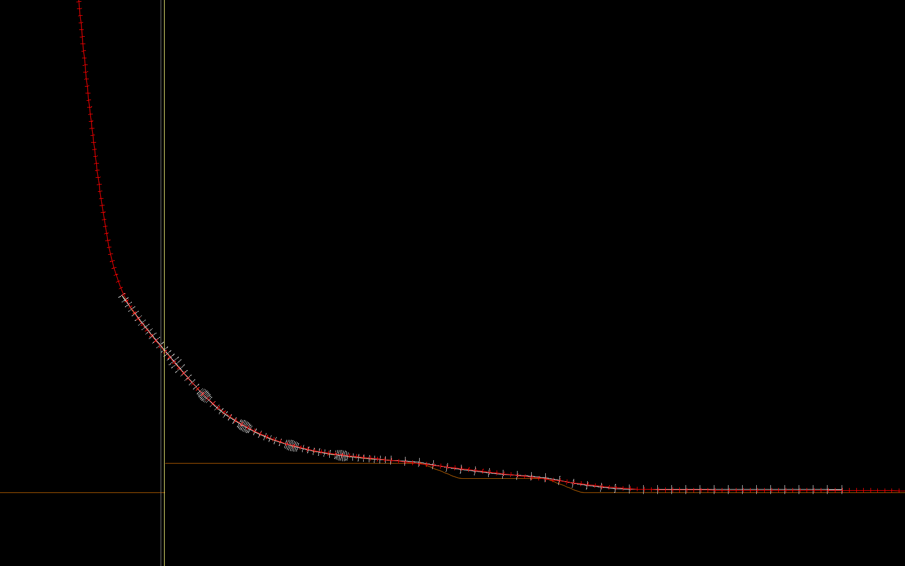
cable hanging inside monopile
monopile
cable inside CPS
scour protection layers on seabed
- Orcaflex model of array cable at a monopile inside a cable protection system

Applying Loads
The loads are typically applied in two steps, an initial static solution followed by dynamics. The static analysis is required to get the system into the appropriate position for dynamic analysis. The static loads acting on the system are its self-weight and the buoyancy (upthrust) from the displaced water.
Dynamic analysis applies the hydrodynamic loads from waves and current. The simulations for dynamic analysis use one wave period to ramp-up the loads then continue for a further three to four wave periods to ensure that the system has settled.
Wave loading can be onerous in the shallow water depth encountered at wind farms. The wave loading varies through the wave cycle. Waves in shallow water are asymmetric with the amplitude of the crest typically greater the amplitude of the trough. The water particle velocity and acceleration are usually modelled using the Dean Stream Function.
The computation effort of using computational fluid dynamics is too onerous thus the semi-empirical Morison’s equation (Morison, et al., 1950) is usually used in a modified form that accounts for the velocity and acceleration of the cable-CPS system (McCormick, 2010). Figure 2 shows the modified form of Morison’s Equation.
$$F=\left(ρA\dot{u}+ρC_{a}V{\dot{u}}_{r}\right)+\frac{1}{2}ρC_{d}Du_{r}\left|u_{r}\right|$$
- Modified Morison’s equation
Where
$$ρ=\text{water density}$$
$$A=\text{cross-sectional area}$$
$$C_{a}=\text{added mass coefficient}$$
$$C_{d}=\text{drag coefficient}$$
$$D=\text{effective drag diameter}$$
$${\dot{u}}_{r}=\text{relative acceleration of water particle and structure}$$
$$\dot{u}=\text{acceleration of structure}$$
$$u_{r}=\text{relative velocity of water particle and structure}$$
A key aspect of Morison’s equation is that it is semi-empirical. The velocities and accelerations are calculated but the drag and inertia coefficients are empirical.

Room to Improve
Global analysis of subsea cables adopts the Roosevelt Principle of “do what you can, with what you have, now” (Roosevelt, 1913). We need to make progress with building wind farms, but we need progress also in doing it better. We are still using methods developed of the offshore oil and gas industry and this aspect needs to be changed.
Consider the drag component of hydrodynamic loading as an example of an area for improvement. The drag loading usually contributes most of the hydrodynamic load in a storm. The drag component of Morison’s Equation is proportional to the relative velocity of the cable-CPS ($u_{r}$), the drag diameter ($D$), and the drag coefficient $(C_{d}$). Reducing the value of any of these three parameters reduces the load on the cable-CPS system.
Marine growth requirements tend to be based on experience from the offshore oil and gas industry, but cable analysis needs more specific values (Griffiths, et al., 2023). The requirement for marine growth is typically set to be 100 mm thickness thus it would double the drag diameter of a 200 mm CPS.
Most of the work on drag coefficients is based on legacy work from the oil and gas industry. Drag coefficients that are specific to CPS and cables seem to be absent from the literature yet a relatively minor change in drag could change a CPS design from being acceptable to unacceptable (or vice-versa) and have significant effects on wind farm cost and viability.
Drag is one area where there is room for improvement and several others can be identified. A brief list of areas for improvement should include CPS-seabed and cable-seabed interaction, hydrodynamic loading for cable/CPS sized components under extreme condition, inherent structural damping in cables and CPS, and defining the actual shape of scour protection layers.

References
Griffiths, T. et al., 2023. The offshore renewables industry may be better served by new bespoke design guidelines than by automatic adoption of recommended practices developed for oil and gas infrastructure: A recommendation illustrated by subsea cable design. Frontiers in Marine Science.
McCormick, M. E., 2010. Ocean Engineering Mechanics: with Applications. Cambridge, UK: Cambridge University Press.
Morison, J. R., Johnson, J. W. & Schaaf, S. A., 1950. The force exerted by surface waves on piles. Journal of Petroleum Technology, 2(5), pp. 149-154.
Orcina, 2023. Orcaflex Theory Manual, v11.4. Ulverston, UK: s.n.
Roosevelt, T., 1913. Theodore Roosevelt; an autobiography [pdf] Retrieved from the Library of Congress, https://www.loc.gov/item/. New York: The Macmillan Company.

