Enhancing Aircraft Safety Through Data-Driven Reduced Order Modelling for Birdstrike Analysis
Dr. R. Lombardi, Dr. C. Sahin
(Noesis Solutions NV, Belgium);
L. Hootsmans, W. Van de Waerdt
(GKN Fokker Aerospace, The Netherlands)
Abstract
Bird collisions pose a significant risk to aircraft safety, potentially causing severe damage to vital parts like wings, tail edges, engines, and cockpit windows. Manufacturers must demonstrate compliance with strict safety standards set by transportation agencies, requiring rigorous physical and numerical impact testing. While numerical simulations offer benefits in flexibility, time, and cost compared to physical tests, they remain complex, resource-intensive, and demand expert analysis. To streamline this process, surrogate models, representing problem behaviour mathematically, could be used, yet many struggle with time-dependent or large-scale crash simulations. Reduced Order Modelling (ROM), especially data-driven ROM, emerges as a promising approach, allowing for faster evaluations in early design stages, albeit with some sacrifice in precision. In this paper, data-driven ROMs were used to reproduce the behaviour of aluminium leading edges, of different thicknesses and radii, upon impact by simulated birds of variable speed. The objective was to determine: if the model could deliver realistic deformation simulations; the amount of time and resources compared to the original computation; the impact of the model’s parameters on the quality of the results.

Data-Driven Reduced Order Models
Data-driven Reduced Order Models (ROMs) are a set of methodologies that leverage existing databases containing full-order solution time histories to create reduced models, enabling cost-effective evaluations. However, this efficiency often comes at the expense of some accuracy. These approaches, developed over recent decades, range from general-purpose to problem-specific solutions. Despite differences in implementation, they typically follow an offline-online framework, involving dataset generation, model training, and model evaluation. The first two operations, which are the most time-consuming, are part of the offline stage. Notably, dataset generation can utilize pre-existing datasets, making it adaptable and efficient. In this study, the reduction of full-order snapshots into a reduced basis is accomplished using Proper Orthogonal Decomposition (POD), a method derived from Single Value Decomposition (SVD). POD identifies dominant variation modes over time, independently applied to both design variables and responses. The resulting reduced parameters are used to train a fully connected Deep Neural Network (DNN), benefiting from the reduced input and output layers due to POD's effects on DNN structure. The DNN models the relationship between reduced state design variables and reduced state responses. The model is generated during the offline training when all its constituents are determined and then stored; the operation leads to an object that can be queried to determine the full-order solution generated by new values of the design variables [1]. The model's reliability hinges on the accuracy of both POD and DNN, with the former influencing the latter. Model quality depends on response complexity and available training data. Adjusting SVD truncation and DNN hyperparameters can enhance accuracy and training time. During the online evaluation phase, the saved projection matrices and normalization boundaries are utilized to transform the design variables of the new experiment into their reduced state. The DNNs are then consulted using these projected design variables to estimate the reduced-order states of the responses. Subsequently, these estimates are projected back to their full-order state using the associated projection/un-projection matrices.
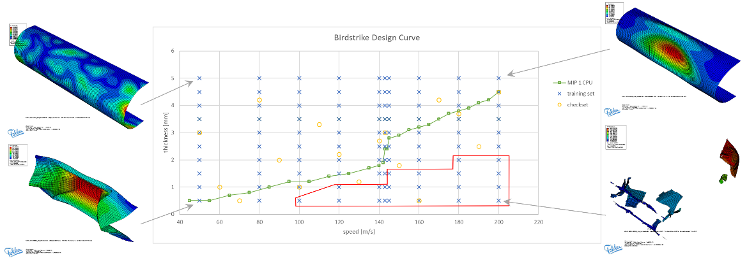
- LE DOE investigation. Performed Abaqus simulations, targeted to be used as training set, are represented by the blue crosses.

Leading Edge Test Case
In a prior study [2], the ROM approach was applied to a simplified bird strike simulation, utilizing an Aluminium octagonal flat plate as the target. The plate, with fixed dimensions, allowed for exploration of the influence of variables like thickness, bird impact speed, and mass on deformation over time. The simulation encompassed various critical aspects such as soft-body bird modelling, bird-plate contact, plate damage initiation and accumulation, high deformation, element failure, and removal. As the ROM approach evolved, a more realistic scenario was created to evaluate performance, using a wing leading edge (LE) model made of uniform-thickness aluminium. The LE model featured flat, parallel upper and lower sides connected by a semi-cylindrical nose with a constant radius. The bay length (rib-to-rib span) was set to 600 mm. The simulation software was Abaqus 2022. The resulting mesh had 14558 total elements of type PC3D and S4R, with upper and lower straight sides constrained. The study considered two failure models: material failure and maximum deformation. The two chosen design variables underwent a Design of Experiments (DOE) process to generate the training and validation dataset, as shown in Figure 1. Images at the corners depict the final simulation step for scenarios at the design space boundaries: negligible deformation, deformation without structural damage, significant deformation with potential spar damage, and LE destruction. The green line distinguishes areas with (below) or without (above) cracks in the structure. The red area denotes experiments resulting in detached or removed elements, resembling the catastrophic bottom-right scenario.
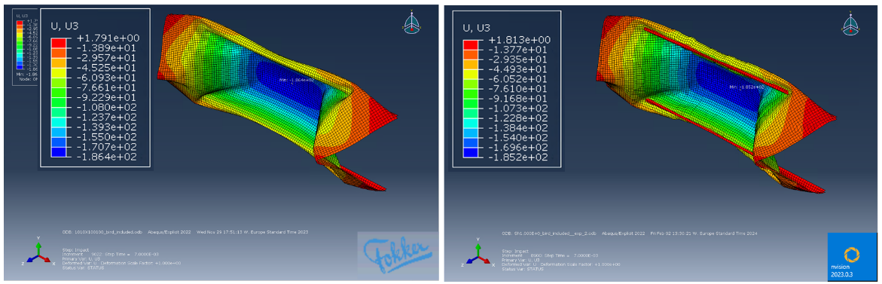
- Comparison native (left) and surrogate model (right) results, for bird speed 100 m/s and LE thickness 2.0 mm. The maximum difference in displacement is 0.3%.

Single LE Geometry
The DOE-planned dataset explored designs of limited interest; subsets of the dataset were tailored to describe the transition between no failed elements and failed elements, along with front spar penetration or non-penetration criteria. Figure 2 illustrate reference results achieved through simulation and the corresponding ROM predictions for a high deformation case. The models were integrated into an optimization workflow to determine the minimum skin thickness capable of withstanding impact without contact between the leading edge and front spar elements. The refined training dataset is the illustrated, orange-bounded area in Figure 3. For this scenario (43 experiments, 14,558 elements), model training took approximately 1800 seconds, while the total setup and evaluation time for the workflow was less than 2 hours. Optimizations were conducted for each impact speed between 50 and 200 m/s, with 10 m/s increments, using both native simulations and model-based analyses. The minimum thickness increment was set to 0.1 mm. The plot displays optimized thicknesses, with green boxes representing Abaqus and yellow circles representing the ROM. Both sets show a similar global trend of thickness versus speed, with the model-based optimization yielding slightly less conservative and thinner results.

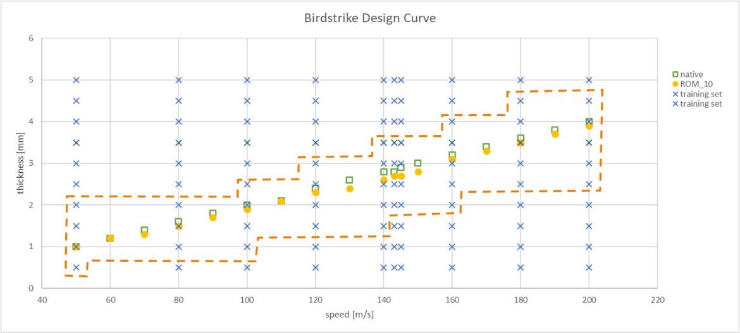
- Comparison of the optimized minimum skin thicknesses, function of impact speed, required to ensure no front spar contact, native simulation (green) and ROM results (yellow).

Conclusions and further developments
The paper introduces and analyses a data-driven Reduced Order Model methodology applied to a simplified crash simulation in the aerospace industry. The ROM predictions align well with reference results from original simulations, both in single design validations and when integrated into advanced design processes like optimization. While simulation time favoured the models, it was slightly less efficient than anticipated. Subsequent investigations revealed the performance bottleneck in the integration interface rather than the model itself, which was rectified. Future efforts will focus on enhancing the approach's flexibility to accommodate multiple geometries and expanding the underlying modelling methodology.

References
[1] Qian Wang, Jan S. Hesthaven, Deep Ray, (2019). Non-intrusive reduced order modeling of unsteady flows using artificial neural networks with application to a combustion problem, Journal of Computational Physics, Volume 384, 2019, Pages 289-307, ISSN 0021-9991.
[2] Lombardi, Panzeri, Sahin, Hootsmans, Van de Waerdt. (2023). Reduced Order modelling for bird strike simulations – Extended abstract – Nafems World Congress 2023.

