From PET Bottle Manufacturing to Pallet Transportation: Virtual Testing for Sustainability
Dr. Padmeya P. Indurkar
(Dassault Systèmes, United Kingdom);
Dr. Gary Menary, Dr. Ross Blair
(Blow Moulding Technologies (BMT), Northern Ireland);
Abstract
The urgent need for sustainability in the food, drink and consumer goods industry has prompted the need for optimized materials engineering, product and packaging development, with a growing emphasis on minimizing environmental footprint with uncompromised product quality.
Through the lens of innovative packaging, this talk showcases 3DEXPERIENCE platform based MODSIM solutions, which integrate our well established modelling, simulation, PLM and digital manufacturing capabilities to enable fully democratized end-to-end product development.
As example, a comprehensive multi-scale virtual twin will be demonstrated starting from a single PET bottle from its blow molding manufacturing process up to a virtual testing of packaging through its pallet transportation. Within the virtual twin, we incorporate requirements stemming from sustainability targets and functional needs gleaned from the entire value chain: bottle manufacturing, production line, transportation, stocking, customer experience, etc. The characteristics of a single bottle are influenced by various factors including materials, shape, and most importantly the manufacturing process parameters.
From there, we show the simulation of a patterned assembly of shrink wrapped PET bottles on a pallet with stretch wrapping. This pallet is then subjected to transportation stability load cases to mimic the accelerations experienced during transit. Our multi-scale virtual twin enables insight into local failure mechanisms at each scale thereby allowing better manufacturing, packaging and transportation strategies upfront. Furthermore, to enable the democratized usage of this virtual twin, we build a fully automated dashboard with an intuitive GUI allowing packaging engineers to perform these simulations without the need to harness dedicated design or simulation tools.
Through workflows such as these, at different stages of product development and packaging, this talk advocates for a widespread adoption of MODSIM technology as a new frontier in the consumer goods industry to address the numerous challenges, ranging from economic efficiency, to a quest for innovative and eco-friendly packaging solutions.

Virtual prototyping: Optimising processing for performance
Transitioning from fossil-based plastics (e.g., PET) to bio-based alternatives presents challenges due to variable mechanical properties and process incompatibility. BMT, pioneers of innovative stretch blow moulding (SBM) technology for sustainable packaging, have developed a unique ‘characterise-digitise-optimise’ workflow to overcome these challenges, accelerating the adoption of sustainable materials and advancing the circular economy.
Initially, rigorous experimental characterisation, including planar biaxial testing of plaques and freeblow analysis of preforms (Fig. 1a and Fig 1b), provides mechanical insights into the polymer resin. This data quantifies the resin’s temperature and strain-rate dependence during SBM, enabling calibration of a constitutive model for finite element (FE) implementation.
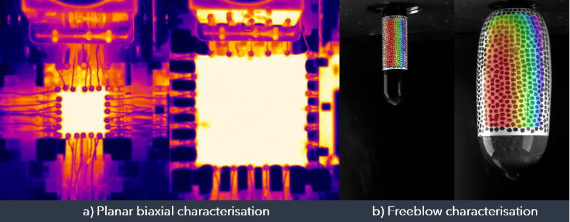
- BMT’s material characterisation techniques used to provide input data for SBM and performance simulations.
BMT has developed innovative software that automates FE simulation setup, using the calibrated material model. Initially, a systematic design of experiments (DoE) varies critical SBM parameters to assess their impact on bottle thickness and modulus distribution. This software also facilitates a streamlined setup of in-service simulations, such as top load and squeeze resistance, linking bottle performance directly to the process recipe (Fig. 2).
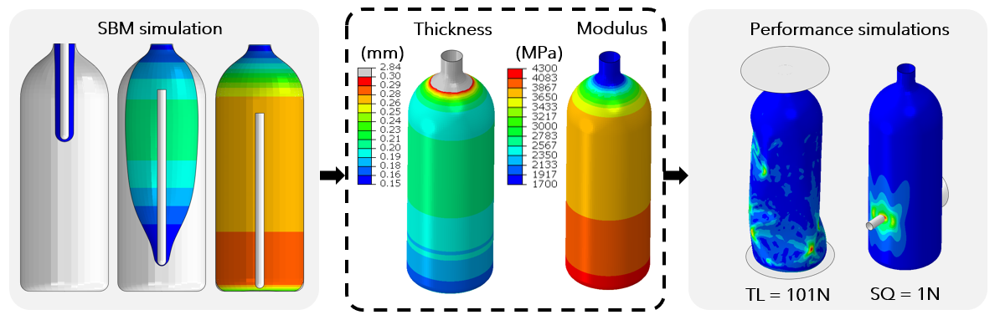
- BMT’s process-to-performance workflow: Thickness and modulus profiles from SBM simulations feed into performance simulations, e.g., top load (TL) and squeeze (SQ).
Surrogate (machine learning) models are trained using SBM and performance simulation data. Once trained, these efficient models enable sensitivity analysis and uncertainty quantification. In this study, the surrogate model identified a robust, optimal recipe to produce an in-spec bottle, tolerating typical process fluctuations (± 3 °C).
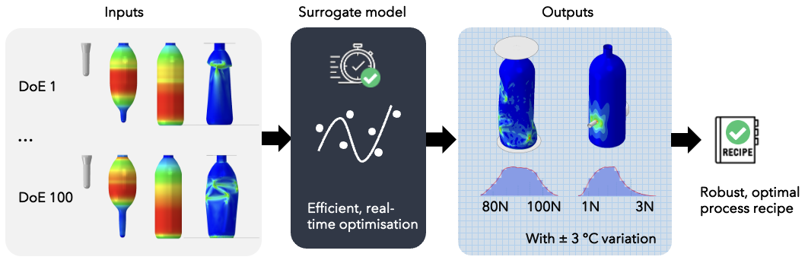
- BMT’s optimisation workflow: A surrogate model is trained using SBM and performance simulation data, then used to identify a robust, optimal process recipe.

Virtual testing of pallet transportation
Having optimized the PET bottle, a crucial requirement to put it to use is the robust design of its packaging and delivery systems to the consumer. In this regard, both its primary and secondary packaging need to be virtually tested, under loads while in-transit in addition to consumer experience.
The 3DEXPERIENCE platform developed by Dassault Systèmes seamlessly integrates the modelling and simulation processes in packaging development through unifying the well-established CATIA® and SIMULIA® solutions widely adopted across industries. Through the lens of a democratised pallet transportation workflow, here we show a glimpse of how 3DEXPERIENCE empowered accelerated engineering and virtual discovery of optimum packaging alternatives enables an end-to-end virtual twin of a PET bottle with packaging.
The PET bottle analysis shown in Section 1 predicts accurate cross section thickness, moduli, and residual stress distribution resulting from the SBM process. In this section, we use this enriched representation supplemented with a capped and fluid filled idealization of the PET bottle, to assemble a multi-scale model of pallet transportation required for evaluation of loads experienced during transit.
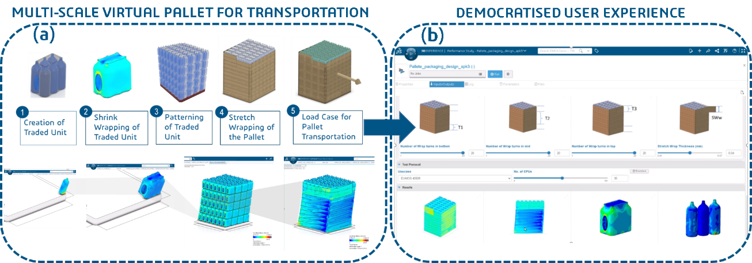
- (a) Multi-scale virtual twin of pallet transportation. (b) A customizable GUI for to perform democratised simulations for this pallet transportation assembly to evaluate packaging during transit testing
Fig. 4a shows the multi-scale virtual twin from a traded unit comprising of 6 PET bottles. This traded unit is first shrink wrapped and then patterned on a pallet. Following this, a tensioned stretch wrapping is virtually applied to impart the assembled traded units a structural stability. Behaviour of this stretch wrap is a critical aspect of this workflow; both the width of the stretch wrap and the number of turns as a function of pallet height are specified. The entire assembly can now be subjected to various loading conditions as documented in the ISTA 3E standard. These include inclined impact deceleration, rotational edge drop, compression and random vibration testing among others. Accounting for a comprehensive material model of PET as shown in Section 1, this approach can be used to predict maximum stresses, and plastic strains as well as damage accrual in the stretch wrap and the PET bottles including the relative displacements of the overall pallet. This is elucidated in Fig. 4a, where the stresses on the surface of a bottle are shown, with critical regions appearing red.
To enable a wider deployment of this workflow, we have fully parametrized and automated this simulation process. The key parameters here include the number of bottles in a traded unit, the number of traded units in a row, the number of assembled rows in a pallet as well as width and number of turns of the shrink wrap at different heights. Using this fully parametrized model, we create a customized user interface with an intuitive GUI (cf. Fig. 4b), where these parameters can be toggled, a representative model is instantiated and simulation results are generated manifesting an automated end-to-end democratized approach. Having access to this GUI, a designer, or a packaging engineer without much simulation know-how can still utilize this GUI to assess packaging quality under transit testing based on accurate simulation.
This 3DEXPERIENCE empowered democratized multi-scale virtual twin methodology enables deeper insight into performance and failure modes in a PET bottle packaged assembly at each scale thereby allowing rapid discovery of enhanced manufacturing, packaging and transportation strategies upfront.

