Battery development using physics-based modelling
Juergen Schneider. Gernot Maier
(AVL List GmbH, Austria);
Abstract
Fast development speeds and low component costs are the key factors for success on the battery development market. From the early concept phase important decisions are made, influencing the entire system development. This includes the selection of a battery cell format and cell chemistry, followed by the development of the most suitable cooling concept. This ultimately affects the BMS strategy for achieving the battery safety and lifetime requirements.
This presentation describes the modelling approach for a fast virtual layout of the battery pack. It shows how the simulation in combination with the measurements helps balancing between performance, safety and the cost while reducing development times. It describes how the thermal model of a battery cell, module and pack is created, implemented, and used.
High precision validated model of a single battery cell and module is presented using the Hyundai IONIQ 5 battery as an example. Battery module thermal model is integrated into a multi-physics system simulation. Measurement comparison is used for the final validation. It concludes which method is best suited for the respective battery development steps as well as how to validate the results using measurements.

Introduction
Unlike in traditional ICE-based vehicles, where the energy storage system (fuel tank) was a comparatively simple component, the energy storage system in electric vehicles is very complex: Depending on the battery cell type, several hundreds or even thousands of cells are found in a battery pack. When developing a battery pack, several sophisticated engineering decisions need to be made.
This starts at the selection of a battery cell format and cell chemistry, followed by the electrical layout of the storage system and development of a suitable cooling and safety concept. Throughout this process, fast development speed and low component costs are key factors for success on the market. Any decision made in an early phase hugely impacts later development stages, therefore engineers need to ensure that these decisions are the right ones. Since hardware prototypes are often not available in early design phases, there is strong demand to support the development using simulation tools.

Simulation Approach
One of the first decisions in the concept and layout phase is the selection of a suitable battery cell for the vehicle. As battery cells come in different formats (Cylindrical, prismatic or pouch) and chemistries, it is desirable to compare cells under their targeted load conditions to find a suitable cell as early as possible.
Simulation can help in this process by running these comparisons in the context of the entire vehicle. Critical questions in the setup of the simulation models are the modelling of the vehicle and the modelling of the battery cells.
The approach presented in this article is based on setting up the simulation model using vehicle and battery pack generators that help to set up the respective components based on simple input parameters (e.g. vehicle dimensions, type of drivetrain) with little effort. These models are then be further refined (Figure 1).
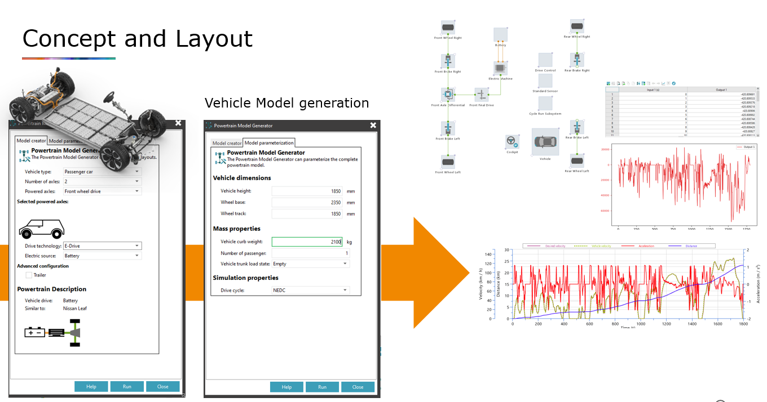
- Powertrain Model Generator
Regarding the modelling of battery cells, it is crucial to use sophisticated electrochemical models that are able to represent the battery cell in a wide range of different conditions. With the knowledge of the electrochemical properties of the anode, cathode and electrolyte, a large number of battery variants can be created using building blocks. On the other hand, the commonly used models, such as equivalent-circuit models are usually not able to represent the battery cell in extreme conditions like at low temperatures or high currents. They also require that the cell is already available in hardware for pulse test measurements.
Once the model is set up, simulations based on real conditions (e.g. drive cycles or fast charging profiles) can be performed. The results of these simulations are then evaluated in a decision matrix with other KPIs such as the costs of the various components (Figure 2).
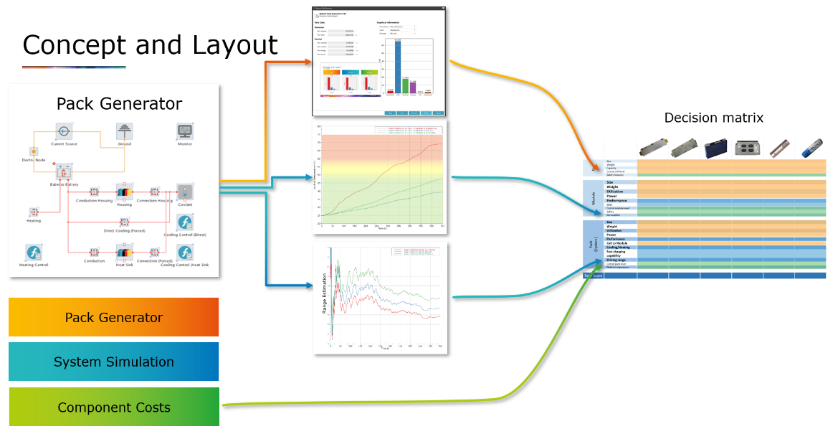
- Decision Matrix
On component level, it is equally important to consider sophisticated battery cell models as on system simulation level. The main task is to ensure optimal and efficient cooling of components such as the battery module under different conditions (Figure 3).
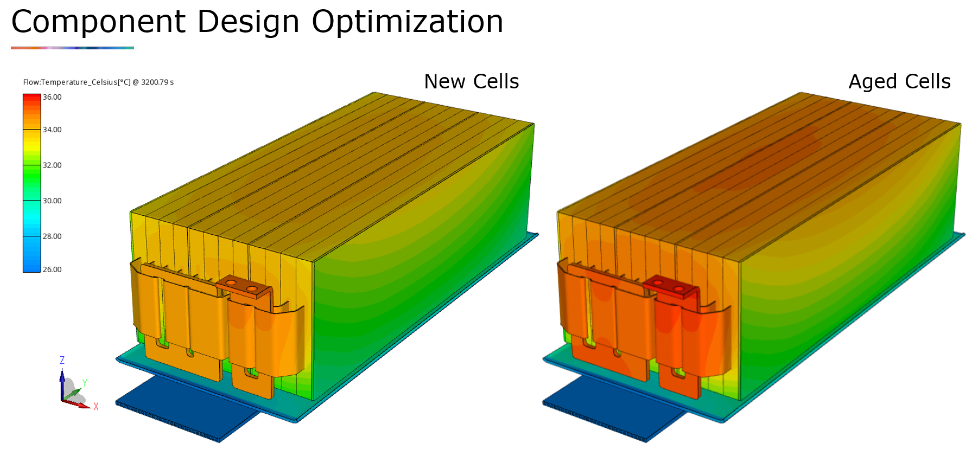
- 3D Component Analysis

Model Validation
Simulation-based methods are only as good as their model accuracy allows. To ensure the process reliability of the method, it is important to compare the respective model components with reference data from measurements. This applies from the cell to the module to the vehicle. The validity of the simulation approaches presented in the previous chapter is demonstrated using the example of the Hyundai IONIQ 5 battery .
A module was equipped with 37 temperature sensors and 6 voltage sensors (Figure 4), and a variation of measurements were carried out to obtain the reference data for comparison with the simulation results (Figures 5 and 6).
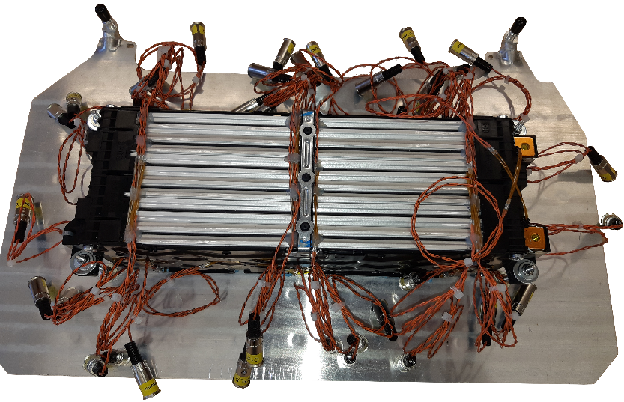
- Battery Module – Measurement setup

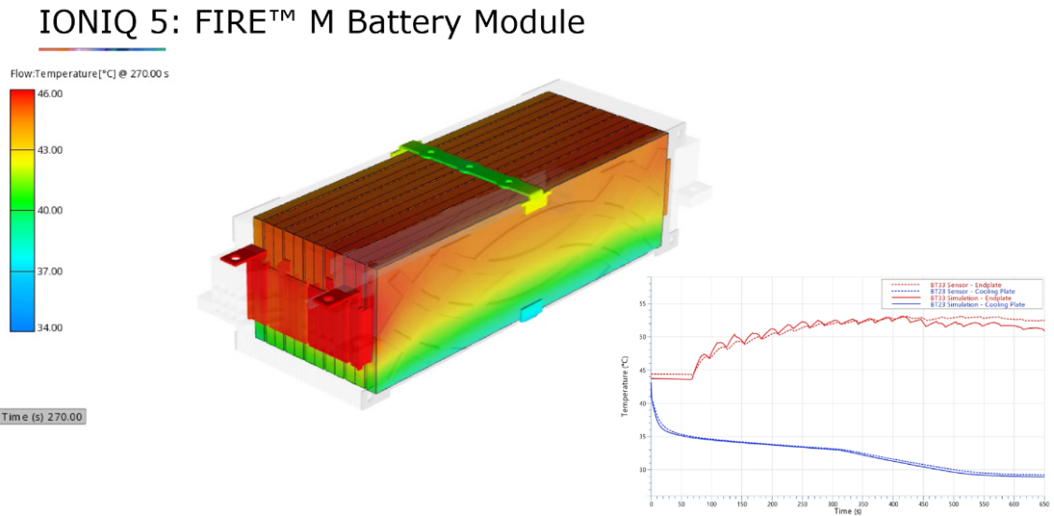
- Battery Module – Simulation vs. Measurement
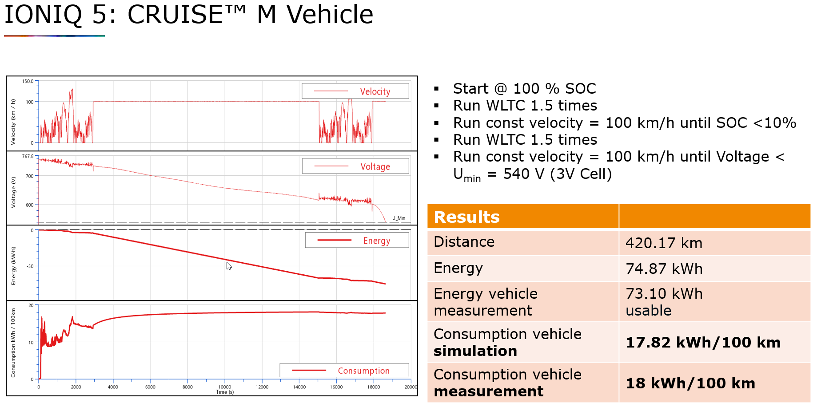
- Vehicle Model – Simulation vs. Measurement

Conclusion
The use of simulation allows development teams to make the right decisions quickly at a very early stage of product development and thus massively reduce development time and costs. This requires an end-to-end approach that provides consistent models from the concept decision to component optimization. The successful use of our models is not only possible because they meet the high requirements for accuracy, but also because they prove this in comparison with measurement data.

